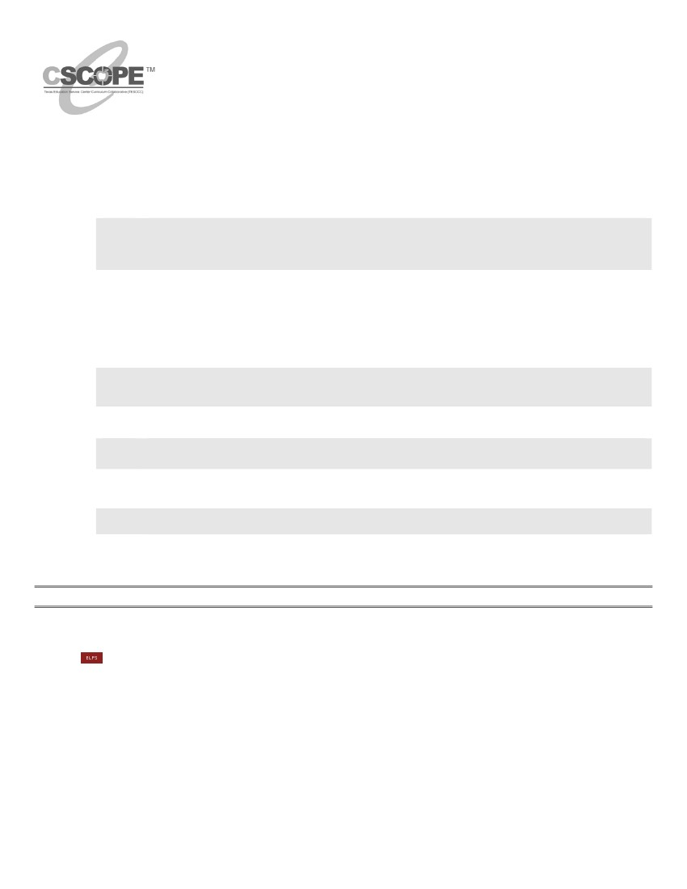
Third Grade
Mathematics
Unit: 08
Lesson: 01
Duration: 7 Days
Measuring Length, Perimeter, and Area
Lesson Synopsis:
Students select the standard units: customary and metric/SI, to measure classroom items. The focus of this lesson is on
linear measurement, including estimation. Students will use standard units of measure to continue their investigations of
perimeter and area.
TEKS
3.11
Measurement. The student directly compares the attributes of length, area, weight/mass, and
capacity, and uses comparative language, to solve problems and answer questions. The
student selects and uses standard units to describe length, area, capacity/volume, and
weight/mass. The student is expected to:
Use linear measurement tools to estimate and measure lengths using standard units.
Use standard units to find the perimeter of a shape.
Use concrete and pictorial models of square units to determine the area of two-dimensional
surfaces.
3.11A
3.11B
3.11C
Process TEKS
3.14 Underlying processes and mathematical tools. The student applies Grade 3 mathematics to
solve problems connected to everyday experiences and activities in and outside of school.
The student is expected to:
3.14A Identify the mathematics in everyday situations.
3.14D Use tools such as real objects, manipulatives, and technology to solve problems.
3.15 Underlying processes and mathematical tools. The student communicates about Grade 3
mathematics using informal language. The student is expected to:
3.15A
3.15B
3.16
3.16A
3.16B
Explain and record observations using objects, words, pictures, numbers, and technology.
Relate informal language to mathematical language and symbols.
Underlying processes and mathematical tools. The student uses logical reasoning. The
student is expected to:
Make generalizations from patterns or sets of examples and non-examples.
Justify why an answer is reasonable and explain the solution process.
GETTING READY FOR INSTRUCTION
Performance Indicator(s):

- Use the appropriate tools to estimate and measure to find the length, perimeter and area of various figures.
(3.11A, 3.11B, 3.11C)
ELPS: 1E, 2E, 2I, 3D, 4E, 5B
KEY Understandings and Guiding Questions:
- Linear measurement tools can be used to estimate and measure length.
  - Why is it important to estimate before measuring?
  - How can estimation be useful in real-world activities?
  - What is the relationship between a measurement tool and the object being measured?
  - What are the tools of linear measurement?
  - How do you determine the correct measurement tool to use?
- Standard units can be used to find the perimeter of a shape.
  - How can you use standard units to find the perimeter of a shape?
- Concrete and pictorial models of square units can be used to determine the area of two-dimensional surfaces.
  - How is area measured?
12/29/10
page 1 of 89
©2010, TESCCC

3rd Grade
Mathematics
Unit: 08 Lesson: 01
Vocabulary of Instruction:
- half
- fourth
- inch
- foot
- yard
- mile
- centimeter
- decimeter
- millimeter
- meter
- height
- width
- length
- customary
- metric/SI
- linear
- area
- perimeter
Materials:
- math journal (1 per student)
- construction paper (9 x 12) (3
sheets per student group)
- standard ruler with both
customary and metric units
(1 per student)
- yardstick (1 per student group)
scissors
- tape
- bulletin board paper (2 sheets
per class)
- construction paper (9 x 12) (or
blank paper) (6 sheets per
student)
- magazines/newspapers
(optional) (2-3 per student)
- unsharpened pencil (1 per
student)
- index card (1 per student)
- marker (1 per student)
- centimeter cubes (1 per
student)
- base-ten blocks (twelve 10-
longs per group)
- meter stick (1 per student
group)
- small bag or box of
miscellaneous objects
between 1 and 5
centimeters long (1 per
group)
- math books (or any same-
size book) (1 per student)
- marker (1 per station)
- 2 identical sets of crayons
(16, 24 and 48 to a box) (1
set at each Station 2)
- 4 identical sets of crayons
(48 to a box) (2 at Station 3
and 2 at Station 4)
- blank sheets of paper (1 per
student)
- color tiles (30 per student)
Resources:
- SPIRALING REVIEW
Each day will begin with a short spiraling review which is designed to revisit previously introduced concepts and
act as a quick student assessment. It is recommended that students be given 5 – 6 minutes to complete the daily
question(s) recording all entries in their math journals. Approximately 4 minutes should be used for discussion.
Two days of each week are called “Fact Time” and should be devoted to developing quick recognition (recall) of
basic facts or focused intervention according to student needs. Teachers should use classroom supplementary
materials such as flashcards, textbook supplements, district programs, etc. based on student needs in the
classroom. All spiraling reviews will be found as a separate attachment in the developer with the first unit of each
six weeks. Incorporate more games and partner activities into warm ups. Teachers should note to the students the
grading criteria for each lesson and homework. How tests will be given and graded should be addressed. Feedback
on homework and assignments should be given on a daily basis to allow for better understanding of the unit material.

STATE RESOURCES
— MTC K-3: Square Numbers
http://www.tea.state.tx.us/math/index.html
— MTR 3-5: Line It Up!
http://www.tea.state.tx.us/math/index.html
— Mathematics TEKS Toolkit: TEKS Clarifying Activity/Lesson/Assessment
http://www.utdanacenter.org/mathtoolkit/index.php
TEXTEAMS: Rethinking Elementary Mathematics Part I: Making Evidence Clear to Students; How Long?
How Many?
TEXTEAMS: Rethinking Elementary Mathematics Part II: Making Rectangles; Measuring Area with
Rectangles; Area with Tiles
- TAKS Mathematics Charts: http://www.tea.state.tx.us/student.assessment/taks/math
©2010, TESCCC
12/29/10
page 2 of 89

3rd Grade
Mathematics
Unit: 08 Lesson: 01
Advance Preparation:
1.
2.
Yardstick/meter stick: If combination yard/meter sticks are only available for classroom use, use a red
permanent marker and draw a line on both edges/widths to indicate the end of the yardstick.
Bulletin Board Paper - Cut two sheets of white bulletin board paper about 24” x 40” to use for Customary and
Metric/SI Charts. These charts will be placed in a Measurement Corner on the wall in the classroom. Another
chart for Weight/Mass and Capacity and Volume will be completed in Lesson 04 and added to the
Measurement Corner.
Handout: Grade 3 TAKS Mathematics Chart (1 per student downloaded from website)
Transparency: Grade 3 TAKS Mathematics Chart (1 per teacher)
Graphic: Visuals for Customary Length (1 per class chart)
Graphic: Customary Units (1 per class chart)
Handout: Tri-Fold Flip Book Directions (1 per student)
Transparency: Customary Ruler (1 per teacher)
Transparency: Customary Ruler (1 per student)
Transparency: Customary Broken Ruler (1 per teacher)
Handout: Customary Broken Ruler (1 per student)
Transparency: Read that Ruler! Customary (1 per teacher)
Handout: Read that Ruler! Customary (1 per student)
Transparency: Which Answer is Correct and Why? (1 per teacher)
Handout (optional): Customary Length Notes/Practice (1 per student as needed)
Handout (optional): Customary Ruler Practice (1 per student as needed)
Graphic: Visuals for Metric Length (1 per class)
Graphic: Metric Units (1 per class)
Handout: Tri-Fold Flip Book Directions (1 per student from Day 1)
Transparency: Metric Ruler (1 per teacher)
Handout: To the Nearest—Metric Recording Sheet (1 per student)
Handout: Read that Ruler! Metric (1 per student)
Handout (optional): Metric Length Notes/Practice (1 per student as needed)
Handout (optional): Metric Ruler Practice (1 per student as needed)
Handout (optional): Additional Combined Measures Practice (1 per student as needed)
Transparency: Textbook Perimeter (1 per teacher)
Handout: Textbook Perimeter (1 per student)
Handout: Perimeter Scavenger Hunt (1 per student)
Handout: Estimate and Measure Perimeter Practice (1 per student)
Transparency: Dot Paper (1 per teacher)
Handout: Dot Paper (1 per student)
Transparency: Finding Area – Notes and Practice (1 per teacher)
Handout: Finding Area – Notes and Practice (1 per student)
Handout: Finding Area Practice (1 per student)
Transparency: Broken Ruler 2 (1 per teacher)
Card Set: Measurement Station Task Cards (run on cardstock) (1 per station)
Handout: Measurement Stations Recording Sheet (1 per student)
Handout: Crayon Box Perimeter Mat (1 per student)
Handout: Crayon Box Area Mat (1 per student)
Handout: Measurement Evaluation (1 per student)
Handout: Grading criteria for measurement unit (1 per student)
3.
4.
5.
6.
7.
8.
9.
10.
11.
12.
13.
14.
15.
16.
17.
18.
19.
20.
21.
22.
23.
24.
25.
26.
27.
28.
29.
30.
31.
32.
33.
34.
35.
36.
37.
38.
39.
40.
Background Information:
In second grade, students measure with non-standard units only. Third grade is the first grade to use the ruler as a
measuring tool. In the previous unit, students were taught to link the ruler, “handmade ruler”, to the number line with whole
numbers and fractions, using inches. Third grade students are to select and use standard units to describe length which
includes both customary units, such as inches, feet, and yards, and metric/ SI units, such as millimeters, centimeters, and
meters. The term “SI” comes from a French phrase, Systeme International (SI) d'unites, meaning International System of
Units; it is a part of the TEKS refinements and is to accompany the term “metric”.
GETTING READY FOR INSTRUCTION SUPPLEMENTAL PLANNING DOCUMENT
Instructors are encouraged to supplement, differentiate and substitute resources, materials, and activities to address the needs of learners. The
Exemplar Lessons are one approach to teaching and reaching the Performance Indicators and Specificity in the Instructional Focus Document for this
©2010, TESCCC
12/29/10
page 3 of 89

3rd Grade
Mathematics
Unit: 08 Lesson: 01
unit. A Microsoft Word template for this Planning document is located at www.cscope.us/sup_plan_temp.doc. If a supplement is created electronically,
users are encouraged to upload the document to their Lesson Plans as a Lesson Plan Resource for future reference.
INSTRUCTIONAL PROCEDURES
Instructional Procedures
ENGAGE
Revision: Prior to start of this unit: Teacher/Instructor will conduct a mini-lesson for
direct teaching of measurement concepts through demonstrations and other visuals.
Pre-exposure of standard ruler and yardstick for struggling learners.
1. Select 4 student volunteers (with varying foot sizes) to come to the front of
the classroom and have each one walk heel-to-toe along a well-defined
classroom length. As each student walks this length, have the whole class
count the steps aloud. Record each student’s total number of steps on the
board or overhead. Prompt students to use their math journals to record
these measures as well. Revision: Partner struggling learner with an on grade-level
student to provide guidance.
• Since these are rough measurements, what kinds of words
should we use to describe each total? Answers may vary but could
include: About, estimated, almost, a little more than, a little less than,
between ____ and ____, etc.
• Why weren’t all these measurements the same? (The feet of each
student were different sizes.)
2. Explain to students that using body measures, or non-standard units of
measure, is a problem because the measures are different for different
people. By using standard units of measure, the problem is solved
because standard units never change. They are the same for everyone. If
two people used standard units of measure to measure the same object,
the measurements would be the same or almost the same. (Provide visual representations)
Notes for Teacher
NOTE: 1 Day = 50 minutes
Suggested Day 1
SPIRALING REVIEW
MATERIALS
• math journal (1 per student)
VOCABULARY
Standard unit –a unit of measure that
has been defined by a recognized
authority, such as a government or
standards organization. For example,
inches, meters, seconds, liters, pounds
and grams are all standard units
EXPLORE/EXPLAIN 1
While explaining, incorporate multiple representations where needed for struggling
learners.
1. Explain to students that one system of standard units that has developed
over time is the customary system of measurement. In this system, the
basic unit of length is the inch. (See vocabulary note at right.)
2. Let students know that you can use your finger to estimate “one inch”.
Demonstrate how to do this by bending your finger and aligning the ruler
with zero starting at one joint and measuring to the other joint.

Explain that although the space between the joints is not an exact
measurement, it is a good estimate or approximation of an inch.
• What are some other objects that might be about 1-inch long?
Answers may vary but could include: The length of a small paper clip, a
color tile, etc.
Remind students that even though these are nonstandard units of
measure, they are still good “estimates” of standard measures.
3. Direct students to discuss what they would do to measure distances in a
sunflower seed-spitting contest.
• Which customary unit of length would you choose? Answers may
vary but could include: inches or feet.
• What other customary units of length do you know? Answers may
vary but could include: yards or miles.
• Why are these units not as appropriate for measuring the
distances in the contest? Answers may vary but could include: With
©2010, TESCCC
12/29/10
Suggested Day 1 Continued
MATERIALS
• construction paper (9” x 12”) (3
sheets per student group)
• standard ruler with both customary
and metric units (1 per student)
• yardstick (1 per student group)
• scissors
• tape
• Handout: Grade 3 TAKS
Mathematics Chart (1 per student)
• Transparency: Grade 3 TAKS
Mathematics Chart (1 per teacher)
• bulletin board paper (1 sheet per
class)
• Graphic: Visuals for Customary
Length (1 per class chart)
• Graphic: Customary Units (1 per
class chart)
• Handout: Tri-Fold Flip Book
Directions (1 per student)
• construction paper (9” x 12”) (or
blank paper) (2 sheets per student)
• magazines/newspapers (optional)
(2-3 per student)
VOCABULARY
customary measurement: the system
of measurement used in the United
page 4 of 89
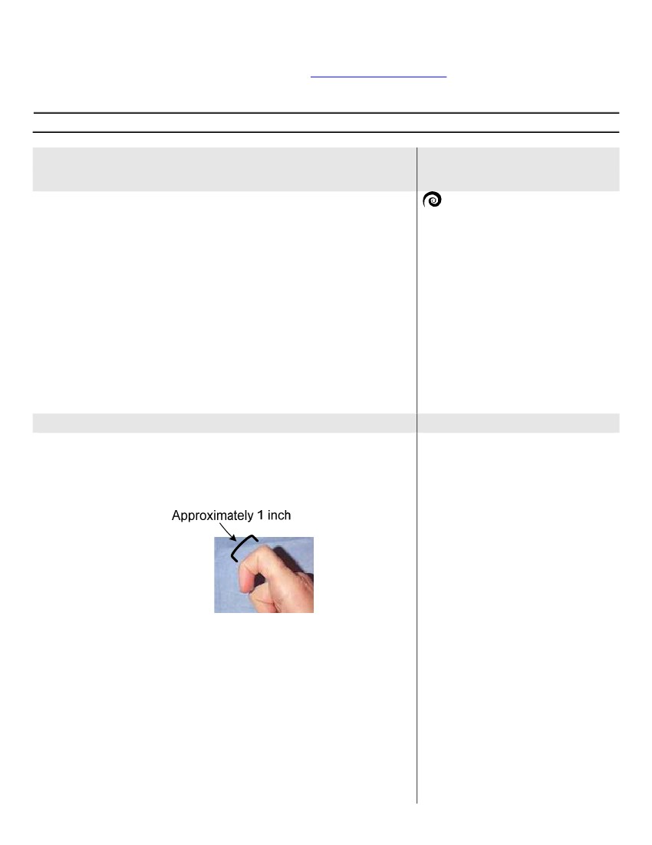
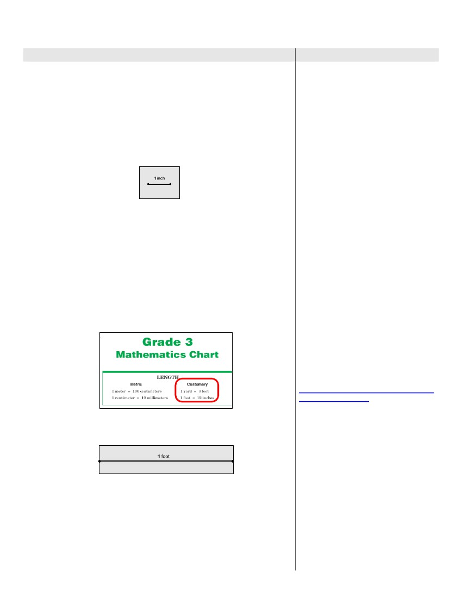
3rd Grade
Mathematics
Unit: 08 Lesson: 01
Instructional Procedures
larger units, it is harder to get precise measurements of shorter
distances.
4. Have students sit in groups of 3-4 per group, and distribute 3 sheets of
construction paper to each group. Revision: Mixed-ability grouping to benefit
struggling learners.
Make sure each group has at least 1 ruler. Model (may need to partner struggling learners
with a peer partner)for the whole class the following process:
Prompt one student from each group to fold a sheet of construction paper in half
lengthwise (hot-dog fold) and then cut along that fold. Next, have another student in
the group take one of the half-sheets of paper and use the ruler to draw a
horizontal one-inch line segment on it with a marker. Instruct another
student in the group to label the line segment “1 inch”, and then trim the
remaining pieces of construction paper from the drawing. Example:
Notes for Teacher
States for measuring length, volume
and weight. Make sure you give direction on
what instrument to use and how the groups will be graded and how much time they will have to complete the task. Allow some time for group feedback
5. Have students look at the other half piece of construction paper.
• About how many inches long is this sheet of construction paper?
How do you know? Answers may vary. Estimates could include using
the 1-inch line segment drawn previously to determine the approximate
length.
Direct students to measure the length of the other half of construction
paper using their rulers. (Demonstrate as directing)
• How long was the length of construction paper? (12 inches)
• What is another name for 12 inches? How do you know? (a foot)
Answers may vary but could include: It’s on the Grade 3 TAKS
Mathematics Chart.
Have students look at handout: Grade 3 TAKS Mathematics Chart to find
the relationships modeled by their paper strips, and display a transparency
of the same on the overhead. Example:
TEACHER NOTE
According to the Publication Manual of
the American Psychological Association
(5th ed.), periods (.) are not used after
abbreviations for units of measure.
However, when using inches, a period is
used (in.) because it could be misread.
The same is true for gallons – a period
is used (gal.) to distinguish it from the
word “gal”.
TEACHER NOTE
The customary ruler on the Grade 3
TAKS Mathematics Chart can be used
in place of a ruler to acclimate students
to its use during the TAKS test. TAKS
Mathematics Charts can be found at the
following TEA website:
http://www.tea.state.tx.us/student.ass
essment/taks/math/
Prompt students in each group to draw a horizontal line segment along the
middle of this sheet of construction paper and label it “1 foot”. Example:
NOTE: When printing the revised TAKS
Mathematics Charts, please make sure
that your Print Menu is set to print the
pages at 100%. Be sure to check printer
settings as well to ensure that rulers
print to scale.
Explicit modeling will provide clear understanding of instructions.
6. Instruct students to fold and cut the remaining 2 sheets of construction
paper the same way as the first sheet to create 4 pieces of paper. Explain
that sometimes large objects need to be measured. Although multiple
standard rulers can be used, it can be difficult. Tell students that if you
measure more than one “foot”, you call them “feet”. Distribute one
yardstick to each group.
• How many feet or standard rulers will fit end to end to equal the
length of one yard? How do you know? (3 feet) Answers may vary
but could include: It’s on the Grade 3 TAKS Mathematics Chart.
Prompt students to lay their strips end-to-end until they have 1 yard. Next,
©2010, TESCCC
12/29/10
page 5 of 89

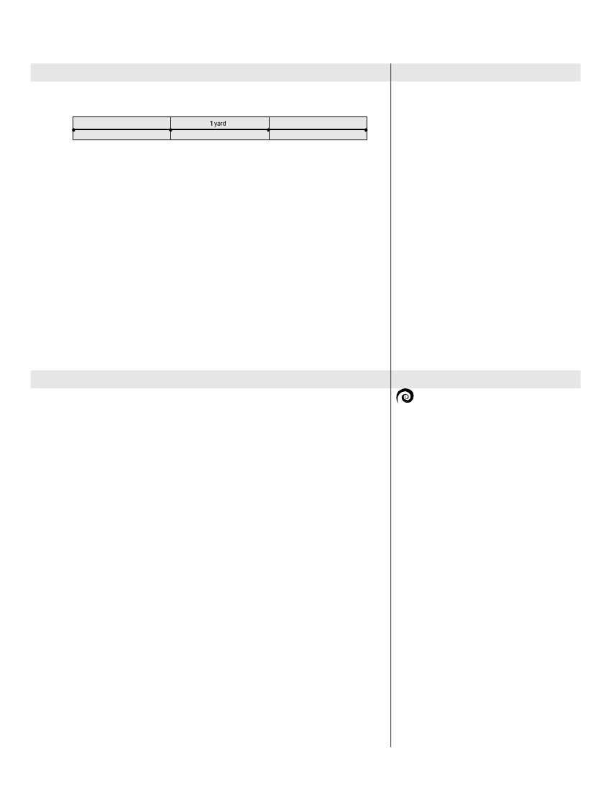
3rd Grade
Mathematics
Unit: 08 Lesson: 01
Instructional Procedures
have them tape these strips together and turn the large strip they created
over onto the “non-taped” side. Label this strip “1 yard”. Example:
Notes for Teacher
TEACHER NOTE
Although 3rd graders are not
responsible for converting measurement
units, it is important that they have
experience with models that
demonstrate the relationships among
different units of measurement. Grade 3
students should also be able to realize
that it will take more “feet” to measure
an item than a “yard”. (VanDeWalle,
2006)
Instruct students to lay each paper strip so that the 1-inch strip is above
the 1-foot strip etc. Have them compare and contrast each customary
measurement length in their groups. Some students may be able to see
that there are 36 inches in the yard after comparing the inch measure with
the foot and then with the yard. Other students may realize that it would
take more of the inch strips to measure an item than the foot strip etc.
Display one set of these strips on a large sheet of bulletin board paper
somewhere in the room for students to use as a reference for later
measurement activities. Use the graphics: Visuals for Customary Length
and Customary Units to title the poster paper with the strips.
7. Distribute handout: Tri-Fold Flip Book Directions and 1 sheet of
construction or blank paper to individual students. Use the directions to
model with students how to make a tri-fold book. (Students made a tri-fold
book in Unit 03, Lesson 02.) Instruct students to label the cover of each
flap as follows: (1) Inches, (2) Feet, and (3) Yards. When students have
finished labeling their books, tell them they are to complete their books by
writing at least 3 items under each flap that would most appropriately be
measured with that unit. If time allows, have students use the back of their
booklets to list 3 items that could be measured in miles.
TEACHER NOTE
If time allows, students may search for 3
magazine or newspaper pictures for
each appropriate unit of measure. They
should cut and glue each picture under
each flap of their booklets.
Suggested Day 2
SPIRALING REVIEW
MATERIALS
• standard ruler with both customary
and metric units (1 per student)
• unsharpened pencil (1 per student)
• Transparency: Customary Ruler
(1 per teacher)
• Transparency: Customary Broken
Ruler (1 per teacher)
• Handout: Customary Broken
Ruler (1 per student)
• Handout: Read that Ruler!
Customary (1 per student)
• index card (1 per student)
• marker (1 per student)
• Transparency: Read that Ruler!
Customary (1 per teacher)
• Transparency: Which Answer is
Correct and Why? (1 per teacher)
• Handout (optional): Customary
Length Notes/Practice (1 per
student as needed)
• Handout (optional): Customary
Ruler Practice (1 per student as
needed)
EXPLORE/EXPLAIN 2
(More representations and modeling needed)
1. Debrief and discuss the items students placed in each category of their flip
books created yesterday.
2. Distribute a new unsharpened pencil (to ensure the same length) and
customary rulers to individual students. Display transparency: Customary
Ruler on overhead and have students work with a partner to estimate the
pencil length before actually measuring it.
•About how long is the pencil in inches? Answers may vary.
Demonstrate on the overhead with the customary ruler how to measure an
object to the nearest inch. Prompt students to locate 0, or the line that
represents zero, on the customary side of the ruler and remind them that it
is important to pay attention to the numbers when aligning the ruler with
the object being measured.
• To the nearest inch, how long is this pencil? Answers may vary.
(About 8 inches.)
3. Explain to the students that when reporting a measurement, it is essential
to name the unit of measure as well as the numerical value. Remind
students that the abbreviation for the word “inch” is “in.”
4. Display transparency: Customary Broken Ruler on overhead and
distribute handout of same to individual students.
• How is this ruler different than your standard ruler? Answers may
vary but could include: It does not begin with zero; part of the ruler is
broken off.
Explain that their ruler is also broken. Have students measure the length of
their pencil with the broken ruler.
• What would the measure of the pencil be if you measure the
pencil beginning with the number 3 on the customary side of the
ruler? (About 8 inches) Some students may say it is the same size,
while others may think it is 3 inches longer.
On the overhead, model measuring the pencil with the broken ruler by
placing one end of the pencil on 3 to determine the actual length. Students
should follow along with the teacher while measuring.
©2010, TESCCC
12/29/10
page 6 of 89

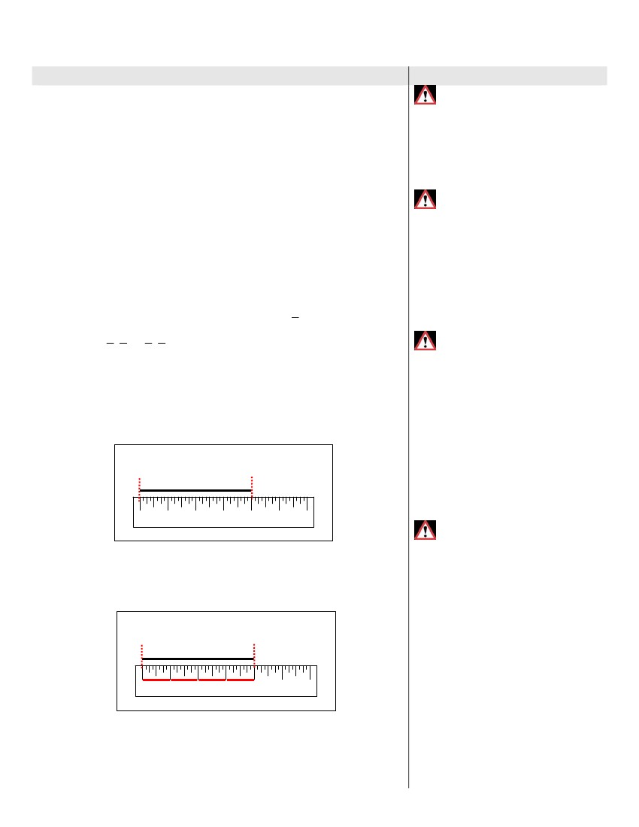
3rd Grade
Mathematics
Unit: 08 Lesson: 01
Instructional Procedures
The pencil appears to be how long? (About 11 inches)
Is the pencil 8 inches in length or 11 inches in length? Answers
may vary but could include: 8 inches because we need to subtract the
3 inches from the 11 inches; we started measuring at 3 inches.
If time allows, give students other places to begin measuring the pencil on
the ruler to determine the length.
5. Distribute handout: Read that Ruler! Customary, one index card, and a
marker to each student. Display the transparency: Read that Ruler!
Customary and direct students to look at problem 1 on page 1 of the
above handout.
Explain that in second grade they were expected to find fractions closer to
zero, closer to one-half or closer to one. This year they will be using
fractional measurements to determine length. In order to measure to the
nearest fourth or half, more tic marks are needed (eighths) for more
precise measuring. (Guided instructional review of second grade fraction concepts
for struggling learners).
6. Before beginning the measuring activity on handout: Read that Ruler!
Customary, have volunteer students demonstrate on the overhead ruler
how to read the following while sliding their finger as they count: inch
markings (1 inch, 2 inch, etc), half-inch marking (0, 1 , 1), and quarter-inch
•
•
Notes for Teacher
MISCONCEPTION
Some students may think that when
measuring linear length, that you place
the edge of the ruler at the starting point
instead of the zero marking on the ruler
at the starting point.
2
MISCONCEPTION
Some students may think when
measuring length to the closest whole
number, that the 1/2 marking is another
whole number marking. If students are
unsure about reading to halves, remind
them of their handmade ruler and that
the extra tic mark between 0 and 1/2 is
used to help determine if the line
segment is closer to 0 or closer to1/2.
MISCONCEPTION
Some students may think that the “value
1/2” can be located between any two
whole numbers on the ruler. For
example, if a student places the “value
1/2” between 1 and 2 inches instead of
between 0 and 1 inch, place your finger
on 0 and slide your finger across the
ruler to 1 reading the length is 1 inch,
and then continue sliding your finger
half way between 1 and 2 reading the
length is 1 1/2 inches to clarify the
placement of 1/2 on the ruler.
markings ( 1 , 2 or 1 , 3 ) similar to the handmade rulers they made in
4 4
2 4
Unit 07. Have all students follow along in the sliding of their finger as the
class counts chorally.
7. Tell students there are specific steps they should follow each time they
measure.
Step 1: Using the index card as a straight edge, mark the beginning
and end of the line segment being measured by drawing a vertical line
segment extending to the ruler. Paper rulers can be printed from the Internet so that
students can construct their own rulers so that they will have a better understanding of ¼.
½, ¾
.
Measure Markings
0
Inches
1
2
3
4
5
6
Step 2: Identify the beginning and ending points on the ruler. Ex: 0
inches and 4 inches.
Step 3: Mark each whole space by drawing a horizontal line segment
between each number to determine the measure. Ex: 0 to 1, 1 to 2, 2
to 3, and 3 to 4.
Measure Markings
MISCONCEPTION
Some students may think when creating
a ruler, that fractional markings have the
same value and become confused
about the markings. For example, when
marking 1/4, 2/4, 3/4, 4/4, they read the
fourth markings all 1/4. After marking
fourths, remind students how to
measure length sliding your finger along
the ruler and reading length of1/4,
length of 2/4, etc.
0
Inches
1
2
3
4
5
6
• How long is the line segment? (4 inches)
Allow the students to complete problems 2, 3, and 4 on the handout.
Monitor and assist students as needed. When all students have completed
page 1, ask students to share their measurements to check for accuracy. (Peer-
partner can provide guidance for struggling learners)
• How did you determine the length of the line segment when it did
not begin at the zero point? Answers may vary but should include:
©2010, TESCCC
12/29/10
page 7 of 89

3rd Grade
Mathematics
Unit: 08 Lesson: 01
Instructional Procedures
Counting whole unit segments (as shown in Step 3.)
Direct students to look at problem #4.
• What are the ways you could determine the length of 3 of these
line segments?? Answers may vary but could include that we could
add up each measure the number of times indicated, or we could
multiply the measure the number of times necessary.
Instructor can vary use of delivery by using Interactive Smartboard (if accessible)
to elicit student participation. Smartboard allows larger text and fun interaction.
8. Display the transparency: Which Answer is Correct and Why? on the
overhead. Have the students decide on the correct measurement and why
it is the better answer.
- To the nearest inch, how long is this crayon? How do you know?
(4 inches long, because the tip of the crayon is closer to the 4-inch
mark than it is to the 5-inch mark.)
- To the nearest half-inch how long is the crayon? Explain. (4 1/2
inches long) Answers may vary but could include: Because the tip of
the crayon is closer to the half-inch mark than the 4-inch mark.)
- When is it useful to measure to the nearest half inch instead of to
the nearest inch? Answers may vary but should include: When you
want a more accurate measurement and/or the object you are
measuring does not end exactly at an inch mark.
- How is measuring to the nearest half inch similar to and different
from measuring to the nearest inch? Answers may vary but could
include: They are similar in that you line up the object to the left side or
0; they are different in that you identify the nearest half inch mark on
the other side of the object, not the nearest inch mark.
Allow the students to complete problems 5, 6, 7, and 8 on the handout.
Monitor and assist students as needed. (Great time to walk around and conduct
CFU(s). When all students have completed page 2, ask students to share their
measurements to check for accuracy. (Peer –Partner for struggling learners).
- How did you find the length to the nearest inch when the line segment did not line-up
exactly with the inch mark? Answers may vary but should include: Finding the inch mark
that is closest to the end of the line segment.
9. Direct students to problem 9 on page 3 of the handout.
- What is the first step when measuring? (Mark the beginning and
ending of each line segment.)
Have students mark the beginning and end of the line segment in problem

- What is Step 2? (Identify the beginning and ending points).
- What are the beginning and end points of this line segment? (0
and 2 1 /3
Notes for Teacher
TEACHER NOTE
In handout: Read that Ruler!
Customary some problems show the
line segment not aligned with zero.
Students should still count the units in
between. Some students may verify with
subtraction, others may count up, and
still others may count individually. Both
national and state assessments have
developed questions about
measurement where one end of the
item to be measured is not aligned with
0 on the ruler.
- What do you notice? (There is a part of an inch that is not a whole
inch.)
- What is Step 3? (Mark the whole spaces.)
- What is the fractional part of the inch? ( 1/2 )
- How many whole inches did you count? (2 inches)
- How long is the line segment? (2 1/3 inches)
ADDITIONAL PRACTICE
Optional handout: Customary Length
Notes/Practice, and Customary Ruler
Practice are available for students who
need more practice with measuring to
the nearest inch or half-inch.
Provide more enrichment activities beyond handouts that students with diverse learning styles can relate to.
Also provide additional enrichment activities for students who mastered the objective.
10. Instruct students to complete the remaining pages of the handout for
homework.
EXPLORE/EXPLAIN 3
1. Debrief and discuss yesterday’s handout: Read that Ruler! Customary as
a class.
2. Explain that in the United States, two measurement systems are used.
One system is called the customary system and uses units such as the
inch, foot, yard, and mile to measure. ( provide visual representations for each)
The other system is called the
metric/SI system and uses units such as millimeter, centimeter, meter, and
©2010, TESCCC
12/29/10
Suggested Day 3
SPIRALING REVIEW
MATERIALS
• standard rulers with both customary
and metric units (1 per student)
page 8 of 89
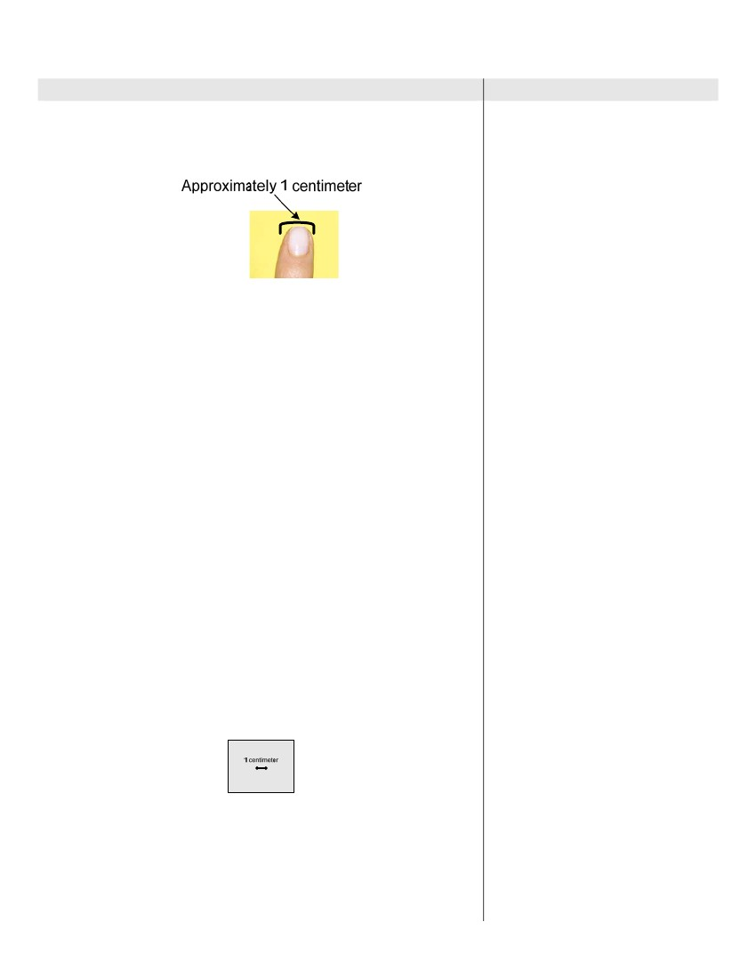
3rd Grade
Mathematics
Unit: 08 Lesson: 01
Instructional Procedures
kilometer to measure length (see vocabulary note at right.) (provide visual
representations for each)
3. Let students know that you can use the width of your finger to estimate
“one centimeter”. Demonstrate how to do this by bending your finger and
aligning the ruler with zero starting at one side of your finger and ending at
the other side of your finger. Example:
•
•
•
•
•
•
•
Notes for Teacher
centimeter cubes (1 per student)
base ten blocks (twelve 10-longs
per group)
construction paper (9” x 12”) (3-4
sheets per student group)
scissors
tape
Handout: Grade 3 TAKS
Mathematics Chart (1 per student
from Day 1)
Transparency: Grade 3 TAKS
Mathematics Chart (1 per teacher
from Day 1)
meter stick (1 per student group)
bulletin board paper (1 per class)
Graphic: Visuals for Metric Length
(1 per class)
Graphic: Metric Units (1 per class)
Handout: Tri-Fold Flip Book
Directions (1 per student from Day
1)
construction paper (or blank paper)
(2 sheets per student)
Explain that although the space between the sides of the finger is not an
exact measurement, it is a good estimate or approximation of a centimeter.
• What are some other objects that might be about 1 centimeter
long? Answers may vary but could include: The width of a large paper
clip, unit cubes, etc.
Remind students that even though these are nonstandard units of
measure, they are still good “estimates” of standard measures.
4. Have students discuss what they would do to measure distances in a
beetle-crawling contest.
• Which metric unit of length would you choose? Answers may vary
but could include: centimeters or millimeters.
• What other metric units of length do you know? Answers may vary
but could include: meters or kilometers.
• Why are these units not as appropriate for measuring the
distances in the contest? Answers may vary but could include: With
larger units, it is harder to get precise measurements of shorter
distances.
5. Distribute rulers and centimeter cubes to individual students. Have
students look at the centimeter side of the standard ruler. Have students
use the metric side of the ruler and measure all sides of the centimeter
cube.
• What is the length of a centimeter cube? (one centimeter on each
side)
6. Have students sit in groups of 3-4 students per group, and distribute 3-4
sheets of construction paper to each group. (Mixed –ability grouping)
Make sure each group has at least 1 ruler. Model for the whole class the same paper-
folding process used for customary measures. (Allow student guidance for struggling
learners). Have a student in the group take one of the half-sheets of paper and use the
ruler to draw a horizontal one-centimeter line segment on it with a marker. Instruct
another student in the group to label the line segment “1 centimeter”, and then trim the
remaining pieces of construction paper from the drawing. Example:
•
•
•
•
•
•
VOCABULARY
metric measurement: the system of
international measure (SI) for length,
volume and mass based on the powers
of ten
Is a centimeter larger or smaller than an inch? (smaller than an
inch)
7. Have students look at each centimeter on the metric side of the ruler and
point out that each centimeter has been divided into equal parts or pieces.
• How has the centimeter been divided? (into 10 equal parts)
Explain to students that the centimeter is divided into ten equal parts which
are called “millimeters”. A “millimeter” is a fractional part of a centimeter; it
•
©2010, TESCCC
12/29/10
page 9 of 89

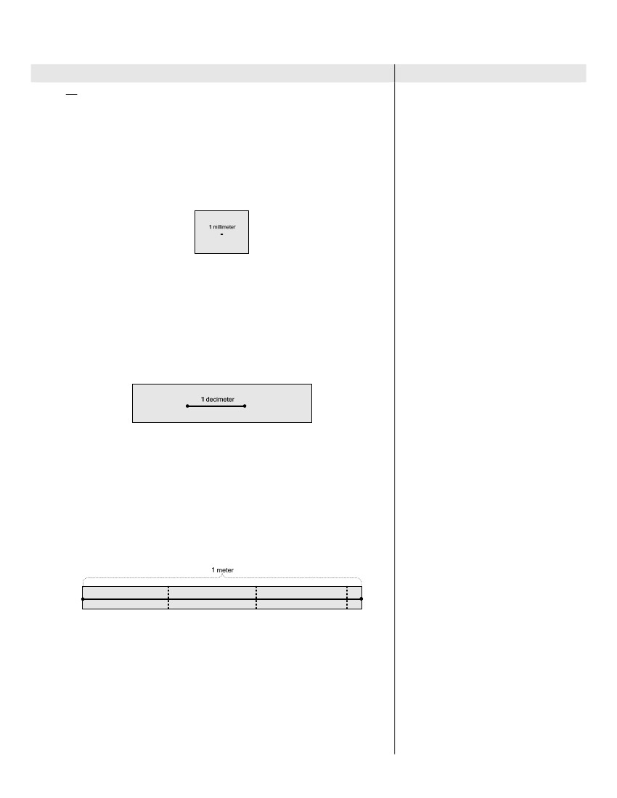
3rd Grade
Mathematics
Unit: 08 Lesson: 01
Instructional Procedures
is 1 of a centimeter. Direct students to look at the space between the
10
millimeter marks.
• How many tic marks do you see within one centimeter? (9) Teachers may need to
refer to skip counting charts so that students will be reminded to start counting at the
next tic mark.
• How many spaces do you see within one centimeter? (10)
Remind students that when measuring, you count the number of spaces
and not the number of tic marks. Have a student volunteer use the metric
side of the ruler to draw a horizontal line segment one millimeter long with
a marker on one of the trimmed pieces of construction paper (this will end
up looking like a dot on the paper). Label this line segment “one
millimeter”. Example:
Notes for Teacher
What objects can you think of that would measure one
millimeter? Answers may vary but could include: The thickness of a
paper clip or the thickness of a dime.
8. Distribute twelve 10-longs to each group of students. Have each group
place one 10-long on the metric ruler.
• How long is one 10-long? (10 centimeters)
Explain that 10 centimeters is known as a decimeter in the metric system.
Have each student group use the metric side of the ruler to draw a
horizontal line segment one decimeter long with a marker on one piece of
construction paper. Label this line segment “one decimeter”. Example:
•
9. Distribute one meter stick to each group.
• How many decimeters or 10-longs (placed end-to-end) do you
think it will take to equal the length of one meter stick? (ten
decimeters or ten 10-longs)
Prompt students to lay their strips end-to-end until they have 1 meter. At
this point, they will discover that they need more than three strips (36
inches.) Make sure they use an additional small strip to make the meter.
Next, have them tape these strips together and turn the large strip they
created over onto the “non-taped” side. Have student groups use the meter
stick to draw a horizontal line segment “one meter” long on the
construction paper strips provided. Label this line segment “one meter”.
Example:
•
How many centimeters are in 1 meter? How do you know? (100)
Answers may vary but could include: It takes ten 10-longs to make a
meter; OR, It’s on the Grade 3 TAKS Mathematics Chart.
Have students look at handout: Grade 3 TAKS Mathematics Chart to find
the relationships modeled by their paper strips, and display a transparency
of the same on the overhead. Example:
TEACHER NOTE
Many purchased standard rulers do not
label the metric side of the ruler in the
same way. Some rulers are labeled
centimeters and others are labeled
millimeters. Check the rulers that are
used by the students to avoid confusion.
If both types of rulers will be used, it will
be necessary to explain that both
indicate metric units of measure.
TEACHER NOTE
Although 3rd graders are not
responsible for knowing the relationship
between a decimeter and a meter, the
decimeter is used to connect metric
©2010, TESCCC
12/29/10
page 10 of 89

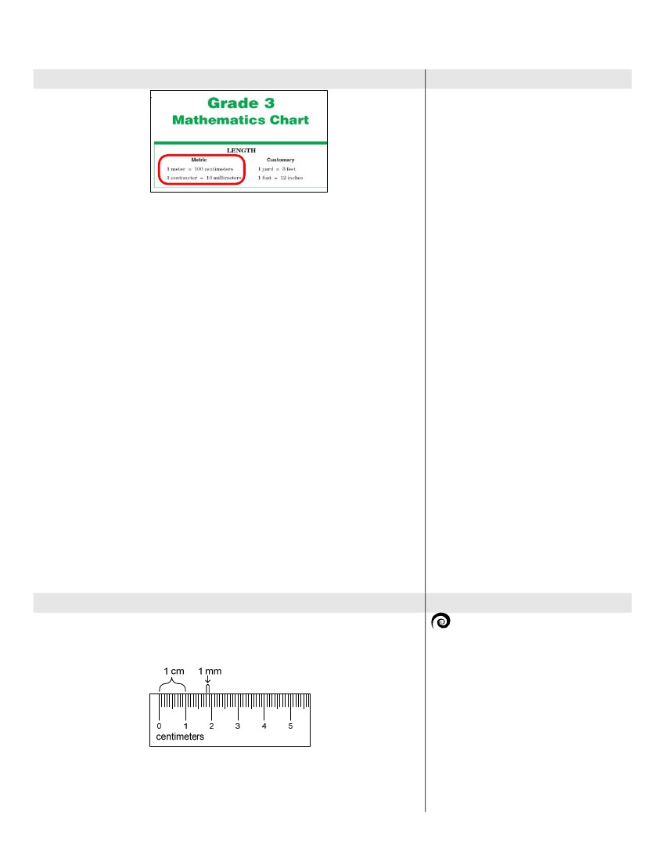
3rd Grade
Mathematics
Unit: 08 Lesson: 01
Instructional Procedures
Notes for Teacher
measure to a “known unit”. In this case,
the known unit is the 10-long.
Place one set of metric strips on bulletin board paper to create a poster
similar to the one created for customary measure. Place the metric poster
next to the poster of customary strips already displayed in the classroom,
and have students make observations about each set of standard
measure. Students should see that although the visuals are the same for
both the customary and metric systems, the unit names to identify
measures of length are different.
• What customary tool does the meter stick remind you of?
(yardstick)
Let students know that a meter stick is slightly longer than a yardstick
(approximately 3 inches longer). Visual: have both sticks on hand to provide visual
representations.
One way to remember the difference is
kinesthetically. Have students face forward, place their right hand on their
nose and extend their left hand out to the side of their body. Tell students
that this is the approximate measure of a yard. Then, with the students
keeping their hands in place, tell them to turn their heads to the right. This
is the approximate measure of a meter. By doing this, students get the
idea of the difference between a yard and a meter (which is that the meter
is slightly longer than the yard).
• How is the meter different? Answers may vary but could include: It is
numbered in centimeters, instead of inches.
Use the graphics: Visuals for Metric Length and Metric Units to title the
poster paper with the strips.
10. Distribute handout: Tri-Fold Flip Book Directions and 1 sheet of
construction or blank paper to individual students. Use the directions to
model with students how to make a tri-fold book. (Students made a tri-fold
book on day 1.) Instruct students to label the cover of each flap as follows:
(1) Millimeters, (2) Centimeters, and (3) Meters. When students have
finished labeling their books, tell them they are to complete their books by
writing at least 3 items under each flap that would most appropriately be
measured with that unit. If time allows, have students use the back of their
booklets to list 3 items that could be measured in Kilometers.
TEACHER NOTE
If time allows, students may search for 3
magazine or newspaper pictures for
each appropriate unit of measure. They
should cut and glue each picture under
each flap of their booklets.
EXPLORE/EXPLAIN 4
1. Distribute rulers to each student. Have them examine the metric-side of
their rulers. Display transparency: Metric Ruler on overhead. Draw the
following on the overhead to demonstrate the two units of measure shown
on the ruler:
Suggested Day 4
SPIRALING REVIEW
MATERIALS
• standard rulers with both customary
and metric units (1 per student)
• Transparency: Metric Ruler (1 per
teacher)
• small bag or box of miscellaneous
objects between 1 and 5
centimeters long (1 per group)
• index card (1 per student)
• Handout: To the Nearest—Metric
Recording Sheet (1 per student)
• Handout: Read that Ruler! Metric
(1 per student)
page 11 of 89
•
•
Which metric unit of measure is smaller? (millimeters)
How many millimeters are in 1 centimeter? How do you know? (10
millimeters) Answers may vary but could include: We counted the
spaces from 0 to 1.
12/29/10
©2010, TESCCC

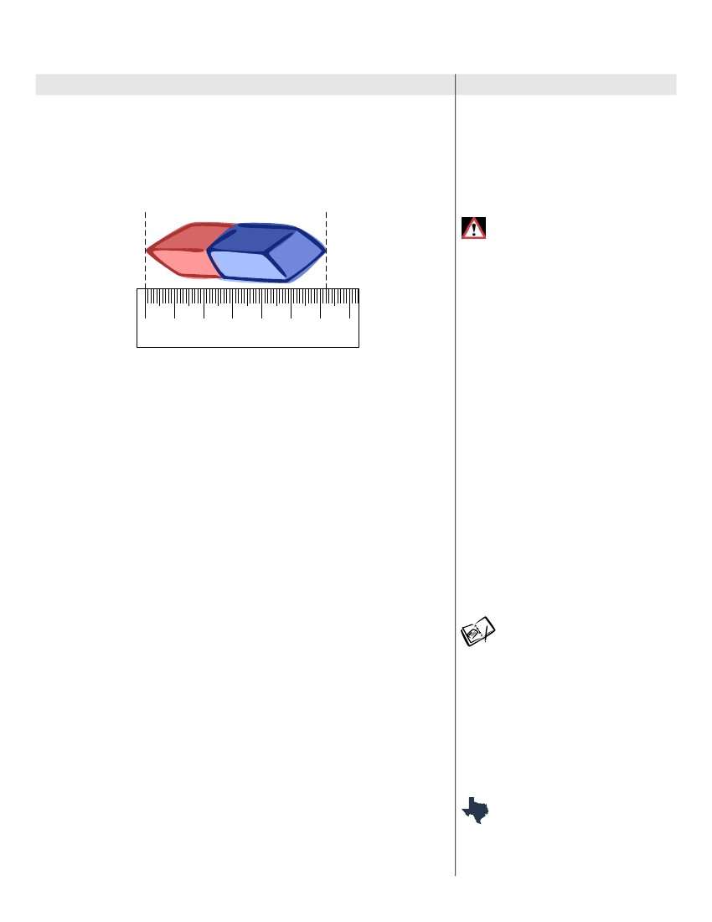
3rd Grade
Mathematics
Unit: 08 Lesson: 01
Instructional Procedures
On this ruler, which unit of measure would be more precise?
Explain. (millimeters) Answers may vary but could include: The
increments are smaller and the smaller the increment, the more
precise the measure.
2. Distribute miscellaneous small objects to student groups. Have students
select an object to measure. Demonstrate on the overhead how to
measure the object chosen to the nearest centimeter. Example:
•
Notes for Teacher
•
•
•
Handout (optional): Metric Length
Notes/Practice (1 per student as
needed)
Handout (optional): Metric Ruler
Practice (1 per student as needed)
Handout (optional): Additional
Combined Measures Practice (1
per student as needed)
MISCONCEPTION
Some students may think that 30
centimeters is equal to12 inches
because of the way standard rulers are
produced.
0
1
2
3
4
5
6
7
centimeters
3.
4.
5.
6.
Tell students to place their ruler against one edge of the object and to
follow the same steps they used with the index card to find the beginning
point and the end point for measuring.
Have students find the centimeter mark closest to the other end.
• To the nearest centimeter, how long is this eraser? (6 cm)
• Which marks on the ruler am I using to determine whether the
eraser is closer to the 6 cm mark or the 7 cm mark? (the millimeter
marks)
• How do you round a length that is not a whole number of
centimeters to the nearest centimeter? Answers may vary but could
include: If the length is halfway or more between the two whole
numbers, round up. If the length is less than halfway between the two
whole numbers, round to the smaller of the two numbers.
• What should you do if the length looks like it falls exactly
between two whole centimeters? Answers may vary but should
include: You round up to the next whole centimeter.
To measure to the nearest centimeter, students may need to round up if an
object measures greater than halfway between the two whole centimeters,
or down if the object measures less than halfway between the two whole
centimeters.
Distribute handout: To the Nearest—Metric Recording Sheet, to each
student.
•What is the difference between an estimate and a measurement?
Answers may vary but could include: An estimate is what you think the
measurement will be; the measurement is the actual number you get
when you measure.
Instruct student to look at the directions for numbers 3 and 4.
• What are the ways you could determine the length of 2 or 3 or
more of the objects you chose to measure? Answers may vary but
could include that we could add up each measure the number of times
indicated, or we could multiply the measure the number of time
necessary.
Prompt students to select 4 different objects from the bag or box at their
table and estimate the length of each object. Then have them measure the
actual length of the object in centimeters and millimeters and record the
measure on the recording sheet.
Distribute handout: Read that Ruler! Metric to individual students and
allow students to work in pairs to determine each measure. Debrief and
12/29/10
TEACHER NOTE
It is important to examine the rulers
students use. Some rulers start with 0
for customary and metric at the same
end of the ruler. Other rulers start with 0
for customary at one end of the ruler
and 0 for metric at the opposite end of
the ruler.
ADDITIONAL PRACTICE
Optional handouts: Metric Length
Notes/Practice and Metric Ruler
Practice are available for students who
need more practice with measuring to
the nearest centimeter.
Also, for additional practice with both
customary and metric measure, the
optional handout (optional): Additional
Combined Measures Practice is
available.
STATE RESOURCES
MTR 3-5: Line It Up!
TEXTEAMS: Rethinking Elementary
Mathematics Part I: Making Evidence
page 12 of 89
©2010, TESCCC

3rd Grade
Mathematics
Unit: 08 Lesson: 01
Instructional Procedures
discuss answers as a class.
Notes for Teacher
Clear to Students; How Long? How
Many?
Suggested Day 5
SPIRALING REVIEW
MATERIALS
• math books (or any same-size
book) (1 per student)
• standard rulers with both customary
and metric units (1 per student)
• Transparency: Textbook Perimeter
(1 per teacher)
• Handout: Textbook Perimeter (1
per student)
• Handout: Perimeter Scavenger
Hunt (1 per student)
• Handout: Estimate and Measure
Perimeter Practice (1 per student)
EXPLORE/EXPLAIN 5
1. Remind students that they have found the perimeter of a shape by
counting units or by adding the side lengths (Unit 04, Lesson 01). Today,
they will find the perimeter of a shape by measuring the side lengths.
2. Direct students take out their math book and a ruler.
• How would you use a ruler to find the perimeter of your book in
inches? (Find the length of each side in inches and then add the
lengths of the sides.)
• Would your method change if you measure the perimeter in
centimeters? (No; you still add the lengths of the sides.)
• What if you measured the perimeter of your math book in
centimeters? Would you use more centimeters or inches? How
do you know? (You would use more centimeters because 1
centimeter is smaller than 1 inch.)
3. Display transparency: Textbook Perimeter on the overhead and distribute
handout of the same to individual students. Direct students to first estimate
the length and width of their book to the nearest inch and record these
amounts in their table. Estimate the perimeter. Then have students use a
ruler to measure the length and width of the book in inches. Have them
record the measurements and calculate the actual perimeter.
• How many side lengths will you need to add to determine the
perimeter of the book? Explain. (4 sides; there are 2 lengths and 2
widths.)
• What side lengths did you add to find the perimeter of this figure?
Answers may vary.
• What is the perimeter of your textbook to the nearest inch?
Answers may vary.
• Could you measure only one length and one width and still find
the perimeter of your book? How do you know? (Yes, because our
book is a rectangle and opposite sides of a rectangle are the same
length.)
4. Direct students to complete the next table by estimating and then
measuring the lengths and widths of their book to the nearest centimeter.
Debrief and discuss answers using the same questions as above only with
metric measure.
5. Distribute handout: Perimeter Scavenger Hunt to individual students.
They will work with a partner to select 4 objects in the room to measure
and find the perimeter. Monitor students as they work. Debrief and discuss
findings as a class.
6. Distribute handout: Estimate and Measure Perimeter Practice to
individual students and have them complete independently in class or for
homework.
EXPLORE/EXPLAIN 6
1. Debrief and discuss yesterday’s handout: Estimate and Measure
Perimeter Practice as a class,
2. Tell students they have found the perimeter of common figures and that
today they will be investigating how to measure the region inside a figure,
or the area of a figure. Remind students that they have already worked
with area when they were multiplying (Unit 05, Lesson 03.) Display
transparency: Dot Paper on the overhead. Outline a 3 x 3 figure on the
grid.
• How can you use dot paper to find the area of this figure?
Answers may vary – accept reasonable responses.
Have students work with a partner to draw the same figure on their dot
paper and then connect the dots to make squares that they can count.
©2010, TESCCC
12/29/10
Suggested Day 6
SPIRALING REVIEW
MATERIALS
• Transparency: Dot Paper (1 per
teacher)
• Handout: Dot Paper (1 per student)
• Transparency: Finding Area –
Notes and Practice (1 per teacher)
• Handout: Finding Area – Notes
and Practice (1 per student)
• Handout: Finding Area Practice
page 13 of 89

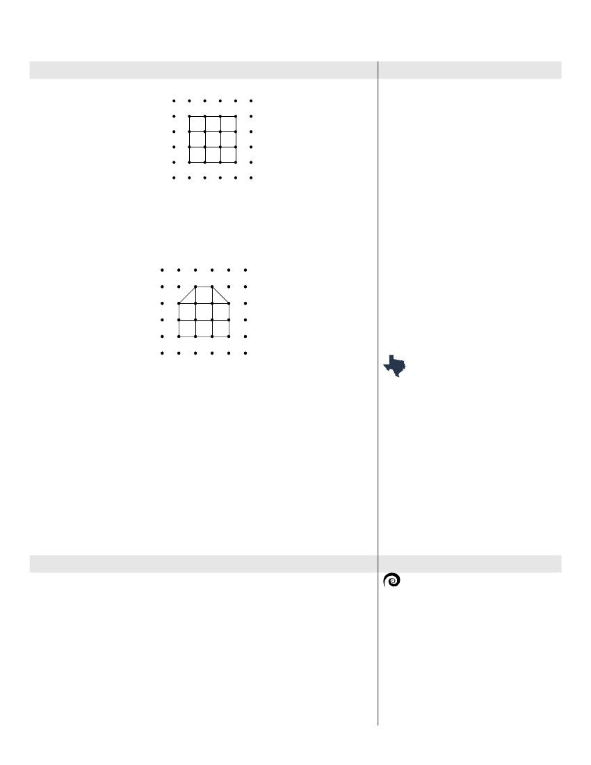
3rd Grade
Mathematics
Unit: 08 Lesson: 01
Instructional Procedures
Model the same on the overhead. Use smart board to utilize technology to apply appealing colors. Example:
Notes for Teacher
(1 per student)
Can you multiply to find the area of this figure? Explain. (Yes; you
can multiply the number of rows by the number in each row.)
• Can you use multiplication to find the area of all figures? Explain.
(No, you can use multiplication to find the area of rectangles, but not
irregular figures.)
3. Change the figure on the transparency: Dot Grid to show the following:
•
Can you multiply units to find the area of this figure? Explain (No,
the figure is not a rectangle.)
• How could you find the area of a figure where there are half
square units? Answers may vary but could include: Count the whole
squares and then add the half squares.
Prompt students to work with a partner to draw this figure on their dot
paper and to find the area of the figure. Debrief and discuss answer as a
class; (8 square units)
• How can a figure with half units have an area that is a whole
number? Answers may vary but should include: If there is an even
number of half units; two half square units equal 1 whole square.
4. Let students know that they can find the area of figures by counting.
Display transparency: Finding Area – Notes and Practice on the
overhead and distribute handout of the same to individual students to
discuss the steps for finding the area of a figure with half units.
5. Distribute handout: Finding Area Practice to individual students and have
them complete independently.
•
STATE RESOURCES
MTC K-3: Square Numbers
TEXTEAMS: Rethinking Elementary
Mathematics Part II: Making
Rectangles; Measuring Area with
Rectangles; Area with Tiles
ELABORATE
1. Discuss the handout: Finding Area Practice with the class.
2. Set up measurement stations in the classroom as follows:
• Measurement Task 1 at two tables, marker, several copies of
handout: Measurement Stations Recording Sheet
• Measurement Task 2 at two tables; crayon boxes (16, 24 and 48);
and several copies of handout: Measurement Stations Recording
Sheet
• Measurement Task 3 at two tables; crayon box (48), several blank
sheets of paper, several copies of handout: Measurement Stations
Recording Sheet, handout: Crayon Box Perimeter Mat
• Measurement Task 4 at two tables, crayon box (48), color tiles,
several blank sheets of paper, several copies of handout:
Measurement Stations Recording Sheet and handout: Crayon Box
©2010, TESCCC
12/29/10
Suggested Day 7
SPIRALING REVIEW
MATERIALS
• Transparency: Broken Ruler 2 (1
per teacher)
• Card Set: Measurement Station
Task Cards (run on cardstock) (1
per station)
• Handout: Measurement Stations
Recording Sheet (1 per student)
• Handout: Crayon Box Perimeter
Mat (1 per student)
• Handout: Crayon Box Area Mat (1
page 14 of 89

3rd Grade
Mathematics
Unit: 08 Lesson: 01
Instructional Procedures
Area Mat
• Measurement Task 5 at two tables and several copies of handout:
Measurement Stations Recording Sheet
Student pairs will rotate through centers, which have been set up prior to
the lesson. In order to have small groups, set up two of each of the centers
to keep the rotations moving. Have students sit in 5 groups of two or three
students. While students are rotating, conduct CFU(s) to ensure understanding of content delivery.
Display transparency: Broken Ruler 2 and explain that in some of the
rotations they will be using the broken ruler. Model measuring the length of
a crayon using the transparency: Broken Ruler 2. Ask the students to
determine where to place the crayon on the ruler and how to determine the
correct length.
Tell students that they will begin working with the Measurement Task at
their assigned table. Keep the expectations high for the groups and challenge them
to be precise on the measurements. Each student is to get the handout: Measurement
Stations Recording Sheet from their table. Explain that they will be taking
their handout: Measurement Stations Recording Sheet with them to use
at each rotation station. Caution them to check the number of the station to
be sure the answer is placed in the correct area on the sheet. (Ex: Some
students may be starting at station 4 and will rotate to 5.) Allow five to
seven minutes for the students to complete the task and record their
results. Each student will be responsible for recording the task results on
his/her own recording sheet.
When the seven minutes are up, students will rotate to the next station to
complete the task. Each group will complete all 5 measurement tasks.
When students have completed the activity, discuss observations that the
students have made using the ruler that did not begin at 0.
Discuss the terms: length, width, and height. Review the difference
between perimeter and area.
Notes for Teacher
•
•
•
•
•
•
per student)
marker (1 at Station 1)
2 identical sets of crayons (16, 24
and 48 to a box) (1 set at each
Station 2)
4 identical sets of crayons (48 to a
box) (2 at Station 3 and 2 at Station
4)
blank sheets of paper (1 per
student)
color tiles (30 per student)
Handout: Grade 3 TAKS
Mathematics Chart (1 per student
from Day 1)
3.
4.
5.
TEACHER NOTE
Crayon boxes which have 16 or 24
measure 2 4 ” by 3 4 ” and
3
3
1
2
” (16) and 1
6.
“ (24) from front to back. The box of 48
is approximately 3 inches by 5 inches,
which would allow students to use
whole numbers to find perimeter and
area. 3 by 5 index cards could be
substituted.
EVALUATE
1. Distribute the handout: Measurement Evaluation to individual students.
Place Grade 3 TAKS Mathematics Charts, a yardstick, and a meter stick
on each table. Have students use the yardsticks and meter sticks to
estimate and then record the measure for their desks and chairs. Assign
the reminder of the handout for homework. Explain how the homework will be graded.
Suggested Day 7 Continued
MATERIALS
• Handout: Measurement
Evaluation (1 per student)
• Handout: Grade 3 TAKS
Mathematics Chart (1 per student
from Day 1)
• yardstick
• meter stick
TAKS CONNECTION
TAKS 2003 Release Question #13, #5,
#35
TAKS 2004 Release Question #31, #15,
#37
TAKS 2006 Release Question #27, #8,
#12
SDAA II 2005 Release Question #10,
#34
SDAA II 2007 Release Question #11,
#24
©2010, TESCCC
12/29/10
page 15 of 89

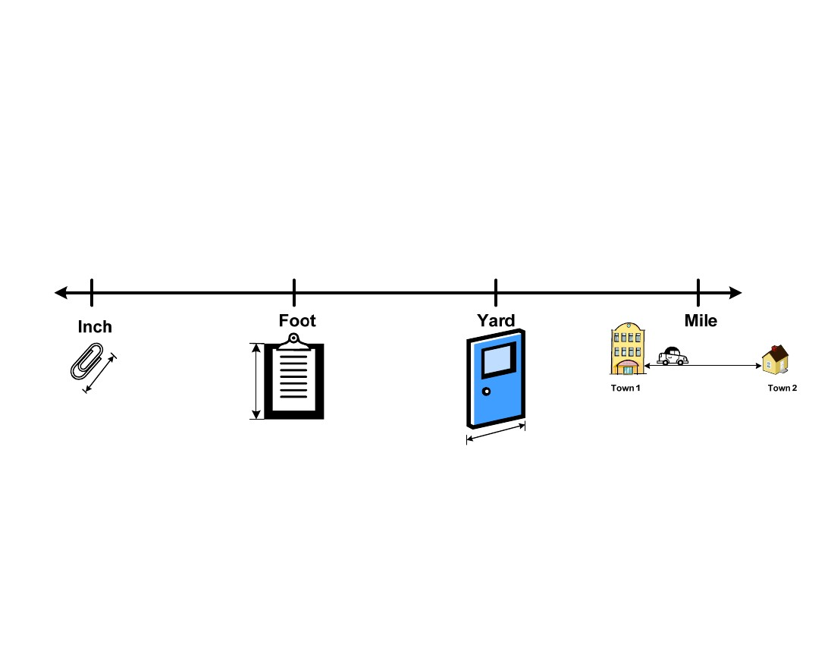
3rd Grade
Mathematics
Unit: 08 Lesson: 01
Visuals for
Customary
Length
Inch (in.), Feet (ft), Yard (yd), Mile
©2010, TESCCC
12/29/10
page 16 of 89

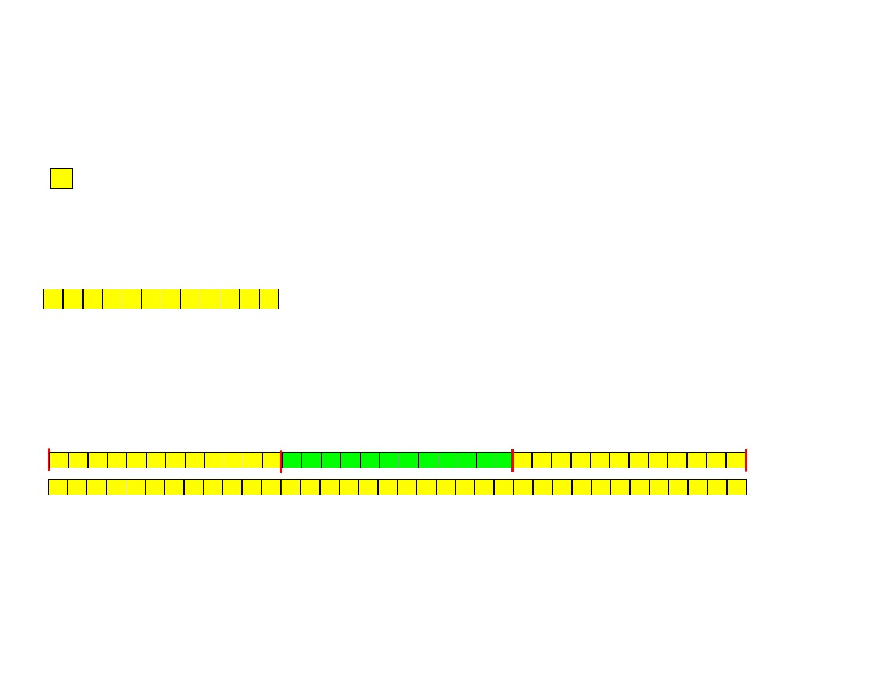
3rd Grade
Mathematics
Unit: 08 Lesson: 01
Customary Units
(Not to scale)
1 inch (in.) = length of 1 color tile
1 foot (ft) = 12 inches (in.)
1 yard (yd) = 3 feet (ft)
1 foot
1 foot
1 foot
1 yard
©2010, TESCCC
12/29/10
page 17 of 89

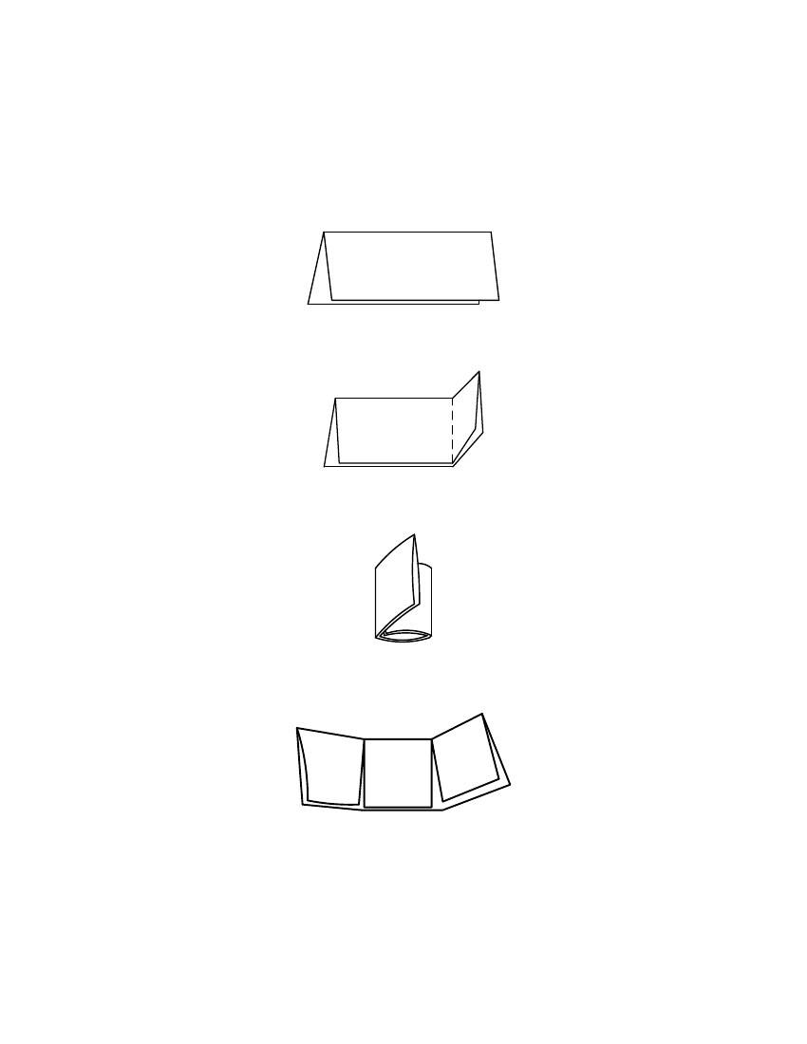
3rd Grade
Mathematics
Unit: 08 Lesson: 01
Tri-Fold Flip Book Directions
(1) Stack the two sheets of paper and fold them in half lengthwise. (Note: Only one
sheet of paper is shown in the drawings. However, these directions will work for
two or more sheets of paper.)
(2) With the paper still folded, fold the right side toward the center, trying to cover
about one-half of the paper.
(3) Fold the left side over the right side to make a book with three folds.
(4) Open the folded book. Cut the first page only along the folds just to the edge of
the original fold. This should form three tabs.
©2010, TESCCC
12/29/10
page 18 of 89

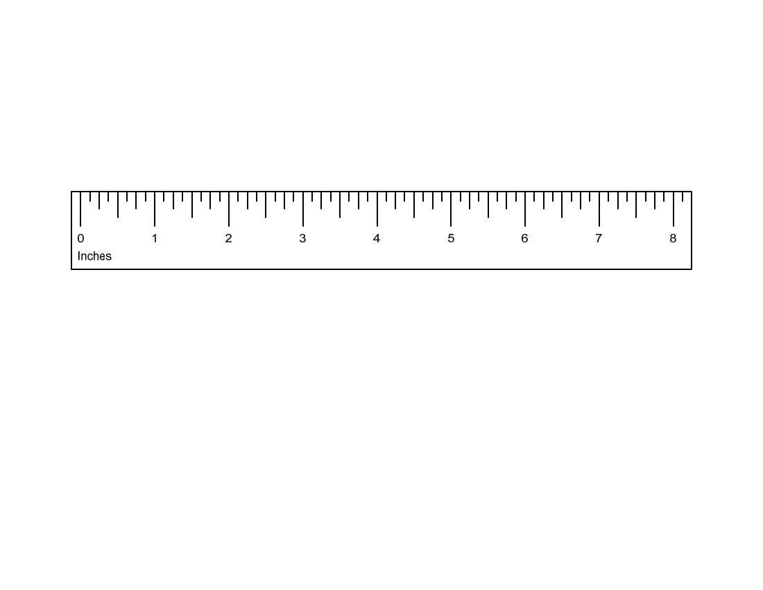
3rd Grade
Mathematics
Unit: 08 Lesson: 01
Customary Ruler
©2010, TESCCC
12/29/10
page 19 of 89

3rd Grade
Mathematics
Unit: 08 Lesson: 01
Customary Broken Ruler
©2010, TESCCC
12/29/10
page 20 of 89

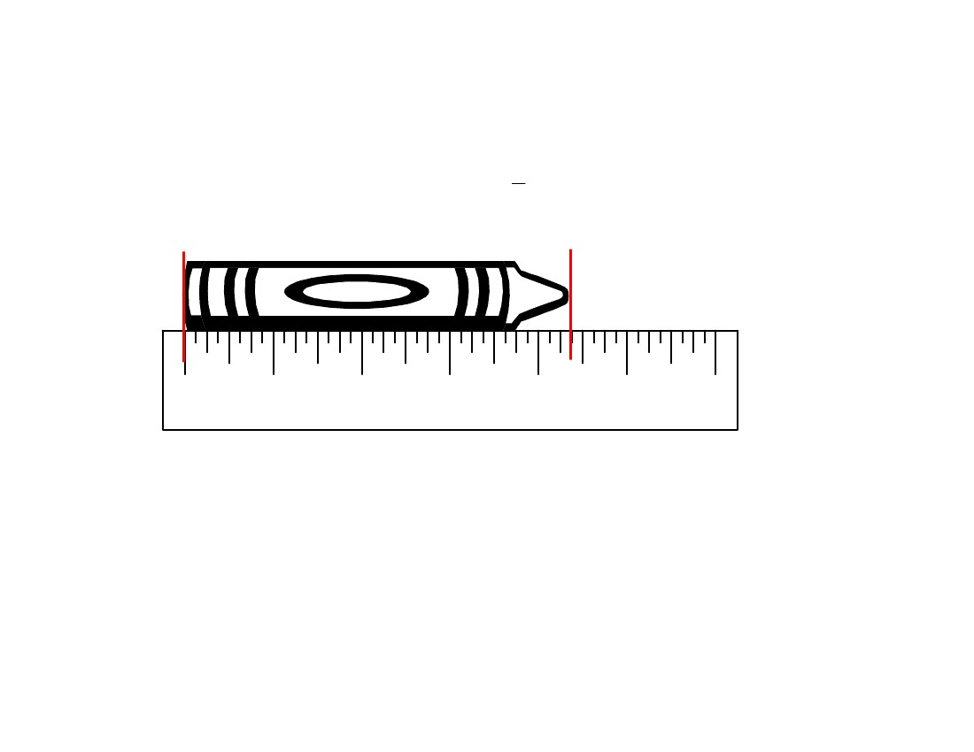
3rd Grade
Mathematics
Unit: 08 Lesson: 01
Which Answer is Correct and Why?
1
4 inches or 4 2 inches?
0
Inches
1
2
3
4
5
6
©2010, TESCCC
12/29/10
page 21 of 89

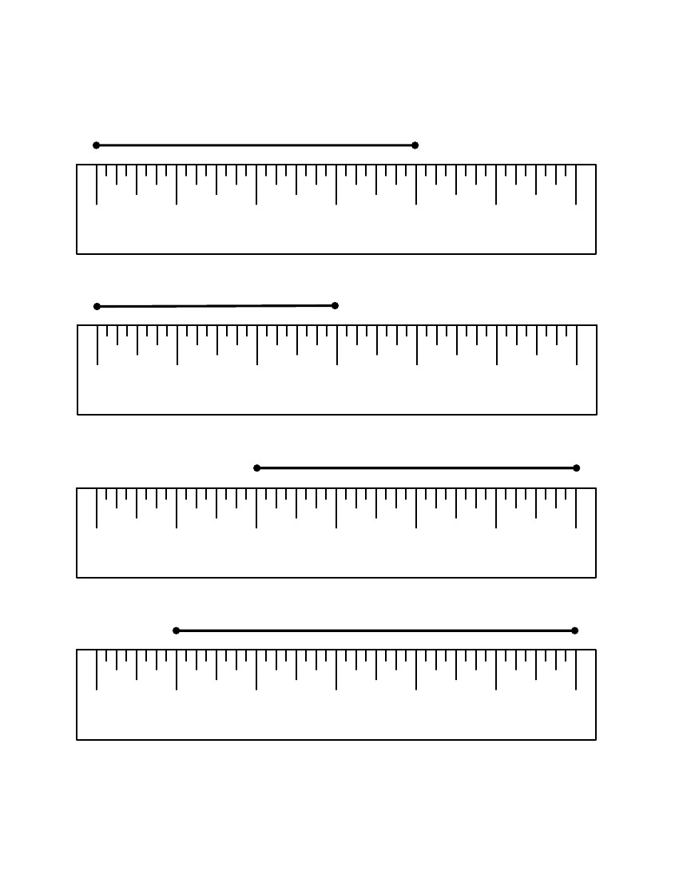
3rd Grade
Mathematics
Unit: 08 Lesson: 01
Read That Ruler! Customary (pp. 1 of 4) KEY
Find the length of each line segment to the nearest inch.
1. Length = 4 inches
0
Inches
1
2
3
4
5
6
2. Length = 3 inches
0
Inches
1
2
3
4
5
6
3. Length = 4 inches
0
Inches
1
2
3
4
5
6
4. Length = 5 inches
0
Inches
1
2
3
4
5
6
If 3 of these line segments were laid end-to-end, what would be the total length of
the line segments? How do you know? 15 inches; Answers may vary but
could include 5 + 5 + 5 = 15 or 5 x 3 = 15 inches.
©2010, TESCCC
12/29/10
page 22 of 89

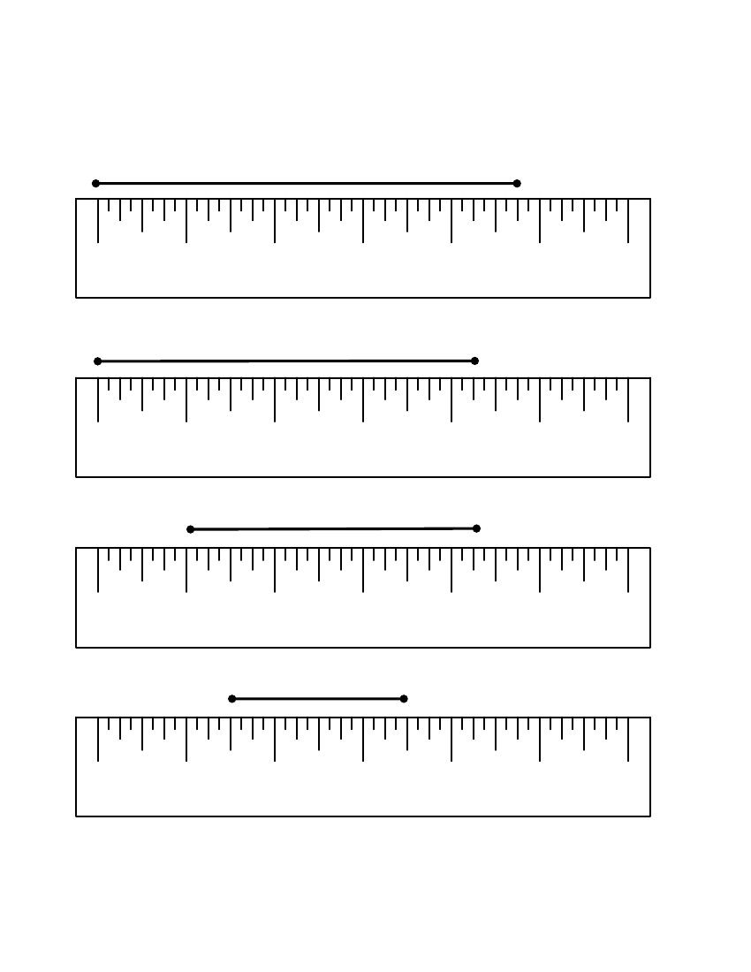
3rd Grade
Mathematics
Unit: 08 Lesson: 01
Read That Ruler! Customary
Find the length of each line segment to the nearest inch.
(pp. 2 of 4)
KEY
5. Length = 5 inches
0
Inches
1
2
3
4
5
6
6. Length = 4 inches
0
Inches
1
2
3
4
5
6
7. Length = 3 inches
0
Inches
1
2
3
4
5
6
8. Length = 2 inches
0
Inches
1
2
3
4
5
6
If 6 of these line segments were laid end-to-end, what would be the total length of
the line segments? How do you know? 12 inches; Answers may vary but
could include 2 + 2 + 2 + 2 + 2 + 2 = 12 or 6 x 2 = 12 inches.
©2010, TESCCC
12/29/10
page 23 of 89

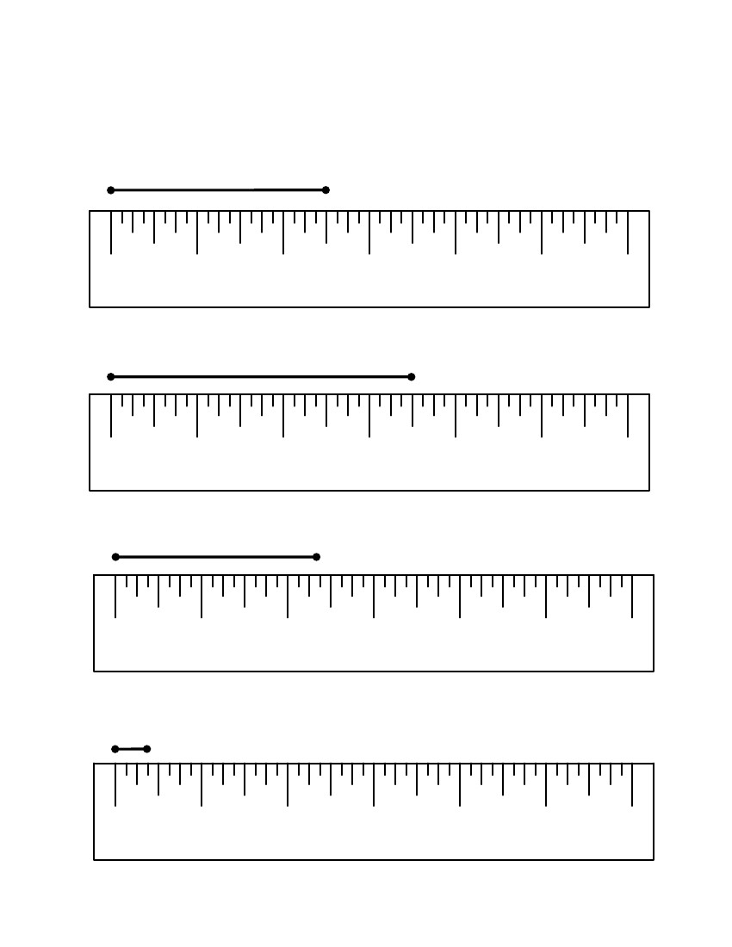
3rd Grade
Mathematics
Unit: 08 Lesson: 01
Read That Ruler! Customary
(pp. 3 of 4)
KEY
Find the length of each line segment to the nearest half inch.
9. Length = 2 1/2 inches
0
Inches
1
2
3
4
5
6
10. Length = 3 1/2 inches
0
Inches
1
2
3
4
5
6
11. Length = 2 1/2 inches
0
Inches
1
2
3
4
5
6
12. Length = 1/2 inch
0
Inches
1
2
3
4
5
6
©2010, TESCCC
12/29/10
page 24 of 89

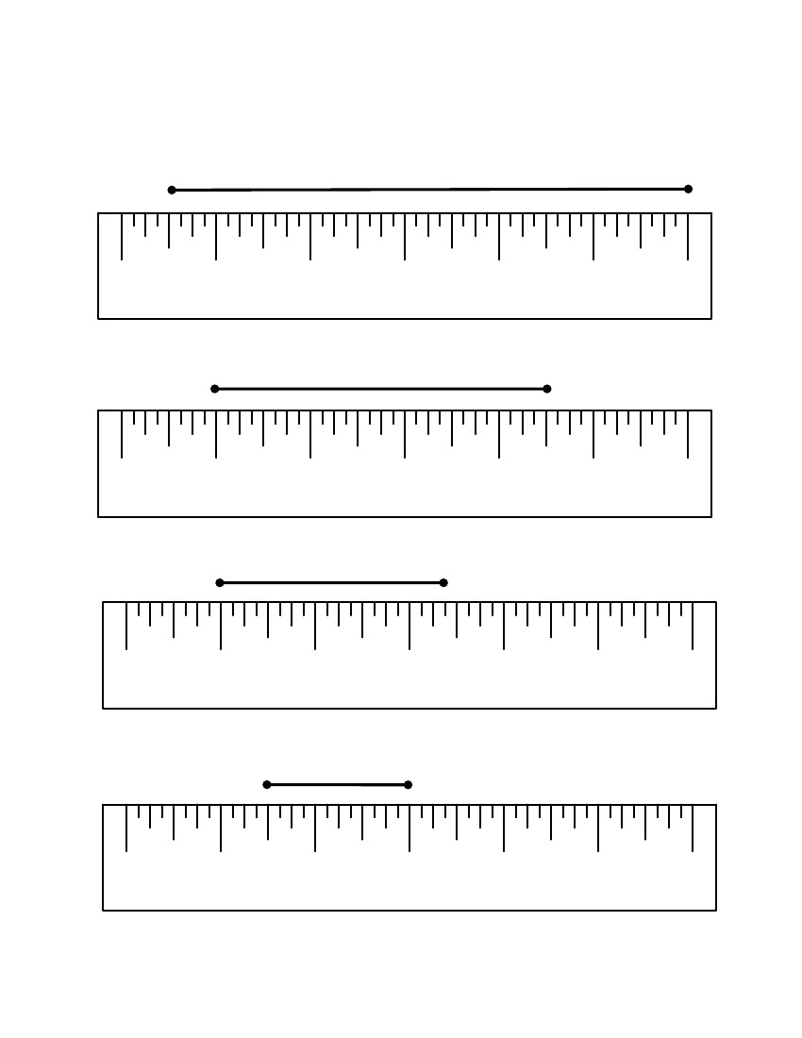
3rd Grade
Mathematics
Unit: 08 Lesson: 01
Read That Ruler! Customary
(pp. 4 of 4)
KEY
Find the length of each line segment to the nearest half inch.
13. Length = 5 1/2 inches
0
Inches
1
2
3
4
5
6
14. Length = 3 1/2 inches
0
Inches
1
2
3
4
5
6
15. Length = 2 1/2 inches
0
Inches
1
2
3
4
5
6
16. Length = 1 1/2 inches
0
Inches
1
2
3
4
5
6
©2010, TESCCC
12/29/10
page 25 of 89

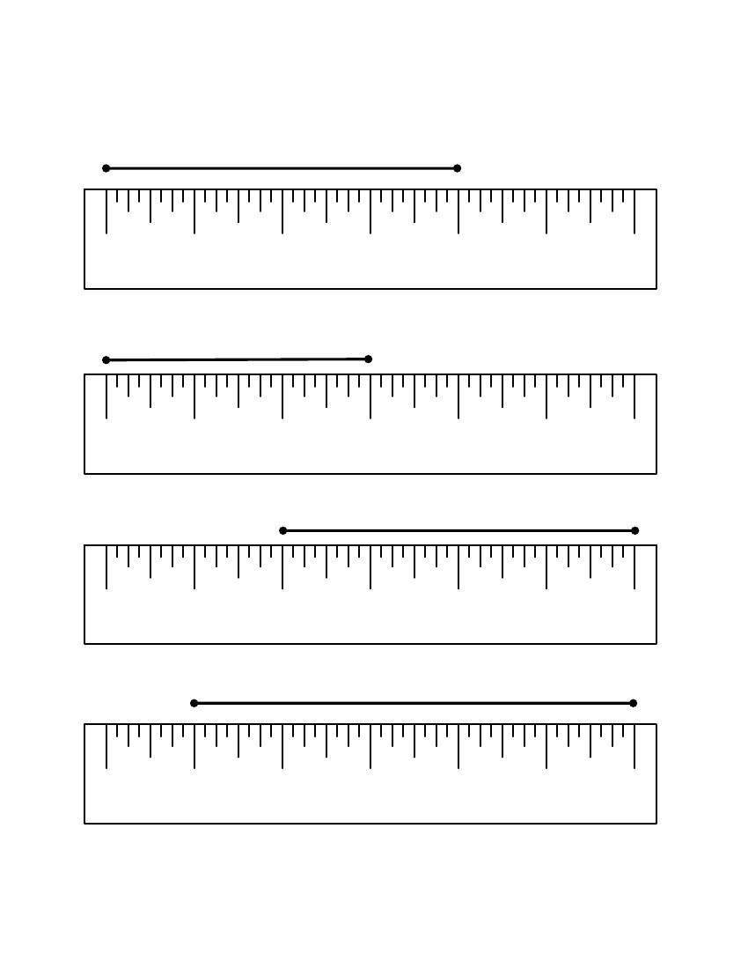
3rd Grade
Mathematics
Unit: 08 Lesson: 01
Read That Ruler! Customary
Graded by peers.
Find the length of each line segment to the nearest inch.
(pp. 1 of 4)
1. Length = _____________
0
Inches
1
2
3
4
5
6
2. Length = _____________
0
Inches
1
2
3
4
5
6
3. Length = _____________
0
Inches
1
2
3
4
5
6
4. Length = _____________
0
Inches
1
2
3
4
5
6
If 3 of these line segments were laid end-to-end, what would be the total length of
the line segments? How do you know?
©2010, TESCCC
12/29/10
page 26 of 89

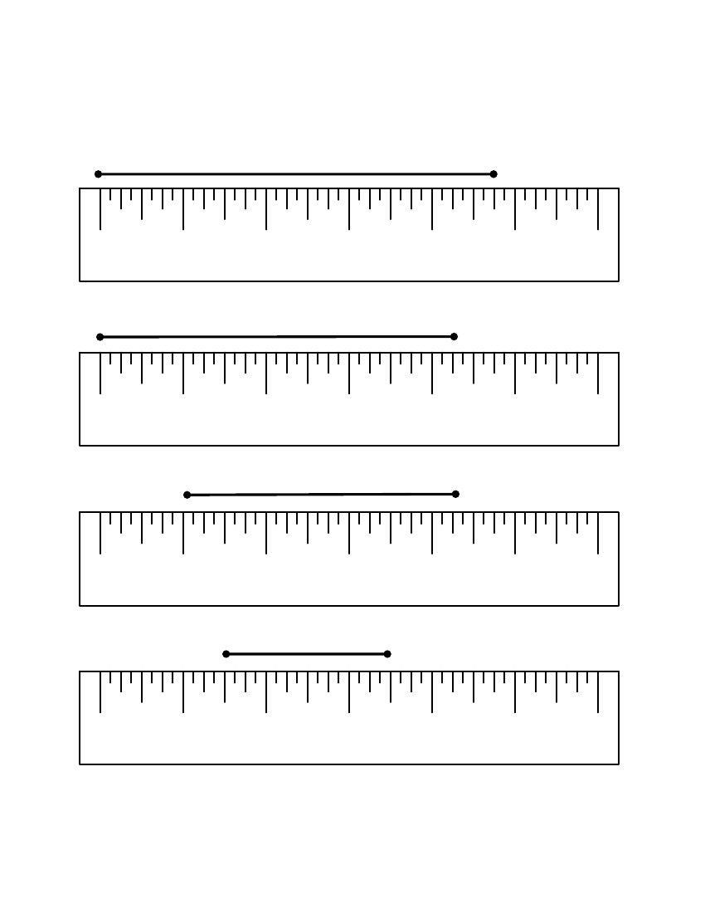
3rd Grade
Mathematics
Unit: 08 Lesson: 01
Read That Ruler! Customary
Find the length of each line segment to the nearest inch.
(pp. 2 of 4)
5. Length = _____________
0
Inches
1
2
3
4
5
6
6. Length = _____________
0
Inches
1
2
3
4
5
6
7. Length = _____________
0
Inches
1
2
3
4
5
6
8. Length = _____________
0
Inches
1
2
3
4
5
6
If 6 of these line segments were laid end-to-end, what would be the total length of
the line segments? How do you know?
©2010, TESCCC
12/29/10
page 27 of 89

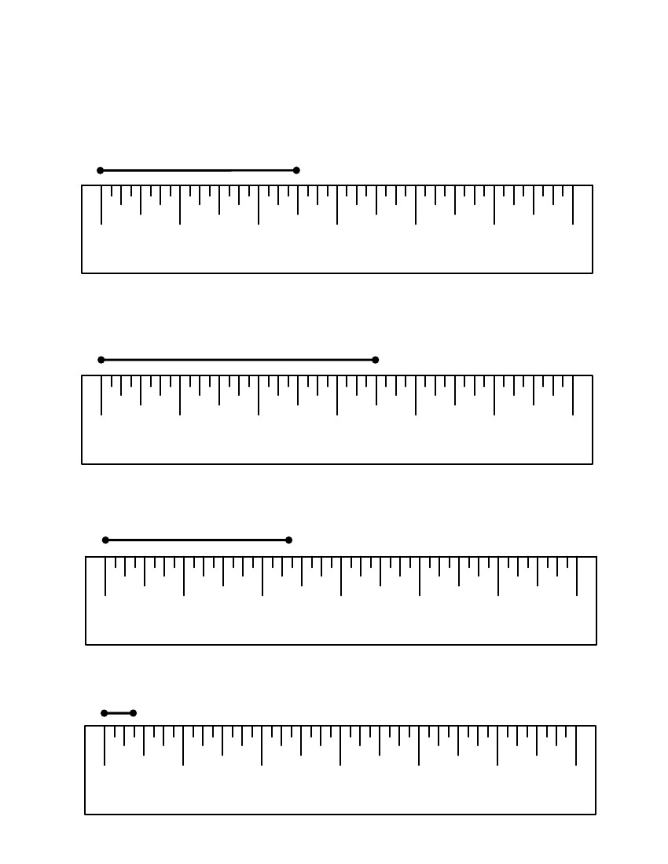
3rd Grade
Mathematics
Unit: 08 Lesson: 01
Read That Ruler! Customary (pp. 3 of 4)
Find the length of each line segment to the nearest half inch.
9. Length = _____________
0
Inches
1
2
3
4
5
6
10. Length = _____________
0
Inches
1
2
3
4
5
6
11. Length = _____________
0
Inches
1
2
3
4
5
6
12. Length = _____________
0
Inches
©2010, TESCCC
1
2
3
4
5
6
12/29/10
page 28 of 89

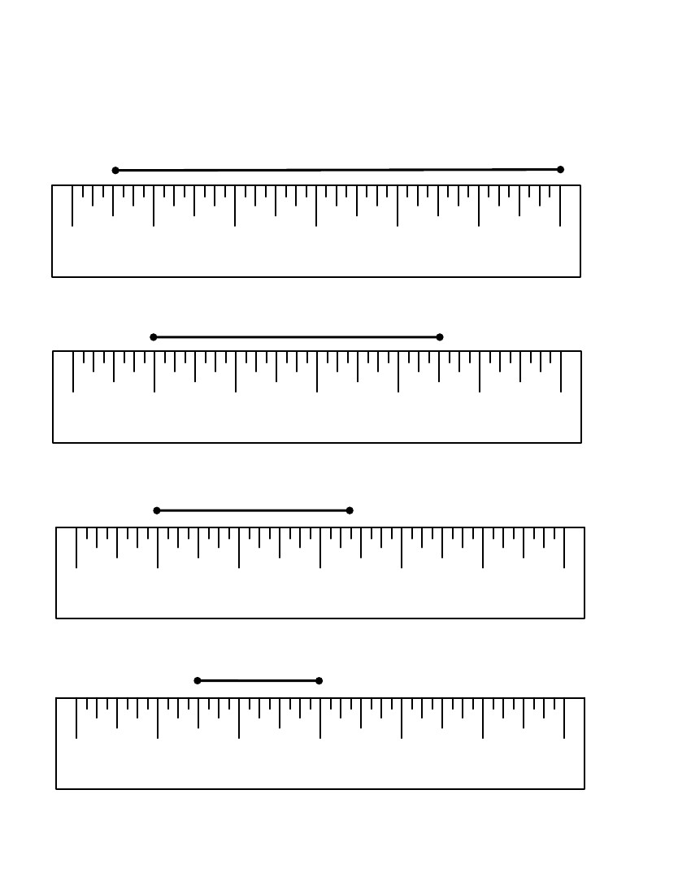
3rd Grade
Mathematics
Unit: 08 Lesson: 01
Read That Ruler! Customary (pp. 4 of 4)
Find the length of each line segment to the nearest half inch.
13. Length = _____________
0
Inches
1
2
3
4
5
6
14. Length = _____________
0
Inches
1
2
3
4
5
6
15. Length = _____________
0
Inches
1
2
3
4
5
6
16. Length = _____________
0
Inches
1
2
3
4
5
6
©2010, TESCCC
12/29/10
page 29 of 89

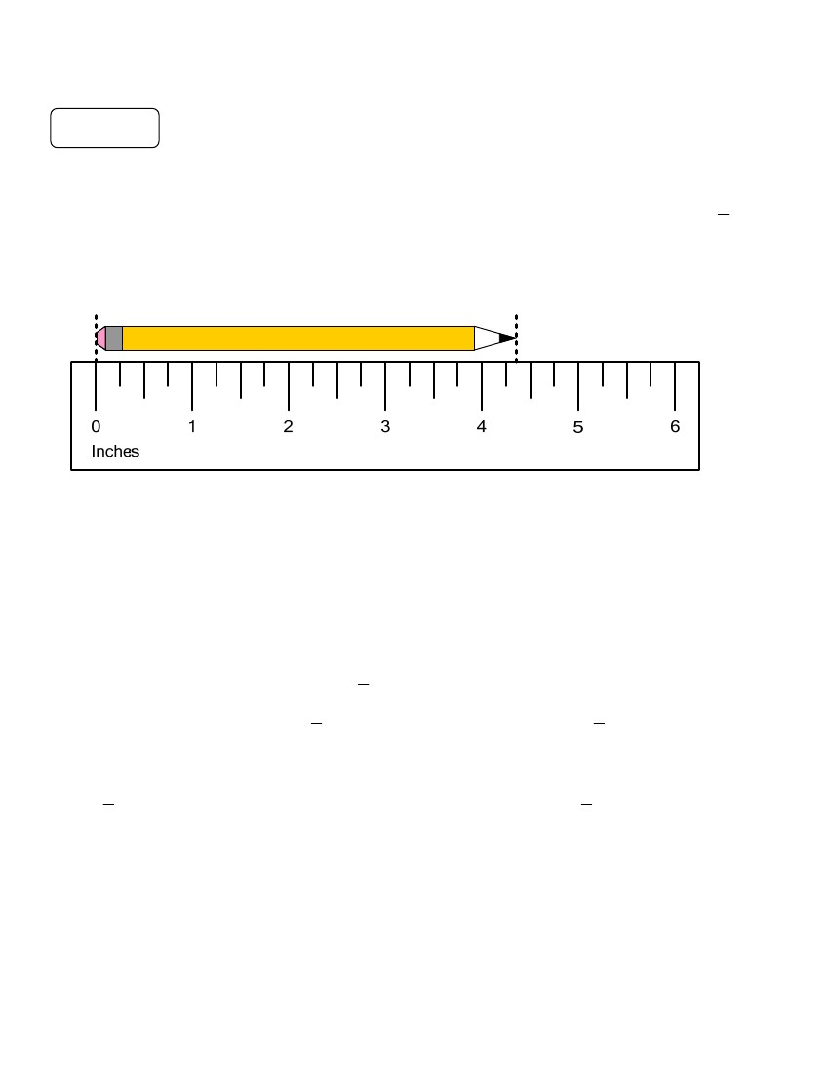
3rd Grade
Mathematics
Unit: 08 Lesson: 01
Customary Length Notes/Practice (pp. 1 of 2) KEY
Notes
Remember that the precision of a measurement is related to the unit of measure you use.
The smaller the unit, the more precise the measurement will be. Measuring to the nearest
inch is more precise than measuring to the nearest inch.
Example:
1
2
How long is this pencil, to the nearest inch?
Step 1: Align the left side of the pencil with the zero mark of the ruler as shown above.
Step 2: Notice where the pencil ends on the ruler. The pencil is between 4 and 5 inches long.
Step 3: Decide whether 4 or 5 is the nearest inch. The length of this pencil is closer to 4
inches than 5 inches.
— To the nearest inch, the pencil is 4 inches long.
How long is the pencil to the nearest
— The pencil is between 4 and 4
1
inch?
2
11
inches long. The pencil is closer to 4 inches long.
22
Which measure is more precise? Why?
11
inch measure is more precise than the inch measure because 4 inches is closerThe
22
than 4 inches to the pencil’s actual length.
©2010, TESCCC
12/29/10
page 30 of 89

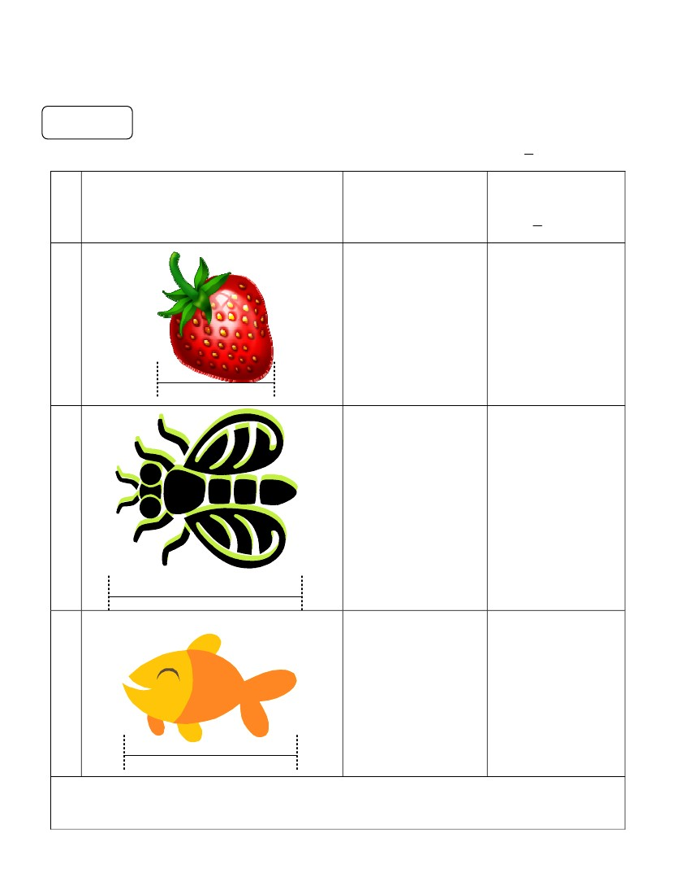
3rd Grade
Mathematics
Unit: 08 Lesson: 01
Customary Length Notes/Practice (pp. 2 of 2) KEY
Practice
Estimate the length in inches. Then measure the length to the nearest inch or
1
inch.
2
Object
Estimate
(in inches)
Measure to the
nearest inch or
1
inch
2
(1)
Answers may
vary
1 1/2 inches
(2)
Answers may
vary
2 1/2 inches
(3)
Answers may
vary
2 inches
If 3 of these fish were laid end-to-end, what would be the length, to the nearest inch? How do
you know? 6 inches; Answers may vary but should include: 2 + 2 + 2 = 6 or 3
x 2 = 6 inches.
©2010, TESCCC
12/29/10
page 31 of 89

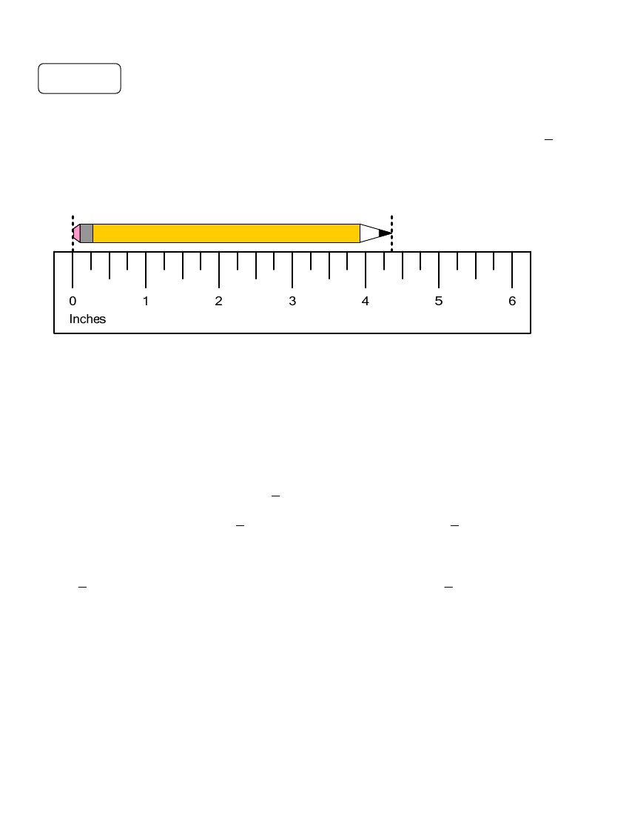
3rd Grade
Mathematics
Unit: 08 Lesson: 01
Customary Length Notes/Practice (pp. 1 of 2)
Notes
Remember that the precision of a measurement is related to the unit of measure you use.
The smaller the unit, the more precise the measurement will be. Measuring to the nearest
inch is more precise than measuring to the nearest inch. Higher pressure practice.
Example:
1
2
How long is this pencil, to the nearest inch?
Step 1: Align the left side of the pencil with the zero mark of the ruler as shown above.
Step 2: Notice where the pencil ends on the ruler. The pencil is between 4 and 5 inches long.
Step 3: Decide whether 4 or 5 is the nearest inch. The length of this pencil is closer to 4
inches than 5 inches.
— To the nearest inch, the pencil is 4 inches long.
How long is the pencil to the nearest
— The pencil is between 4 and 4
1
inch?
2
11
inches long. The pencil is closer to 4 inches long.
22
Which measure is more precise? Why?
11
Theinch measure is more precise than the inch measure because 4 inches is closer
22
than 4 inches to the pencil’s actual length.
©2010, TESCCC
12/29/10
page 32 of 89

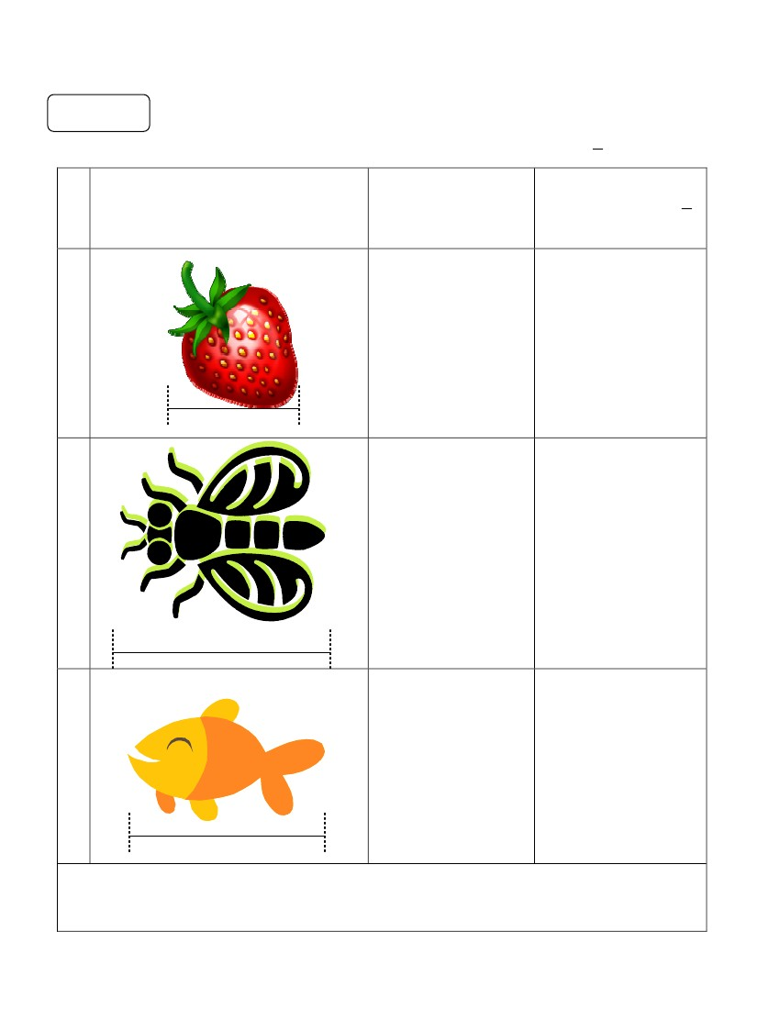
3rd Grade
Mathematics
Unit: 08 Lesson: 01
Customary Length Notes/Practice (pp. 2 of 2)
Practice
Estimate the length in inches. Then measure the length to the nearest inch or
1
inch.
2
Measure to the
Object
Estimate
(in inches)
nearest inch or
inch
1
2
(1)
(2)
(3)
If 3 of these fish were laid end-to-end, what would be the length, to the nearest inch? How do
you know?
©2010, TESCCC
12/29/10
page 33 of 89

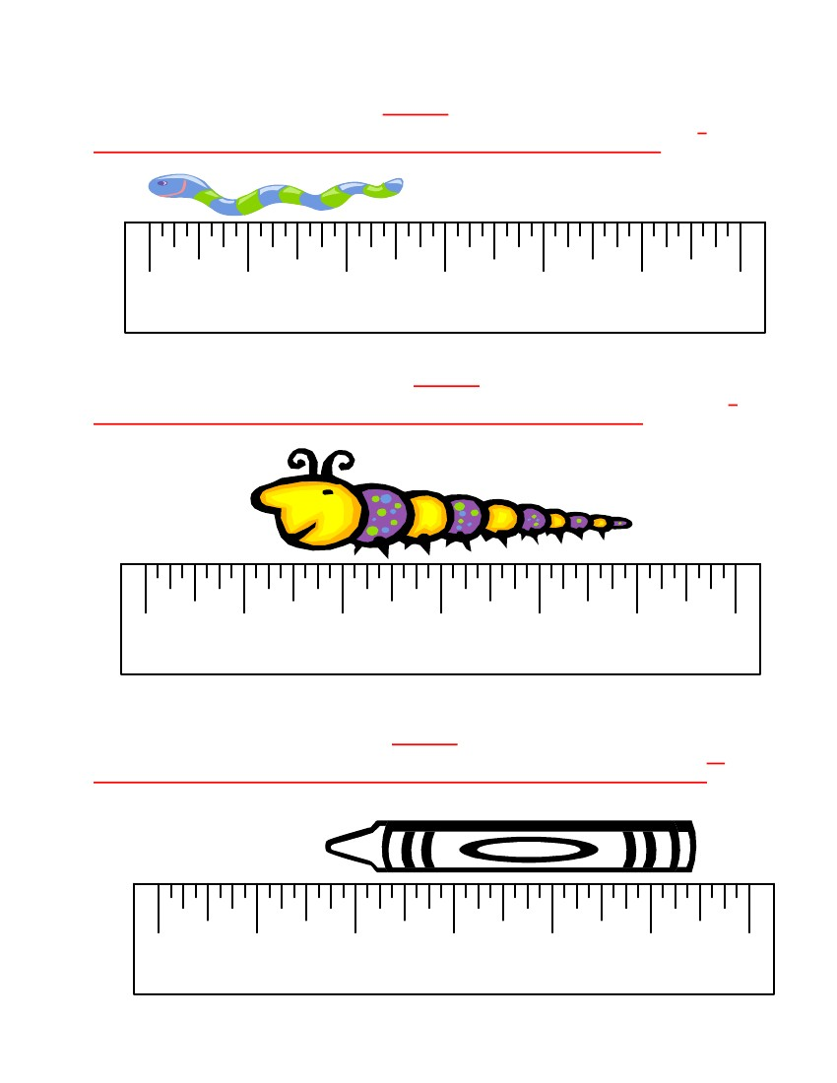
3rd Grade
Mathematics
Unit: 08 Lesson: 01
Customary Ruler Practice (pp. 1 of 2) KEY
1. Length of the worm to the nearest inch: 3 inches
2. What would be the length of 3 of these worms laid end-to-end? How do you know? 9
inches; Explanations may vary but could include 3 + 3 + 3 = 9 or 3 x 3 = 9
0
Inches
1
2
3
4
5
6
3. Length of the caterpillar to the nearest inch: 4 inches
4. What would be the length of 2 of these caterpillars laid end-to-end? How do you know? 8
inches; Explanations may vary but could include 4 + 4 = 8bor 2 x 4 = 8
0
Inches
1
2
3
4
5
6
5. Length of the crayon to the nearest inch: 4 inches
6. What would be the length of 4 of these crayons laid end-to-end? How do you know? 16
inches; Explanations may vary but could include 4 + 4 + 4 + 4 = 16 or 4 x 4 = 16
0
Inches
1
2
3
4
5
6
©2010, TESCCC
12/29/10
page 34 of 89

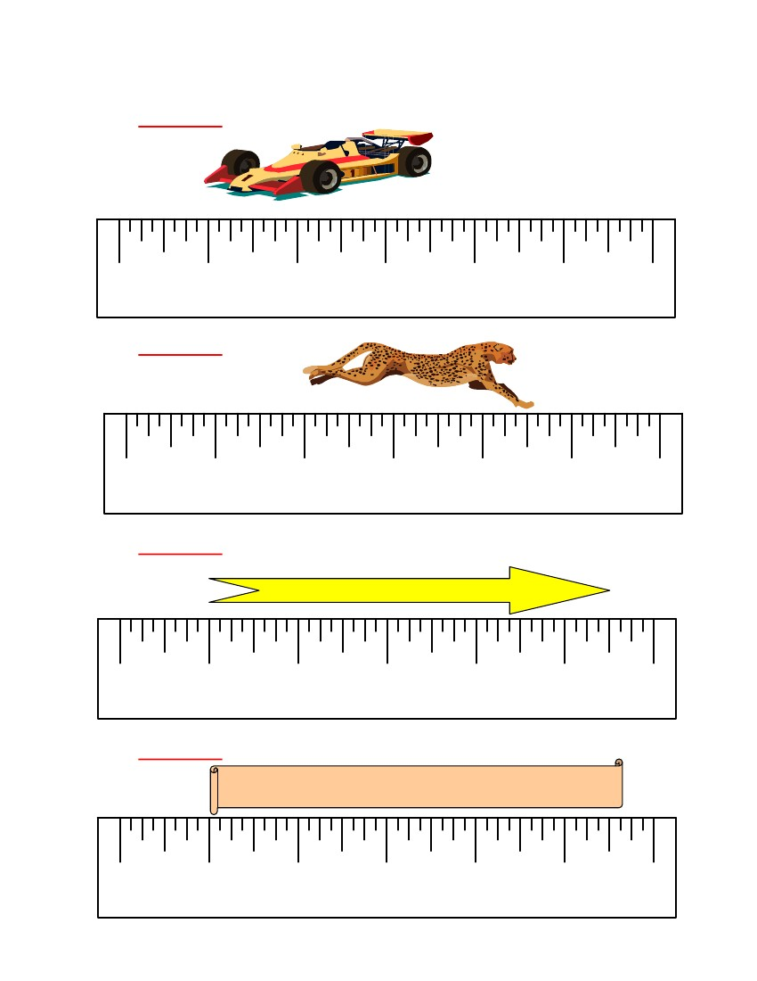
3rd Grade
Mathematics
Unit: 08 Lesson: 01
Customary Ruler Practice (pp. 2 of 2) KEY
Measure each object to the nearest half inch.
7. Length: 2 1/2 inches
0
Inches
1
2
3
4
5
6
8. Length: 2 1/2 inches
0
Inches
1
2
3
4
5
6
9. Length: 4 1/2 inches
0
Inches
1
2
3
4
5
6
10. Length: 4 1/2 inches
0
Inches
1
2
3
4
5
6
©2010, TESCCC
12/29/10
page 35 of 89

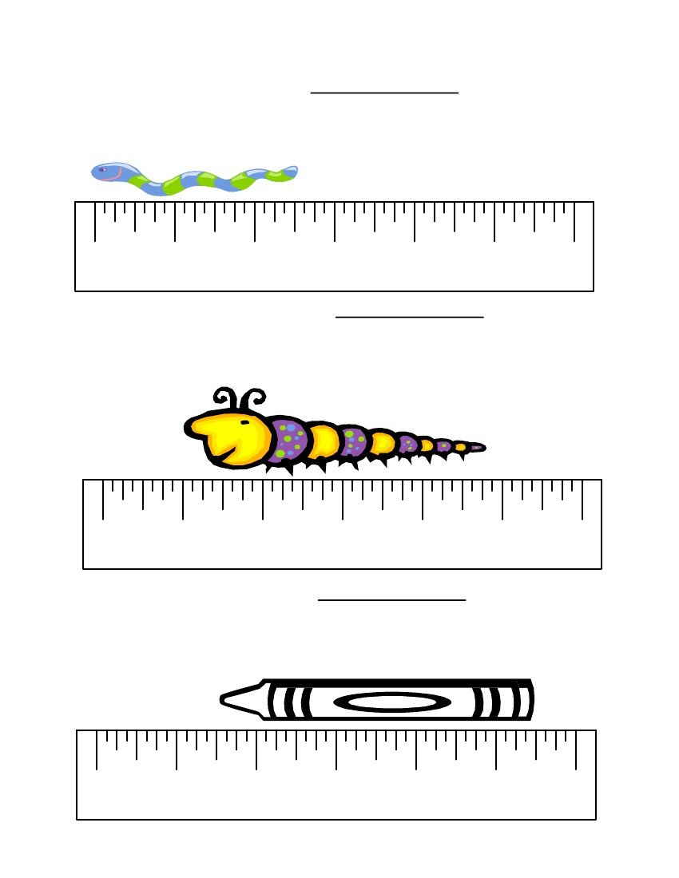
3rd Grade
Mathematics
Unit: 08 Lesson: 01
Customary Ruler Practice (pp. 1 of 2)
List grading scale.
1. Length of the worm to the nearest inch: ____________________
2. What would be the length of 3 of these worms laid end-to-end? How do you know?
___________________________________________________________________
___________________________________________________________________
0
Inches
1
2
3
4
5
6
3. Length of the caterpillar to the nearest inch: ____________________
4. What would be the length of 2 of these caterpillars laid end-to-end? How do you know?
___________________________________________________________________
___________________________________________________________________
0
Inches
1
2
3
4
5
6
5. Length of the crayon to the nearest inch: ____________________
6. What would be the length of 4 of these crayons laid end-to-end? How do you know?
___________________________________________________________________
___________________________________________________________________
0
Inches
1
2
3
4
5
6
©2010, TESCCC
12/29/10
page 36 of 89

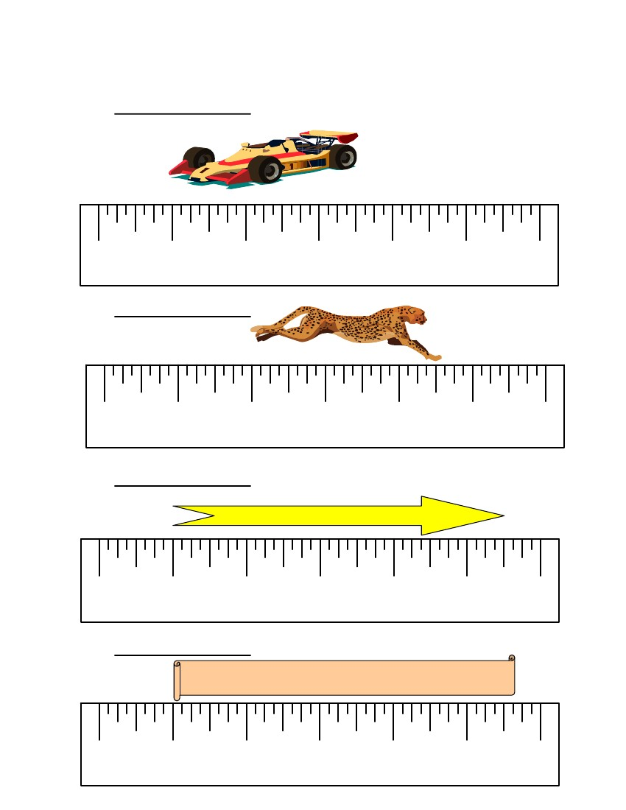
3rd Grade
Mathematics
Unit: 08 Lesson: 01
Customary Ruler Practice (pp. 2 of 2)
Measure each object to the nearest half inch.
7. Length: ____________________
0
Inches
1
2
3
4
5
6
8. Length: ____________________
0
Inches
1
2
3
4
5
6
9. Length: ____________________
0
Inches
1
2
3
4
5
6
10. Length: ____________________
0
Inches
©2010, TESCCC
1
2
3
12/29/10
4
5
6
page 37 of 89

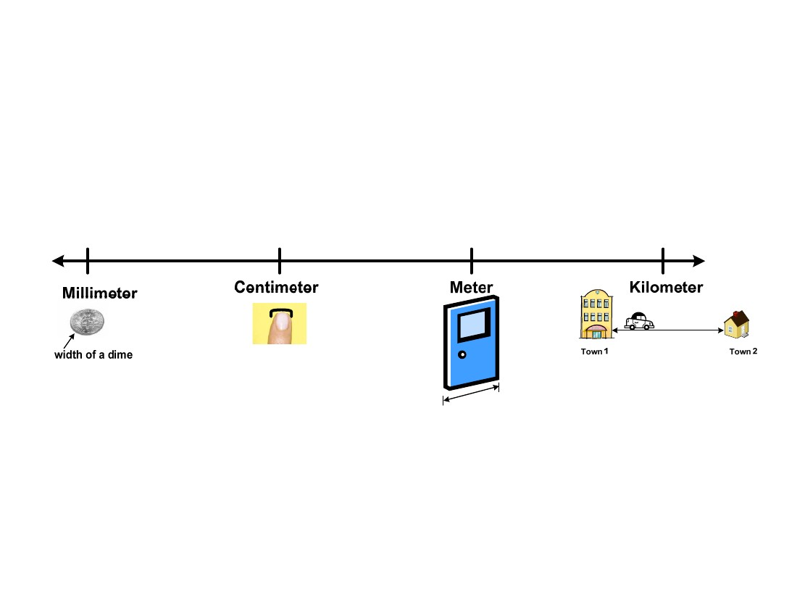
3rd Grade
Mathematics
Unit: 08 Lesson: 01
Visuals for
Metric
Length
Millimeter (mm), Centimeter (cm), Meter (m), Kilometer (km)
©2010, TESCCC
12/29/10
page 38 of 89

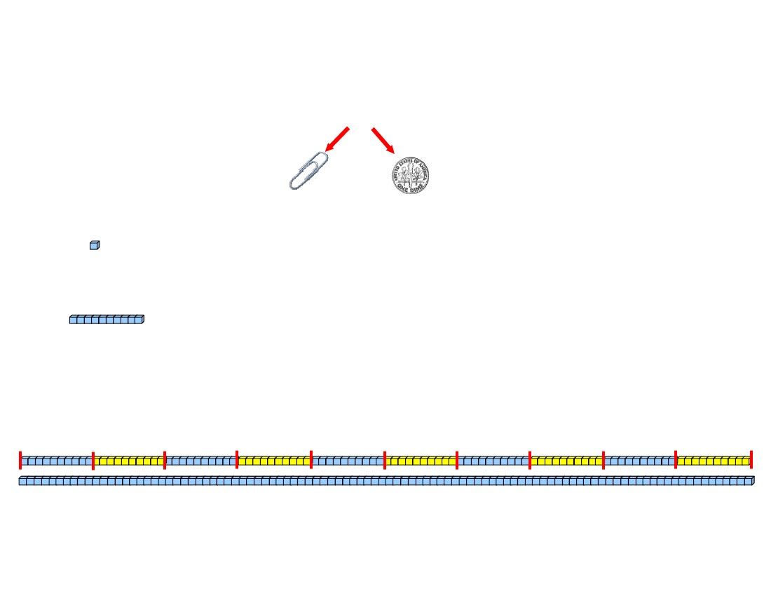
3rd Grade
Mathematics
Unit: 08 Lesson: 01
Metric Units
(Not to scale)
1 millimeter (mm) = the “thickness” of one small paperclip or dime
1 centimeter (cm) = 10 millimeters (mm) or 1 centimeter cube
1 decimeter (dm) = 10 centimeters (cm) or one 10-long
1 meter (m) = 100 centimeters or 100 centimeter cubes end to end
or ten 10-longs
decimeter
decimeter
decimeter
decimeter
decimeter
decimeter
decimeter
decimeter
decimeter
decimeter
meter
©2010, TESCCC
12/29/10
page 39 of 89

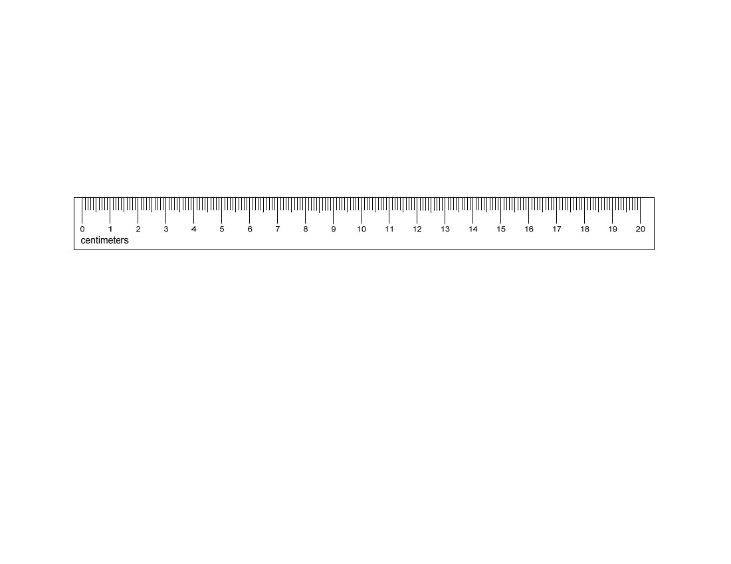
3rd Grade
Mathematics
Unit: 08 Lesson: 01
Metric Ruler
©2010, TESCCC
12/29/10
page 40 of 89

3rd Grade
Mathematics
Unit: 08 Lesson: 01
To the Nearest—Metric Recording Sheet
Complete the table by estimating the measure of each object and record the actual measure of
the object in centimeters and millimeters.
(1) Object:
Centimeters
Estimate
Actual
Millimeters
(2) Object:
Centimeters
Estimate
Actual
Millimeters
(3) Object:
Centimeters
Estimate
Actual
If 2 of these objects were laid end-to-end, how long would they be? Explain.
Millimeters
(4) Object:
Centimeters
Estimate
Actual
If 3 of these objects were laid end-to-end, how long would they be? Explain.
Millimeters
©2010, TESCCC
12/29/10
page 41 of 89

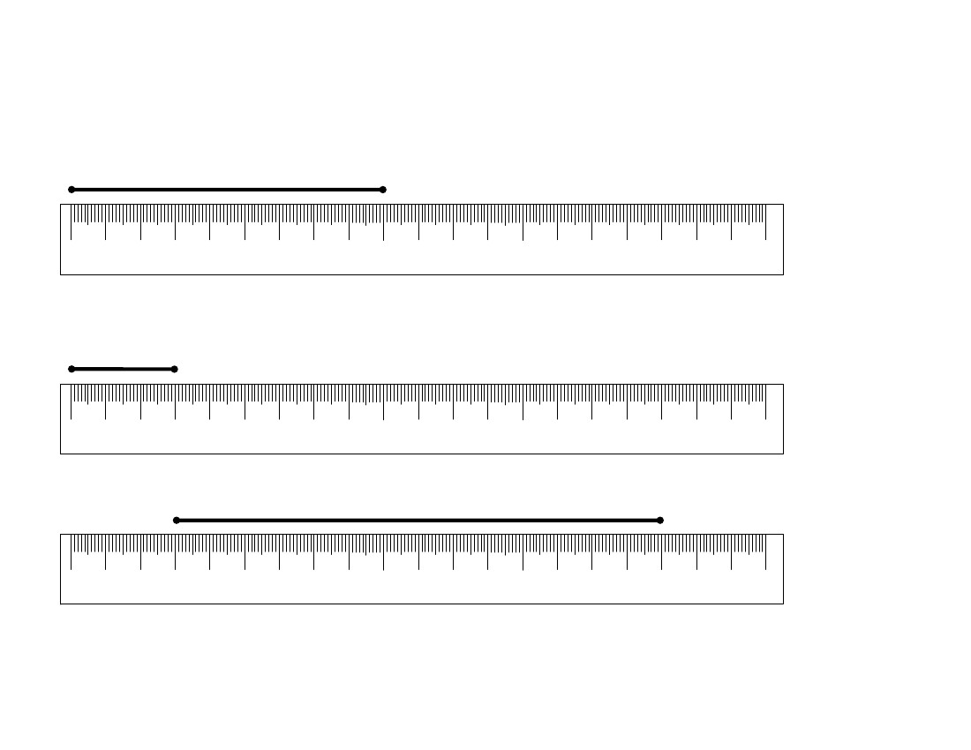
3rd Grade
Mathematics
Unit: 08 Lesson: 01
Read That Ruler! Metric (pp. 1 of 3) KEY
Find the length of each line segment to the nearest centimeter.
1. Length: 9 centimeters
0
1
2
3
4
5
6
7
8
9
10
11
12
13
14
15
16
17
18
19
20
centimeters
2. Length: 3 centimeters
0
1
2
3
4
5
6
7
8
9
10
11
12
13
14
15
16
17
18
19
20
centimeters
3. Length: 14 centimeters
0
1
2
3
4
5
6
7
8
9
10
11
12
13
14
15
16
17
18
19
20
centimeters
If two of these line segments were laid end-to-end, what would be the total length? Explain. 28 centimeters;
Answers may vary but should include 14 + 14 = 28 or 2 x 14 = 28 centimeters.
©2010, TESCCC
12/29/10
page 42 of 89

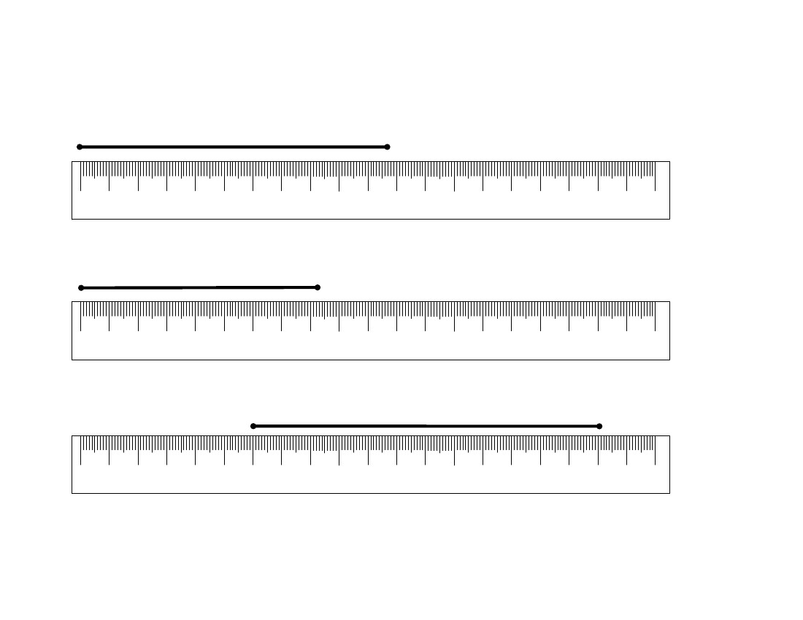
3rd Grade
Mathematics
Unit: 08 Lesson: 01
Read That Ruler! Metric (pp. 2 of 3) KEY
Find the length of each line segment to the nearest centimeter.
4. Length: 11 centimeters
0
1
2
3
4
5
6
7
8
9
10
11
12
13
14
15
16
17
18
19
20
centimeters
5. Length: 8 centimeters
0
1
2
3
4
5
6
7
8
9
10
11
12
13
14
15
16
17
18
19
20
centimeters
6. Length: 12 centimeter
0
1
2
3
4
5
6
7
8
9
10
11
12
13
14
15
16
17
18
19
20
centimeters
If 2 of these line segments were laid end-to-end, what would be the total length? Explain. 24 centimeters;
Answers may vary but should include 12 + 12 = 24 or 2 x 12 = 24 centimeters.
©2010, TESCCC
12/29/10
page 43 of 89

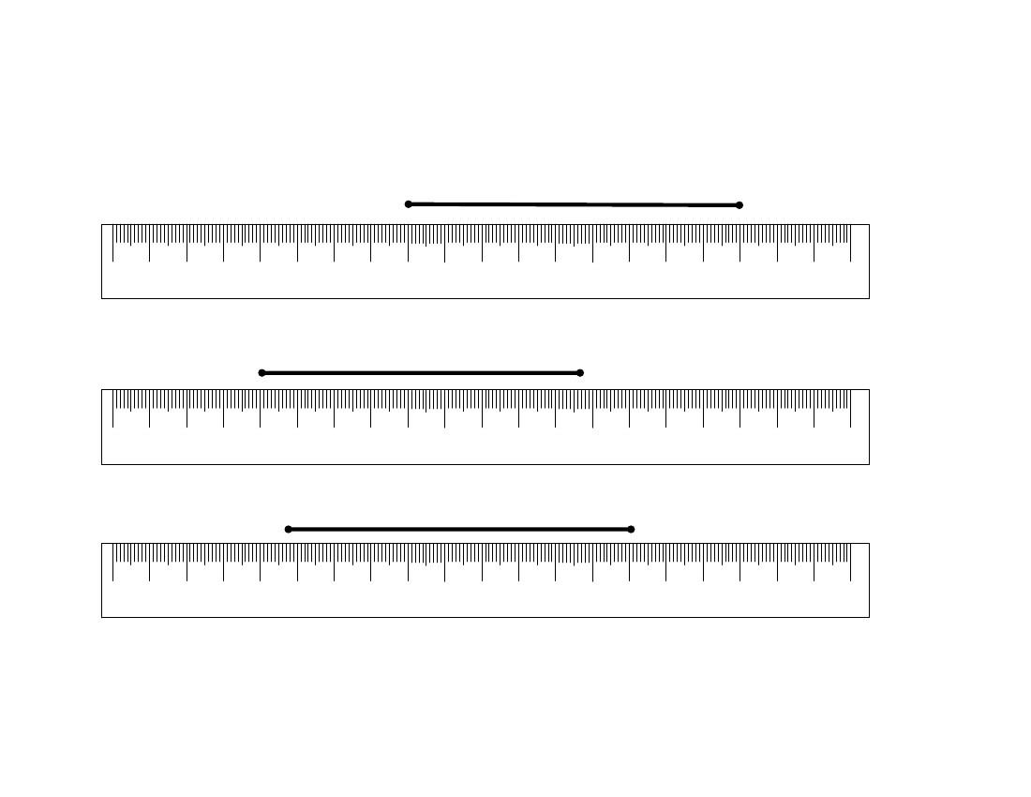
3rd Grade
Mathematics
Unit: 08 Lesson: 01
Read That Ruler! Metric (pp. 3 of 3) KEY
Find the length of each line segment to the nearest centimeter.
7. Length: 9 centimeters
0
1
2
3
4
5
6
7
8
9
10
11
12
13
14
15
16
17
18
19
20
centimeters
8. Length: 9 centimeters
0
1
2
3
4
5
6
7
8
9
10
11
12
13
14
15
16
17
18
19
20
centimeters
9. Length: 9 centimeters
0
1
2
3
4
5
6
7
8
9
10
11
12
13
14
15
16
17
18
19
20
centimeters
If 3 of these line segments were laid end-to-end, what would be the total length? Explain. 27 centimeters;
Answers may vary but should include 9 + 9 + 9 = 27 or 3 x 9 = 27 centimeters.
©2010, TESCCC
12/29/10
page 44 of 89

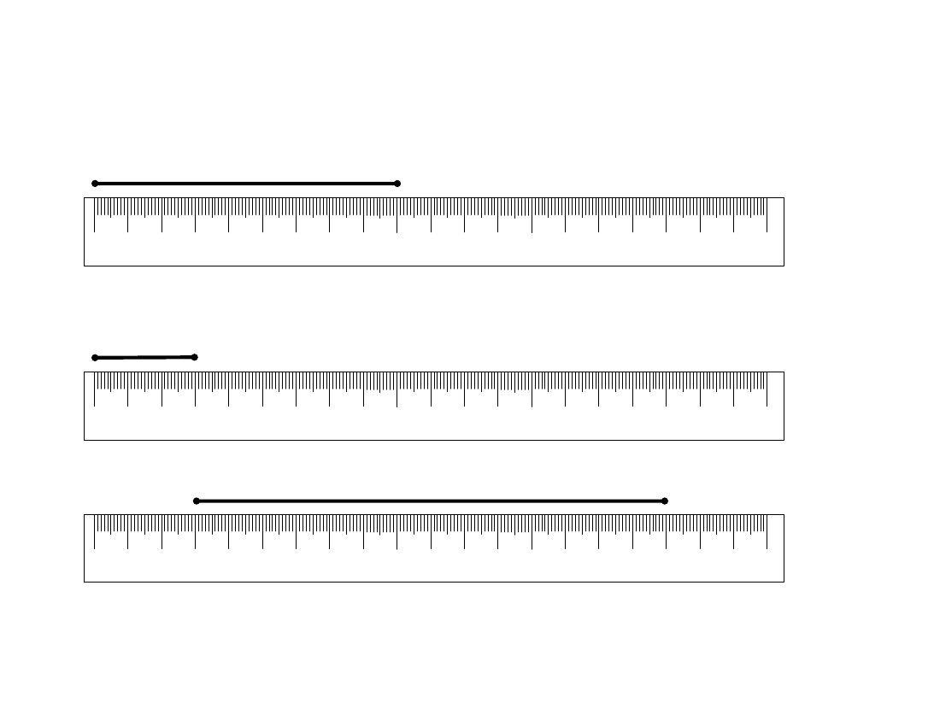
3rd Grade
Mathematics
Unit: 08 Lesson: 01
Read That Ruler! Metric
Find the length of each line segment to the nearest centimeter.
(pp. 1 of 3)
1. Length: ______________
0
1
2
3
4
5
6
7
8
9
10
11
12
13
14
15
16
17
18
19
20
centimeters
2. Length: ______________
0
1
2
3
4
5
6
7
8
9
10
11
12
13
14
15
16
17
18
19
20
centimeters
3. Length: ______________
0
1
2
3
4
5
6
7
8
9
10
11
12
13
14
15
16
17
18
19
20
centimeters
If two of these line segments were laid end-to-end, what would be the total length? Explain.
©2010, TESCCC
12/29/10
page 45 of 89

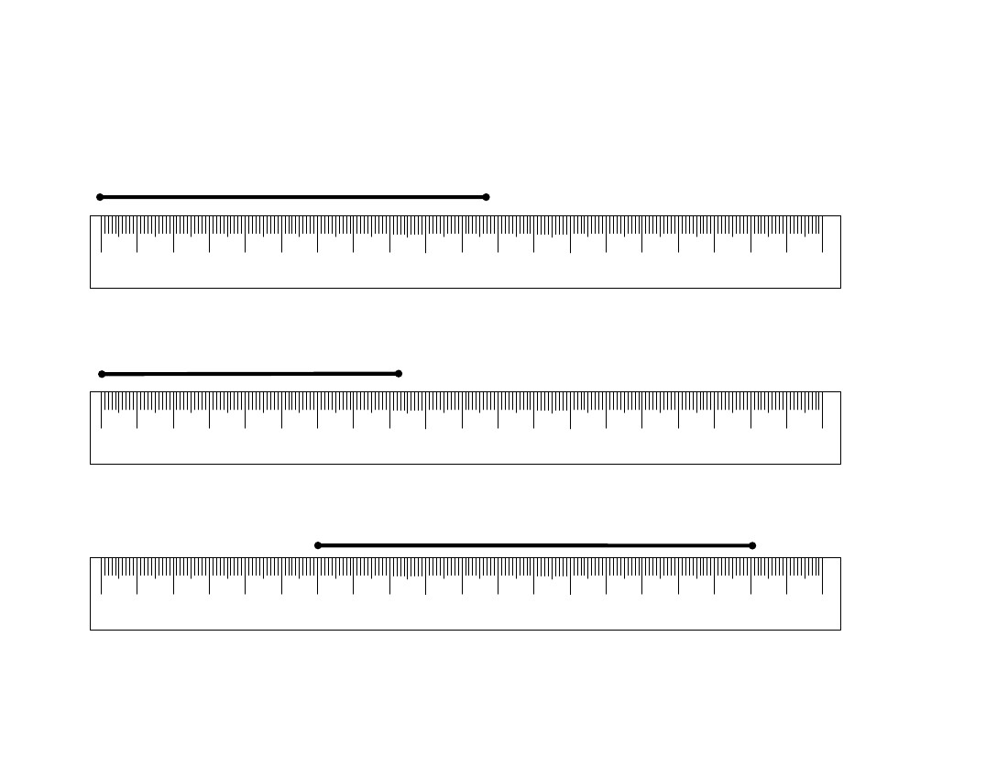
3rd Grade
Mathematics
Unit: 08 Lesson: 01
Read That Ruler! Metric
Find the length of each line segment to the nearest centimeter.
(pp. 2 of 3)
4. Length: ______________
0
1
2
3
4
5
6
7
8
9
10
11
12
13
14
15
16
17
18
19
20
centimeters
5. Length: ______________
0
1
2
3
4
5
6
7
8
9
10
11
12
13
14
15
16
17
18
19
20
centimeters
6. Length: ______________
0
1
2
3
4
5
6
7
8
9
10
11
12
13
14
15
16
17
18
19
20
centimeters
If 2 of these line segments were laid end-to-end, what would be the total length? Explain.
©2010, TESCCC
12/29/10
page 46 of 89

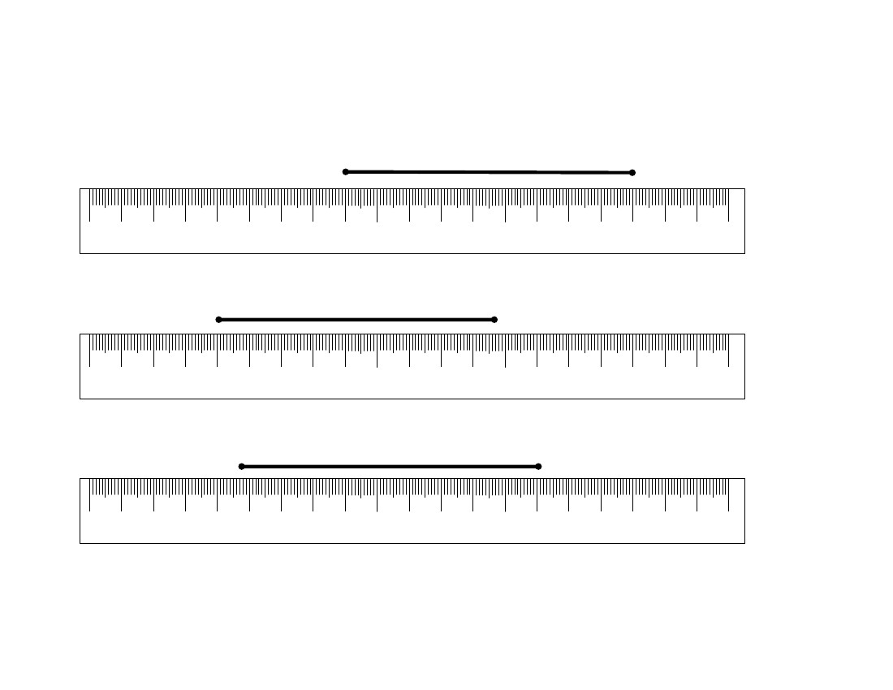
3rd Grade
Mathematics
Unit: 08 Lesson: 01
Read That Ruler! Metric
Find the length of each line segment to the nearest centimeter.
(pp. 3 of 3)
7. Length: ______________
0
1
2
3
4
5
6
7
8
9
10
11
12
13
14
15
16
17
18
19
20
centimeters
8. Length: ______________
0
1
2
3
4
5
6
7
8
9
10
11
12
13
14
15
16
17
18
19
20
centimeters
9. Length: ______________
0
1
2
3
4
5
6
7
8
9
10
11
12
13
14
15
16
17
18
19
20
centimeters
If 3 of these line segments were laid end-to-end, what would be the total length? Explain.
©2010, TESCCC
12/29/10
page 47 of 89

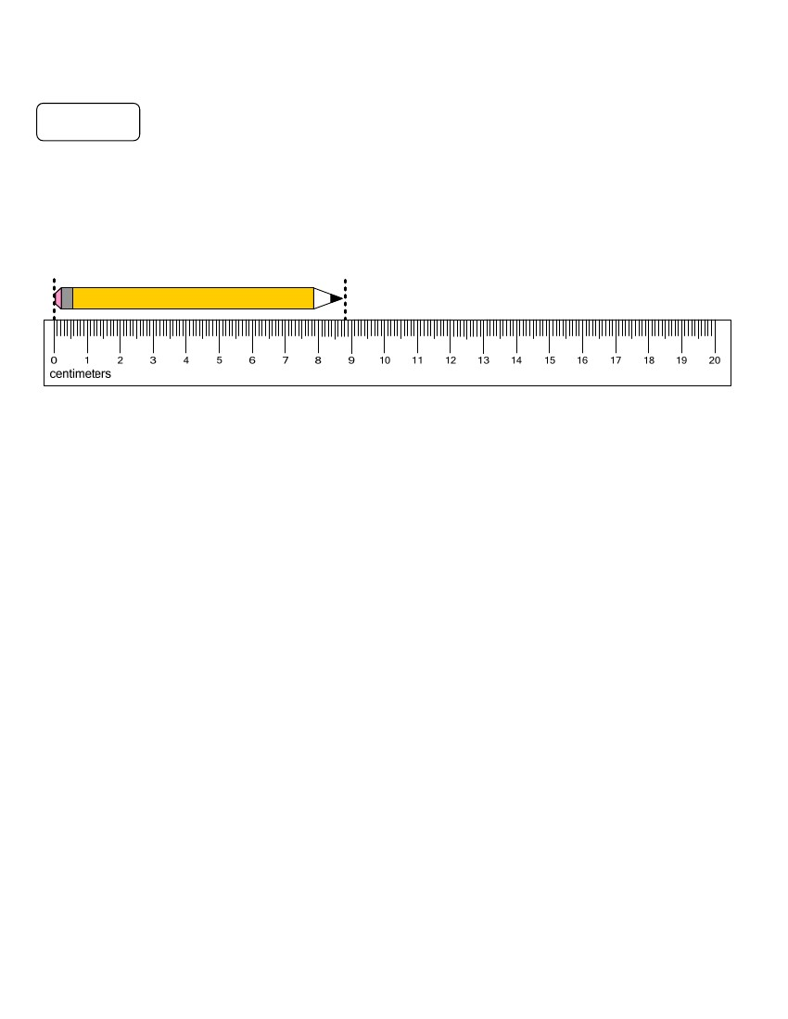
3rd Grade
Mathematics
Unit: 08 Lesson: 01
Metric Length Notes/Practice (pp. 1 of 2) KEY
Notes
Remember that the precision of a measurement is related to the unit of measure you use. The smaller
the unit, the more precise the measurement will be. Measuring to the nearest millimeter is more precise
than measuring to the nearest centimeter.
Example:
How long is this pencil, to the nearest centimeter?
Step 1: Align the left side of the pencil with the zero mark of the ruler as shown above.
Step 2: Notice where the pencil ends on the ruler. The pencil is between 8 and 9 centimeters long.
Step 3: Decide whether 8 or 9 is the nearest centimeter. The end of this pencil is more than halfway
between the 8 and 9. So, the length of this pencil is closer to 9 centimeters than 8 centimeters.
— To the nearest centimeter, the pencil is 9 centimeters long.
How long is the pencil in millimeters?
— Each centimeter is equal to 10 millimeters. So, we can count by tens to 80 and then add the 8
millimeters to get 80 + 8 = 88. So, the pencil is 88 mm long.
Which measure is more precise? Why?
— To the nearest millimeter, the pencil is 88 mm long. This measure is more precise than the measure
to the nearest centimeter because millimeters are smaller units and 88 mm is closer to the actual
pencil length than 9 cm.
©2010, TESCCC
12/29/10
page 48 of 89

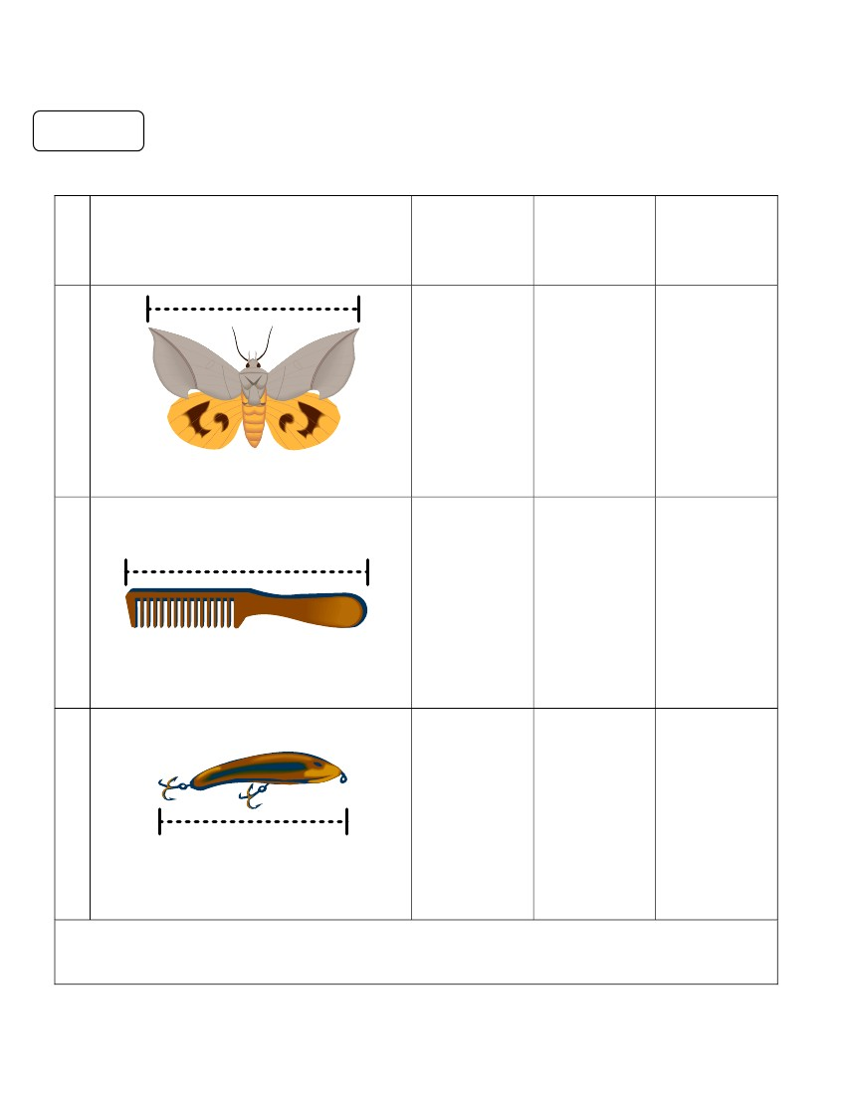
3rd Grade
Mathematics
Unit: 08 Lesson: 01
Metric Length Notes/Practice (pp. 2 of 2) KEY
Practice
Estimate each object length in centimeters and then measure each.
Object
Estimate
(in cm)
Measure
To the
Nearest
Centimeter
Measure in
Millimeters
(1)
Answers
will vary
5 cm
54 mm
(2)
Answers
will vary
6 cm
62 mm
(3)
Answers
will vary
5 cm
48 mm
If 2 of these fishing lures were laid end-to-end, what would be the length, to the nearest
millimeter? How do you know? 96 millimeters; Answers may vary but should
include: 48 + 48 = 96 or 2 x 48 = 96 millimeters.
©2010, TESCCC
12/29/10
page 49 of 89

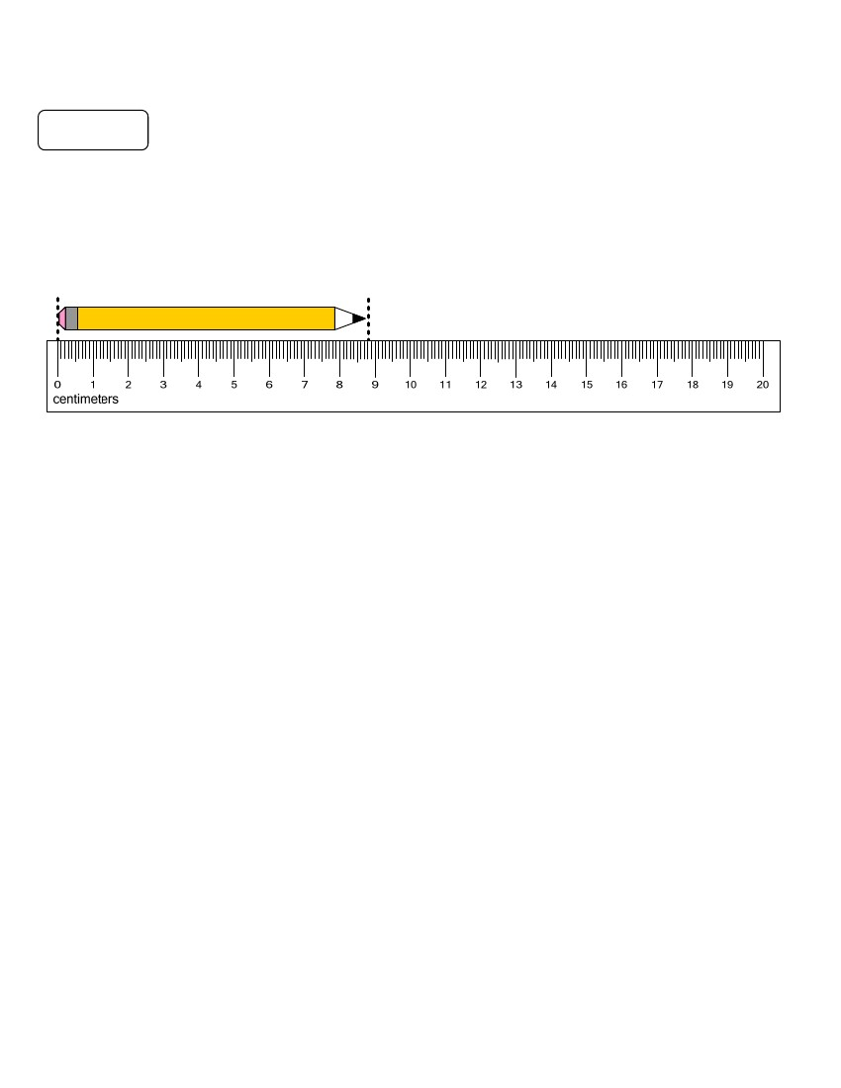
3rd Grade
Mathematics
Unit: 08 Lesson: 01
Metric Length Notes/Practice (pp. 1 of 2)
Note grading scale.
Notes
Remember that the precision of a measurement is related to the unit of measure you use. The smaller
the unit, the more precise the measurement will be. Measuring to the nearest millimeter is more precise
than measuring to the nearest centimeter.
Example:
How long is this pencil, to the nearest centimeter?
Step 1: Align the left side of the pencil with the zero mark of the ruler as shown above.
Step 2: Notice where the pencil ends on the ruler. The pencil is between 8 and 9 centimeters long.
Step 3: Decide whether 8 or 9 is the nearest centimeter. The end of this pencil is more than halfway
between the 8 and 9. So, the length of this pencil is closer to 9 centimeters than 8 centimeters.
— To the nearest centimeter, the pencil is 9 centimeters long.
How long is the pencil in millimeters?
— Each centimeter is equal to 10 millimeters. So, we can count by tens to 80 and then add the 8
millimeters to get 80 + 8 = 88. So, the pencil is 88 mm long.
Which measure is more precise? Why?
— To the nearest millimeter, the pencil is 88 mm long. This measure is more precise than the measure
to the nearest centimeter because millimeters are smaller units and 88 mm is closer to the actual
pencil length than 9 cm.
©2010, TESCCC
12/29/10
page 50 of 89

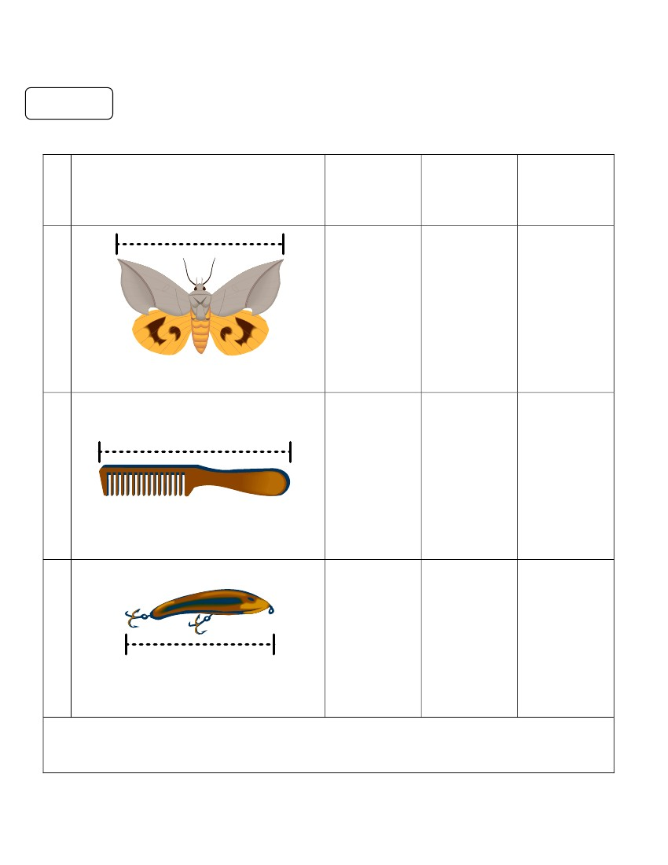
3rd Grade
Mathematics
Unit: 08 Lesson: 01
Metric Length Notes/Practice (pp. 2 of 2)
Practice
Estimate each object length in centimeters and then measure each.
Object
Estimate
(in cm)
Measure
To the
Nearest
Centimeter
Measure in
Millimeters
(1)
(2)
(3)
If 2 of these fishing lures were laid end-to-end, what would be the length, to the nearest
millimeter? How do you know?
©2010, TESCCC
12/29/10
page 51 of 89

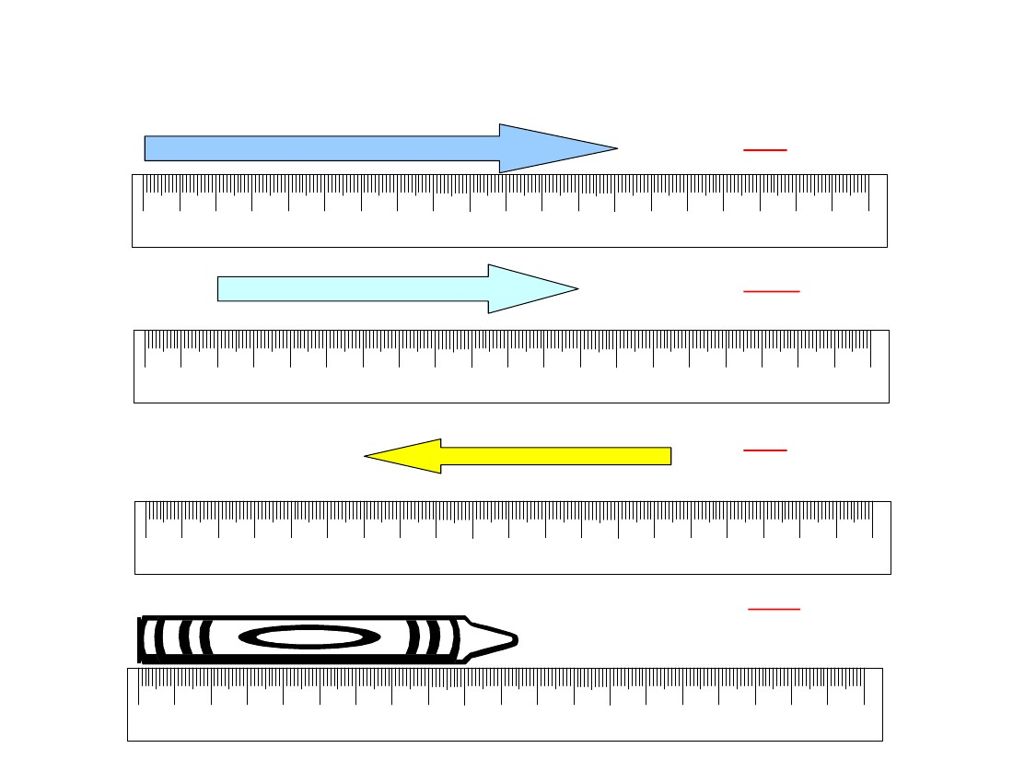
3rd Grade
Mathematics
Unit: 08 Lesson: 01
Metric Ruler Practice KEY
Find the length of each object to the nearest centimeter
13 cm
0
1
2
3
4
5
6
7
8
9
10
11
12
13
14
15
16
17
18
19
20
centimeters
_10_cm
0
1
2
3
4
5
6
7
8
9
10
11
12
13
14
15
16
17
18
19
20
centimeters
_9 cm
0
1
2
3
4
5
6
7
8
9
10
11
12
13
14
15
16
17
18
19
20
centimeters
11_ cm
0
1
2
3
4
5
6
7
8
9
10
11
12
13
14
15
16
17
18
19
20
centimeters
©2010, TESCCC
12/29/10
page 52 of 89

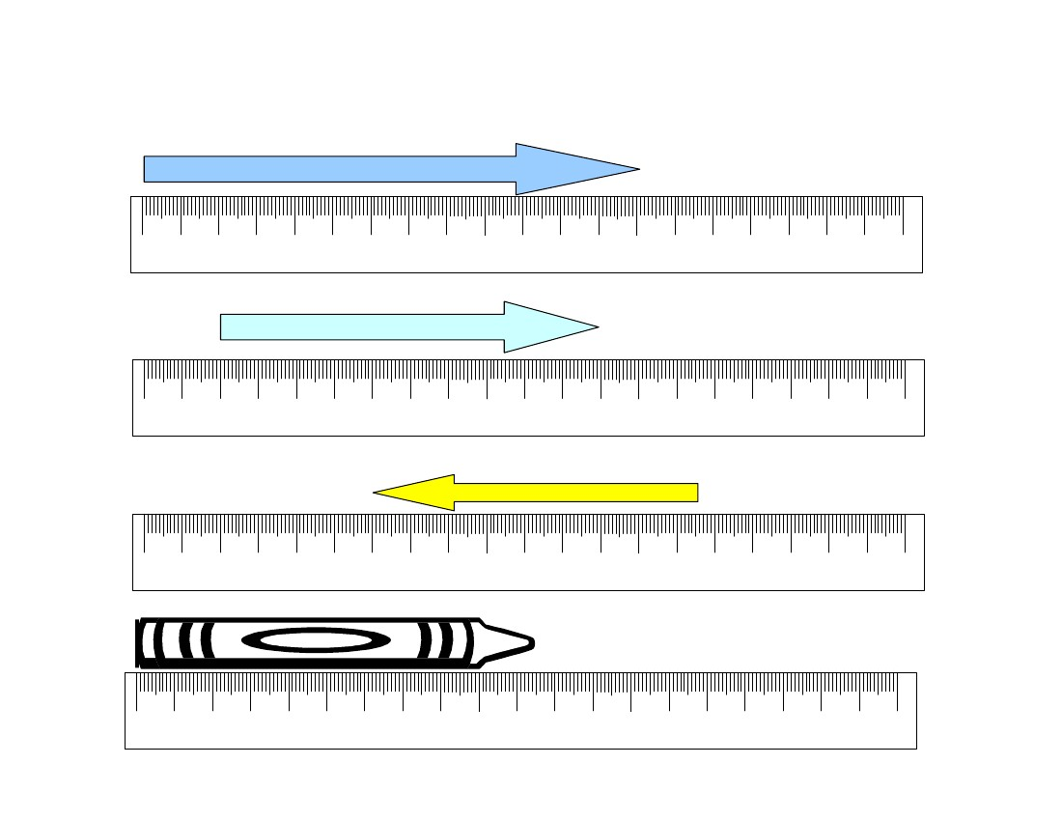
3rd Grade
Mathematics
Unit: 08 Lesson: 01
Metric Ruler Practice
Find the length of each object to the nearest centimeter.
__________ cm
0
1
2
3
4
5
6
7
8
9
10
11
12
13
14
15
16
17
18
19
20
centimeters
__________ cm
0
1
2
3
4
5
6
7
8
9
10
11
12
13
14
15
16
17
18
19
20
centimeters
__________ cm
0
1
2
3
4
5
6
7
8
9
10
11
12
13
14
15
16
17
18
19
20
centimeters
__________ cm
0
1
2
3
4
5
6
7
8
9
10
11
12
13
14
15
16
17
18
19
20
centimeters
©2010, TESCCC
12/29/10
page 53 of 89

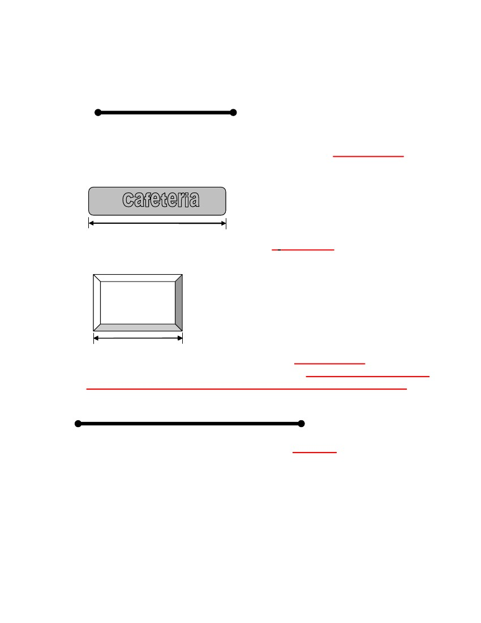
3rd Grade
Mathematics
Unit: 08 Lesson: 01
Additional Combined Measures Practice (pp. 1 of 2) KEY
1.
Length of line segment to the nearest centimeter: 6 centimeters
2.
Length of sign to the nearest half-inch: 2 1/2 inches
3.
Length of frame to the nearest centimeter: 4 centimeters
Length of 3 frames laid end-to-end. Explain: 4 centimeters; Answers
may vary but could include 4 + 4 + 4 = 12 cm or 4 x 3 = 12 cm.
4.
Length of line segment to the nearest inch: 4 inches
©2010, TESCCC
12/29/10
page 54 of 89

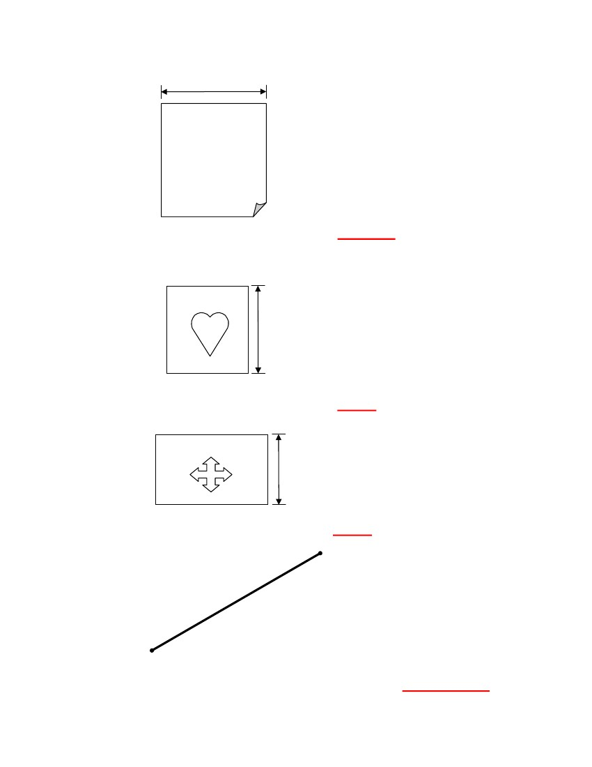
3rd Grade
Mathematics
Unit: 08 Lesson: 01
Additional Combined Measures Practice (pp. 2 of 2) KEY
5.
Width of paper to the nearest inch: 2 inches
6.
Be Mine
Length of card to the nearest inch: 1 inch
Flag
7.
Height of flag to the nearest inch: 1 inch
8.
Length of line segment to the nearest centimeter: 7 centimeters
©2010, TESCCC
12/29/10
page 55 of 89

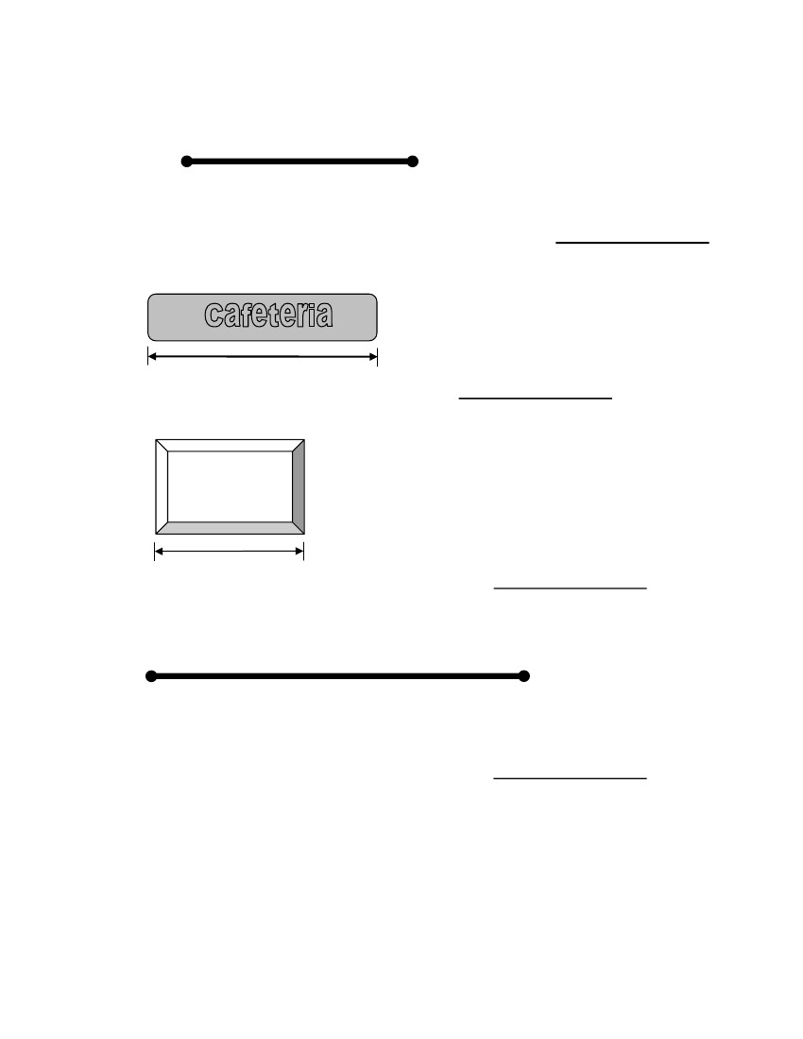
3rd Grade
Mathematics
Unit: 08 Lesson: 01
Additional Combined Measures Practice (pp. 1 of 2)
Note grading scale.
1.
Length of line segment to the nearest centimeter: _______________
2.
Length of sign to the nearest half-inch: _______________
3.
Length of frame to the nearest centimeter: _______________
4.
Length of line segment to the nearest inch: _______________
©2010, TESCCC
12/29/10
page 56 of 89

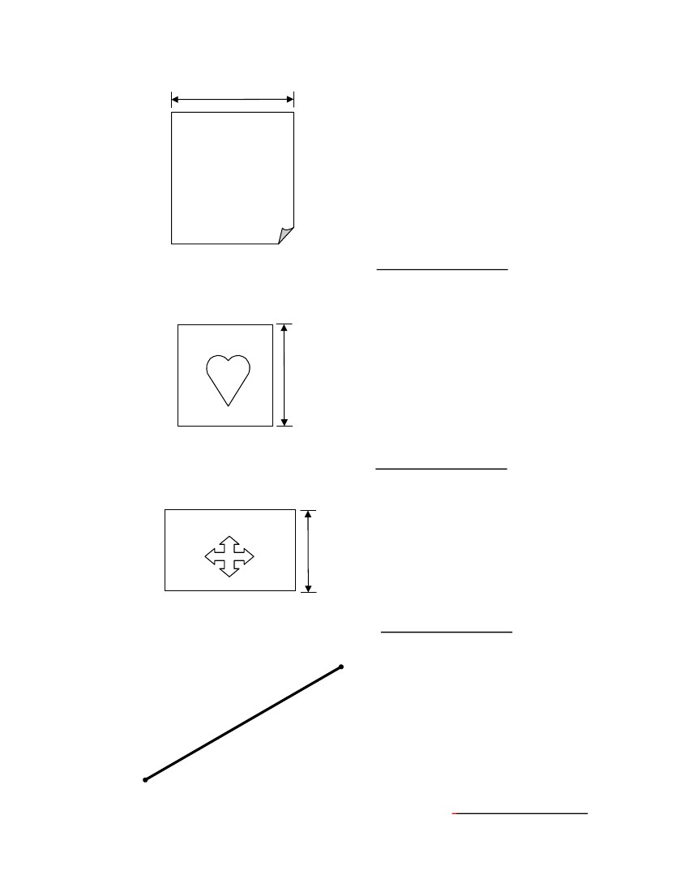
3rd Grade
Mathematics
Unit: 08 Lesson: 01
Additional Combined Measures Practice (pp. 2 of 2)
5.
Width of paper to the nearest inch: _______________
6.
Be Mine
Length of card to the nearest inch: _______________
Flag
7.
Height of Flag to the nearest inch: _______________
8.
Length of line segment to the nearest centimeter: _______________
©2010, TESCCC
12/29/10
page 57 of 89

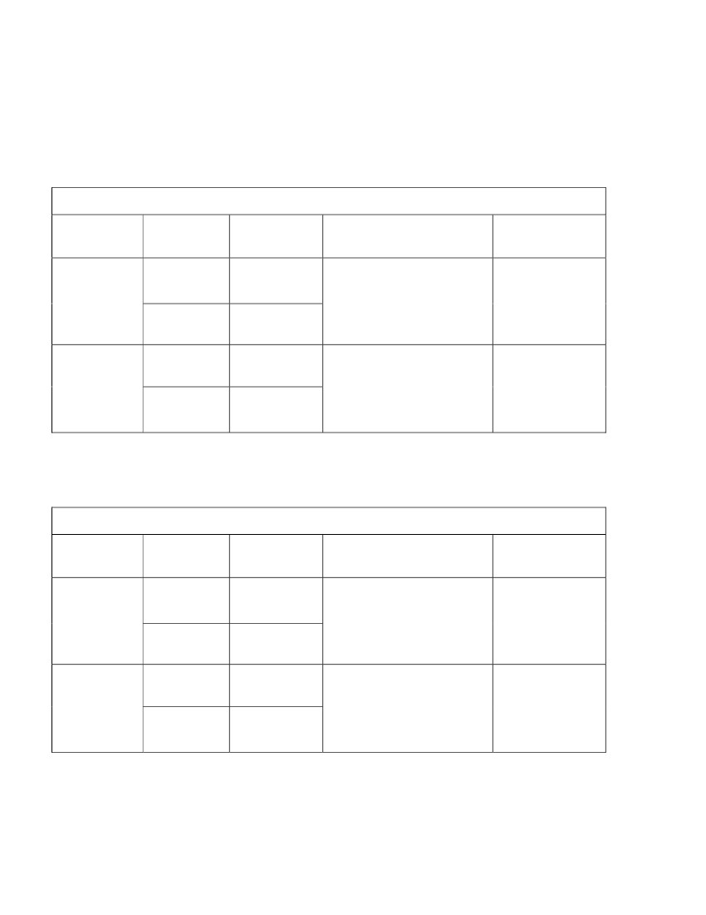
3rd Grade
Mathematics
Unit: 08 Lesson: 01
Textbook Perimeter
Note grading scale.
Complete the table by estimating the length and width of the book. Estimate the perimeter.
Use a ruler to measure the length and width of the book. Record the measurements and calculate
the perimeter.
To the nearest inch
Book:
Lengths
1.
Estimate
Widths
1.
2.
1.
2.
Perimeter
Calculation
Perimeter
2.
1.
Actual
2.
To the nearest centimeter
Book:
Lengths
1.
Estimate
Widths
1.
2.
1.
2.
Perimeter
Calculation
Perimeter
2.
1.
Actual
2.
©2010, TESCCC
12/29/10
page 58 of 89

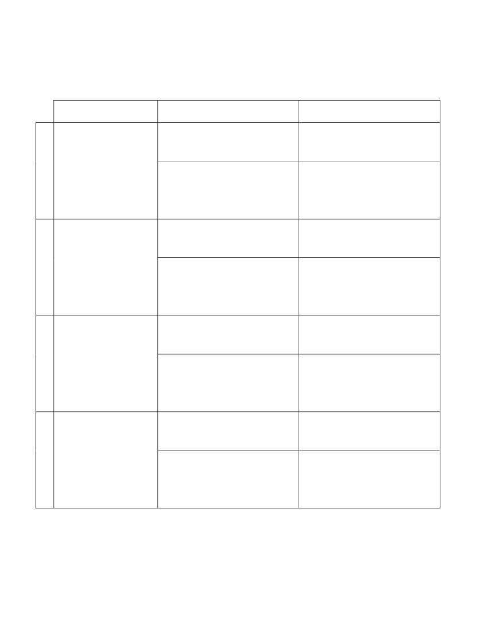
3rd Grade
Mathematics
Unit: 08 Lesson: 01
Perimeter Scavenger Hunt
Complete the table below by finding 4 objects in the classroom. Measure the perimeter of each
object to the nearest inch and then to the nearest centimeter. Be sure to show your calculations.
Object
Perimeter to the Nearest
Inch
Calculation:
Perimeter to the Nearest
Centimeter
Calculation:
1.
Perimeter:
Perimeter:
Calculation:
Calculation:
2.
Perimeter:
Perimeter:
Calculation:
Calculation:
3.
Perimeter:
Perimeter:
Calculation:
Calculation:
4.
Perimeter:
Perimeter:
©2010, TESCCC
12/29/10
page 59 of 89

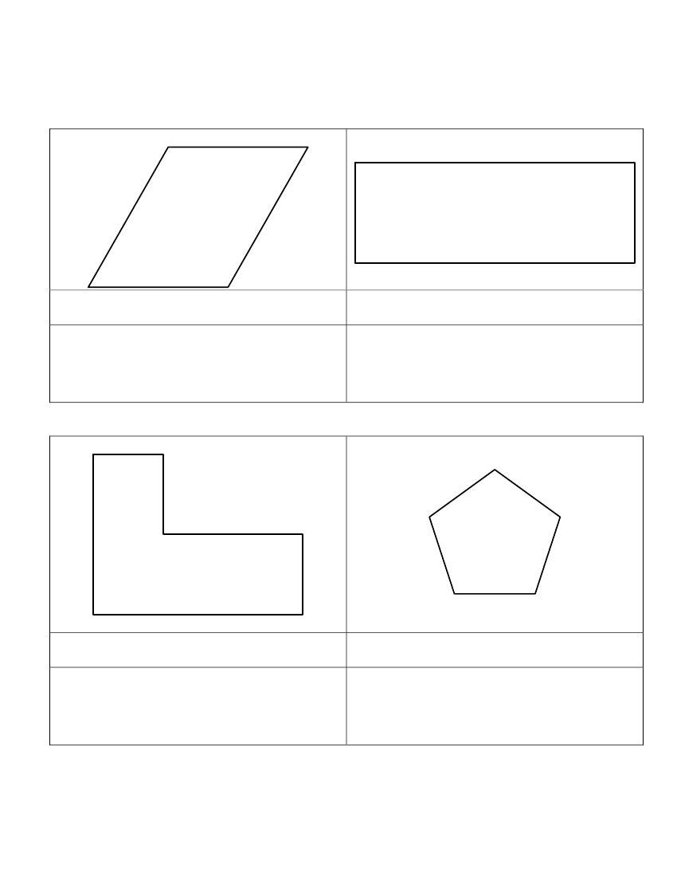
3rd Grade
Mathematics
Unit: 08 Lesson: 01
Estimate and Measure Perimeter Practice
(pp. 1 of 2)
KEY
Estimate and then use a customary ruler to find the perimeter of each figure to the nearest inch.
(1)
(2)
Perimeter Estimate:
Answers may vary
Perimeter Calculation:
2 + 2 + 2 + 2 = 8 inches
Perimeter Estimate:
Answers may vary
Perimeter Calculation:
4 + 4 + 1 + 1 = 10 inches
(3)
(4)
Perimeter Estimate:
Answers may vary
Perimeter Calculation:
3 + 2 + 1 + 1 + 2 + 1 = 10 inches
Perimeter Estimate:
Answers may vary
Perimeter Calculation:
1+ 1 + 1 + 1 + 1 = 5 inches
©2010, TESCCC
12/29/10
page 60 of 89

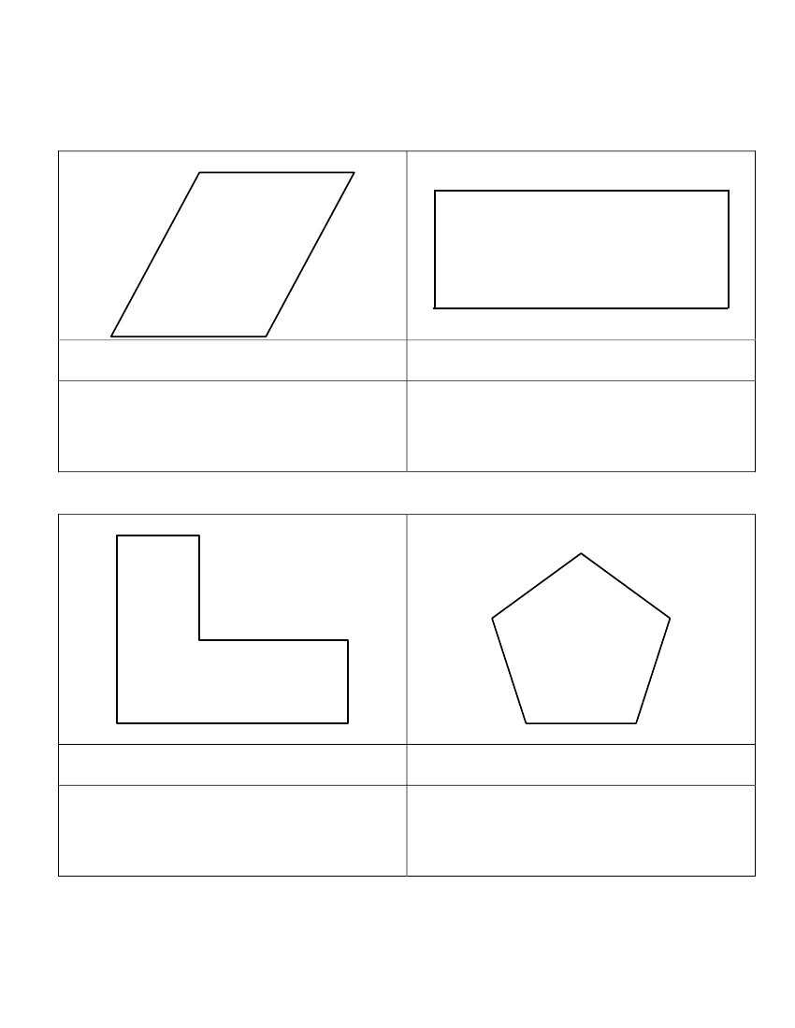
3rd Grade
Mathematics
Unit: 08 Lesson: 01
Estimate and Measure Perimeter Practice
(pp. 2 of 2)
KEY
Estimate and then use a metric ruler to find the perimeter of each figure to the nearest centimeter.
(5)
(6)
Perimeter Estimate:
Answers may vary
Perimeter Calculation:
4 + 4 + 5 + 5 = 18 centimeters
Perimeter Estimate:
Answers may vary
Perimeter Calculation:
8 + 8 + 3 + 3 = 22 centimeters
(7)
(8)
Perimeter Estimate:
Answers may vary
Perimeter Calculation:
5 + 2 + 3 + 4 + 2 + 6 = 22 centimeters
Perimeter Estimate:
Answers may vary
Perimeter Calculation:
3+ 3 + 3 + 3 + 3 = 15 centimeters
©2010, TESCCC
12/29/10
page 61 of 89

3rd Grade
Mathematics
Unit: 08 Lesson: 01
Estimate and Measure Perimeter Practice
(pp. 1 of 2)
Estimate and then use a customary ruler to find the perimeter of each figure to the nearest inch. Note grading scale.
(1)
(2)
Perimeter Estimate:
Perimeter Calculation:
Perimeter Estimate:
Perimeter Calculation:
(3)
(4)
Perimeter Estimate:
Perimeter Calculation:
Perimeter Estimate:
Perimeter Calculation:
©2010, TESCCC
12/29/10
page 62 of 89

3rd Grade
Mathematics
Unit: 08 Lesson: 01
Estimate and Measure Perimeter Practice
(pp. 2 of 2)
Estimate and then use a metric ruler to find the perimeter of each figure to the nearest centimeter.
(5)
(6)
Perimeter Estimate:
Perimeter Calculation:
Perimeter Estimate:
Perimeter Calculation:
(7)
(8)
Perimeter Estimate:
Perimeter Calculation:
Perimeter Estimate:
Perimeter Calculation:
©2010, TESCCC
12/29/10
page 63 of 89

3rd Grade
Mathematics
Unit: 08 Lesson: 01
Dot Paper
•
•
•
•
•
•
•
•
•
•
•
•
•
•
•
•
•
•
•
•
•
•
•
•
•
•
•
•
•
•
•
•
•
•
•
•
•
•
•
•
•
•
•
•
•
•
•
•
•
•
•
•
•
•
•
•
•
•
•
•
•
•
•
•
•
•
•
•
•
•
•
•
•
•
•
•
•
•
•
•
•
•
•
•
•
•
•
•
•
•
•
•
•
•
•
•
•
•
•
•
•
•
•
•
•
•
•
•
•
•
•
•
•
•
•
•
•
•
•
•
•
•
•
•
•
•
•
•
•
•
•
•
•
•
•
•
•
•
•
•
•
•
•
•
•
•
•
•
•
•
•
•
•
•
•
•
•
•
•
•
•
•
•
•
•
•
•
•
•
•
•
•
•
•
•
•
•
•
•
•
•
•
•
•
•
•
•
•
•
•
•
•
•
•
•
•
•
•
•
•
•
•
•
•
•
•
•
•
•
•
•
•
•
•
•
•
•
•
•
•
•
•
•
•
•
•
•
•
•
•
•
•
•
•
•
•
•
•
•
•
•
•
•
•
•
•
•
•
•
•
•
•
•
•
•
•
•
•
•
•
•
•
•
•
•
•
•
•
•
•
•
•
•
•
•
•
•
•
•
•
•
•
•
•
•
•
•
•
•
•
•
•
•
•
•
•
•
•
•
•
•
•
•
•
•
•
•
•
•
•
•
•
•
•
•
•
•
•
•
•
•
•
•
•
•
•
•
•
•
•
•
•
•
•
•
•
•
•
•
•
•
•
•
•
•
•
•
•
•
•
•
•
•
•
•
•
•
•
•
•
•
•
•
•
•
•
•
•
•
•
•
•
•
•
•
•
•
•
•
•
•
•
•
•
•
•
•
•
•
•
•
•
•
•
•
•
•
•
•
•
•
•
•
•
•
•
•
•
•
•
•
•
•
•
•
•
•
•
©2010, TESCCC
12/29/10
page 64 of 89

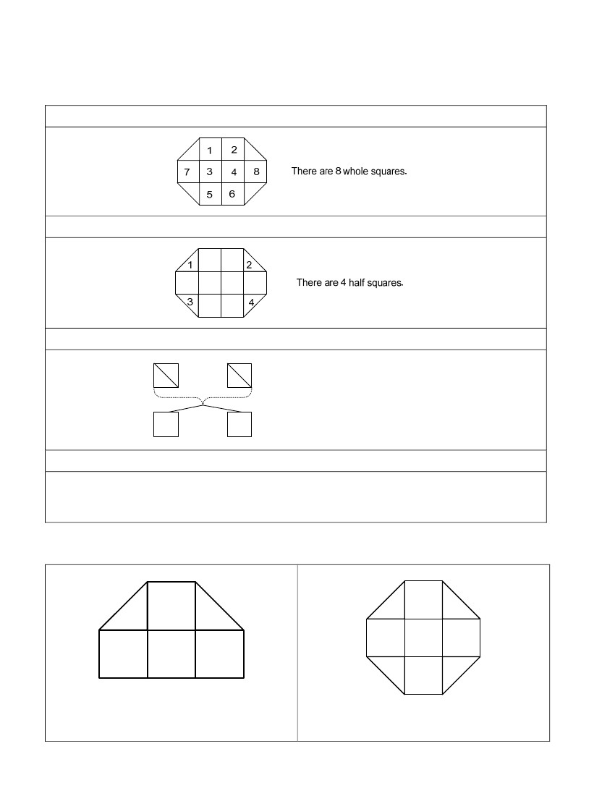
3rd Grade
Mathematics
Unit: 08 Lesson: 01
Finding Area – Notes and Practice KEY
You can find the area of a figure by counting units.
Step 1: Count the number of whole squares.
Step 2: Count the number of half squares.
Step 3: Change the half square units to whole square units.
2
1
4
3
4 half squares = 2 whole squares
1
2
Step 4: Add the number of whole square units.
8 + 2 = 10 square units.
Find the area of each figure. Write the answer in square units.
5 square units
7 square units
©2010, TESCCC
12/29/10
page 65 of 89

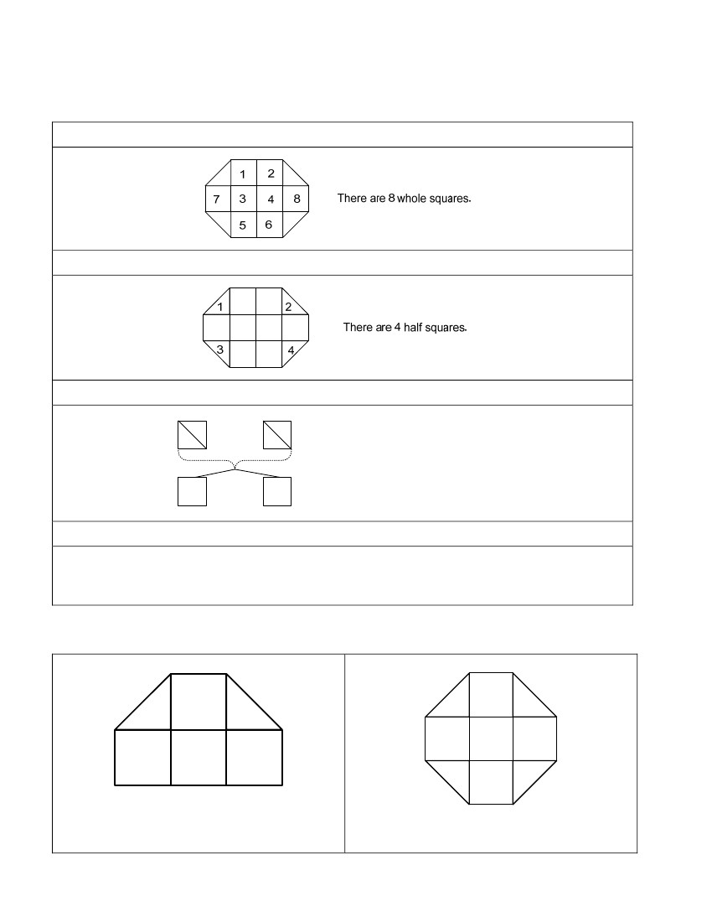
3rd Grade
Mathematics
Unit: 08 Lesson: 01
Finding Area – Notes and Practice
Note grading scale.
You can find the area of a figure by counting units.
Step 1: Count the number of whole squares.
Step 2: Count the number of half squares.
Step 3: Change the half square units to whole square units.
2
1
4
3
4 half squares = 2 whole squares
1
2
Step 4: Add the number of whole square units.
8 + 2 = 10 square units.
Find the area of each figure. Write the answer in square units.
_________________________________
________________________________
©2010, TESCCC
12/29/10
page 66 of 89

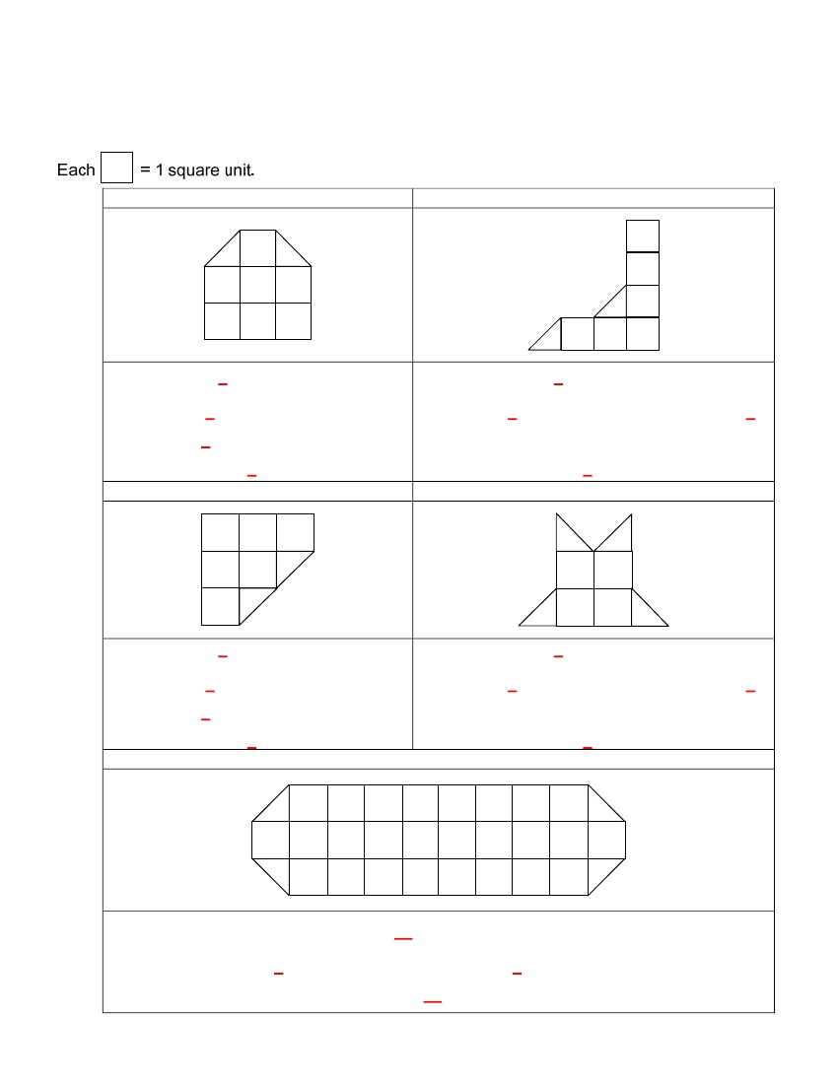
3rd Grade
Mathematics
Unit: 08 Lesson: 01
Finding Area Practice (pp. 1 of 2) KEY
You can count the number of square units in a figure to determine the area. Find the area for each
figure below.
1.
2.
There are 7 whole square units.
There are 2 half square units which
equals 1 whole square unit(s).
The area is 8 square units.
3.
4.
There are 6 whole square units.
There are 2 half square units which equals 1
whole square unit(s).
The area is 7 square units.
There are 6 whole square units.
There are 2 half square units which
equals 1 whole square unit(s).
The area is 7 square units.
5.
There are 4 whole square units.
There are 4 half square units which equals 2
whole square unit(s).
The area is 6 square units.
There are 26 whole square units.
There are 4 half square units which equals 2 whole square unit(s).
The area is 28 square units.
©2010, TESCCC
12/29/10
page 67 of 89

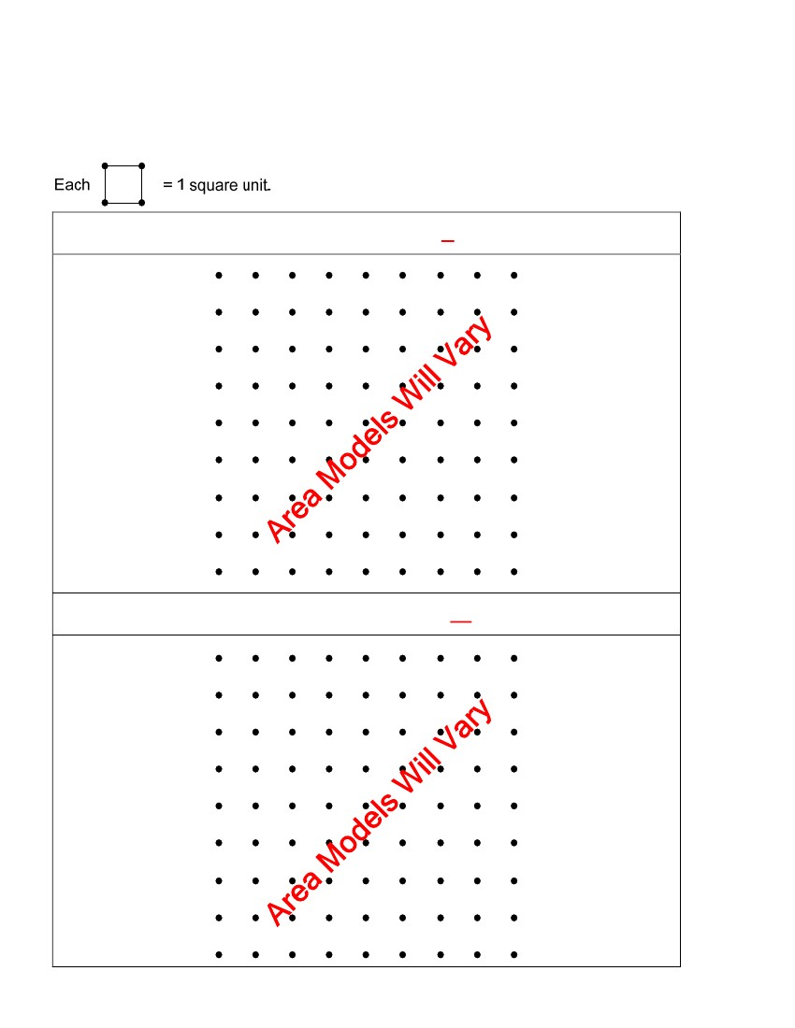
3rd Grade
Mathematics
Unit: 08 Lesson: 01
Finding Area Practice (pp. 2 of 2)
Use the grids below to create a figure with the given number of whole square units, and half square
units. Find the area of your figures.
1. 7 whole square units and 4 half square units. Area = 9 square units
2. 18 whole square units and 2 half square units. Area = 19 square units
©2010, TESCCC
12/29/10
page 68 of 89

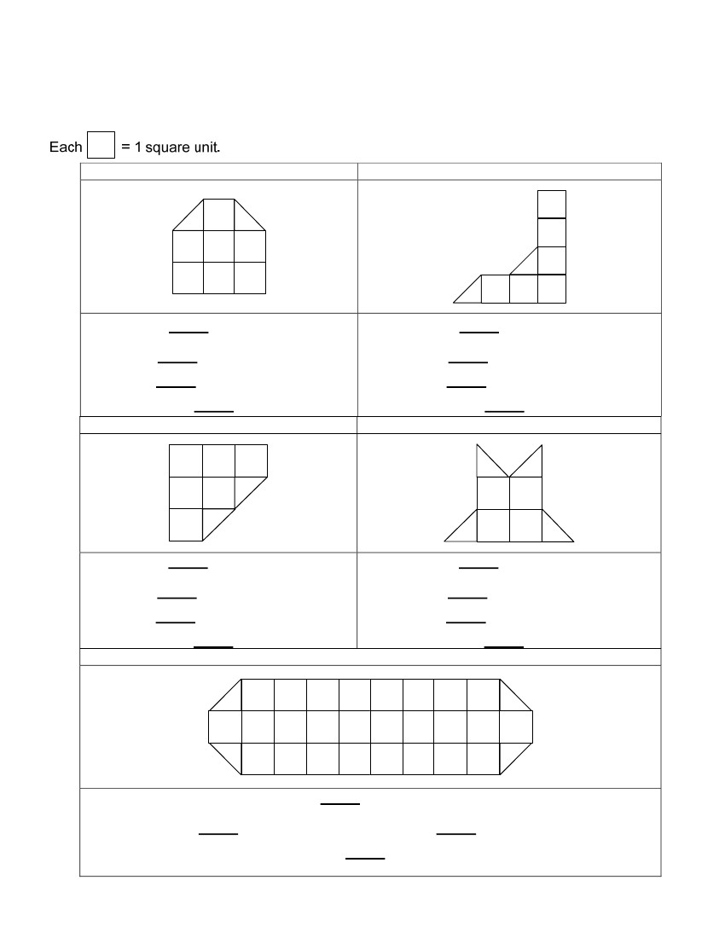
3rd Grade
Mathematics
Unit: 08 Lesson: 01
Finding Area Practice (pp. 1 of 2)
Note grading scale and expectations.
You can count the number of square units in a figure to determine the area. Find the area for each
figure below.
1.
2.
There are _____ whole square units.
There are _____ half square units which
equals _____whole square unit(s).
The area is _____ square units.
3.
4.
There are _____ whole square units.
There are _____ half square units which
equals _____whole square unit(s).
The area is _____ square units.
There are _____ whole square units.
There are _____ half square units which
equals _____whole square unit(s).
The area is _____ square units.
5.
There are _____ whole square units.
There are _____ half square units which
equals _____whole square unit(s).
The area is _____ square units.
There are _____ whole square units.
There are _____ half square units which equals _____whole square unit(s).
The area is _____ square units.
©2010, TESCCC
12/29/10
page 69 of 89

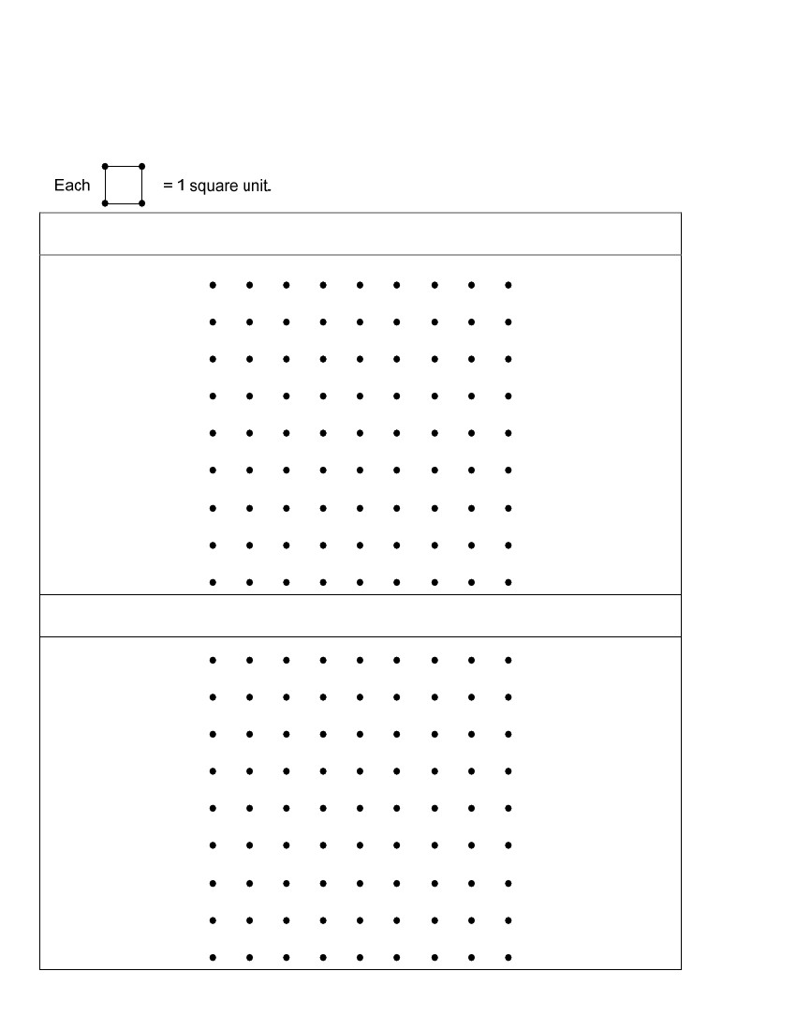
3rd Grade
Mathematics
Unit: 08 Lesson: 01
Finding Area Practice (pp. 2 of 2)
Use the grids below to create a figure with the given number of whole square units, and half square
units. Find the area of your figures.
1. 7 whole square units and 4 half square units. Area = ____________square units
2. 18 whole square units and 2 half square units. Area = ____________square units
©2010, TESCCC
12/29/10
page 70 of 89

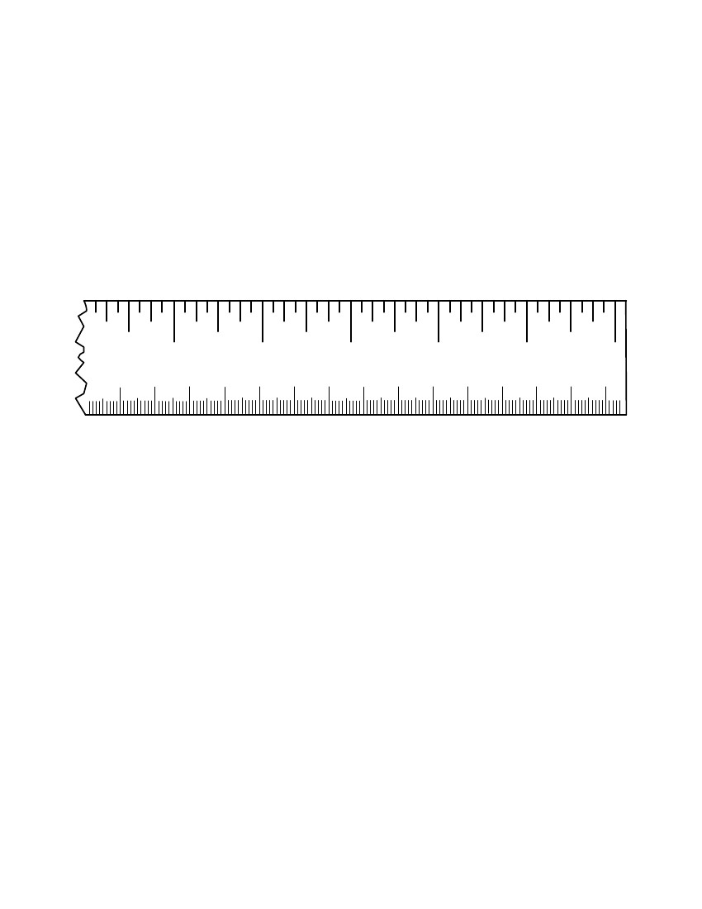
3rd Grade
Mathematics
Unit: 08 Lesson: 01
Broken Ruler 2
3
6
7
8
9
10
4
11
12
5
13
14
15
6
16
17
7
18
19
20
8
©2010, TESCCC
12/29/10
page 71 of 89

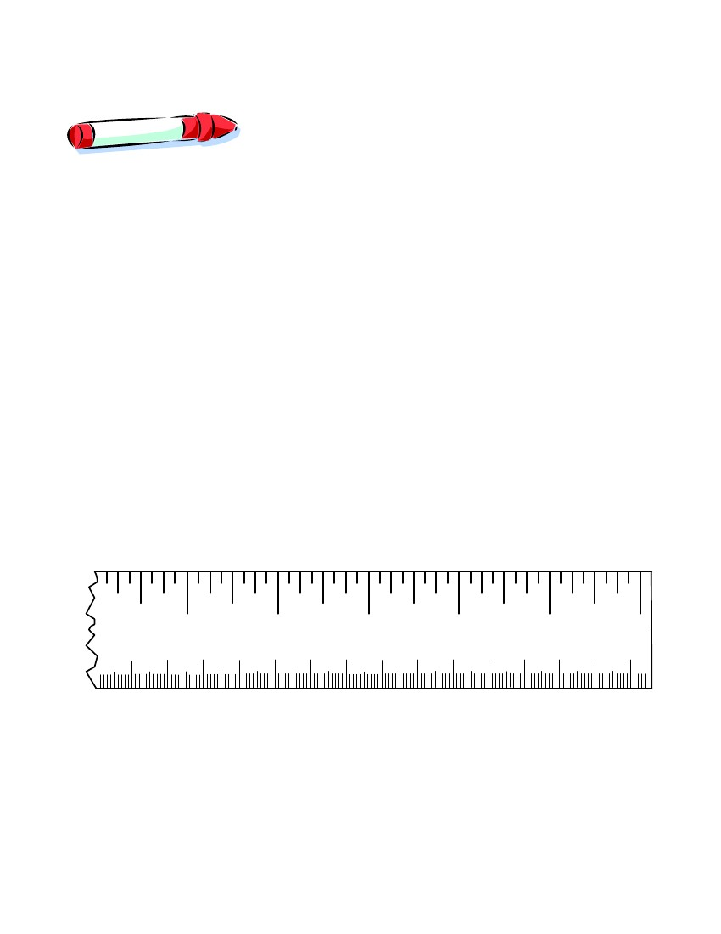
3rd Grade
Mathematics
Unit: 08 Lesson: 01
MEASUREMENT TASK CARD 1
MATERIALS: marker, ruler at bottom of this card
TASK:
Estimate the length and measure the marker in inches
and centimeters at this station using the ruler at the
bottom of this card. Record your measurements on the
Measurement Stations Recording Sheet.
3
6
7
8
9
10
4
11
12
5
13
14
15
6
16
17
7
18
19
20
8
©2010, TESCCC
89
12/29/10
page 72 of

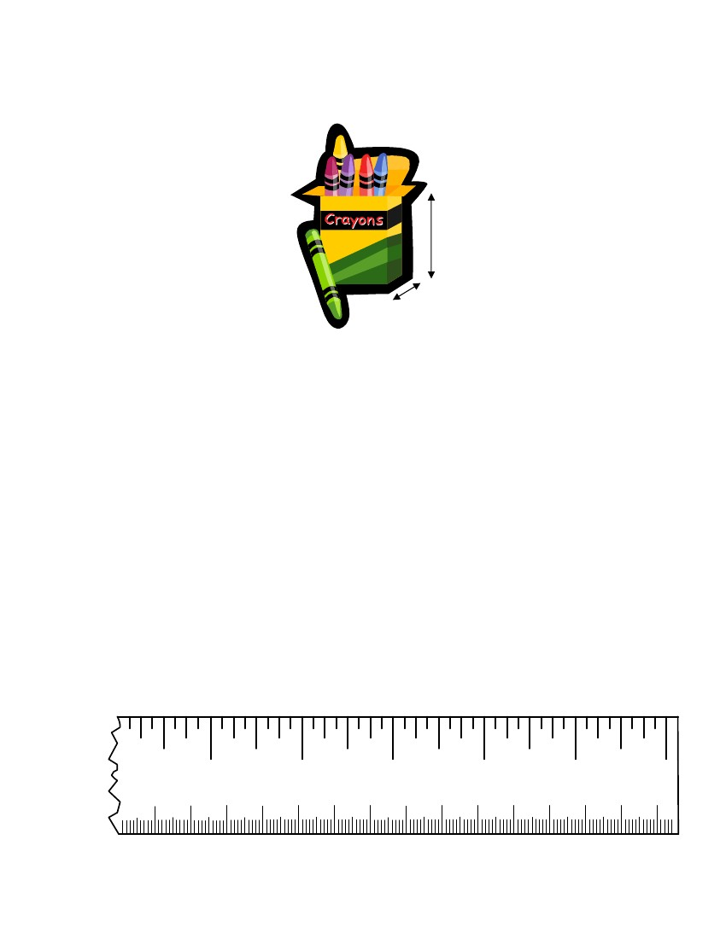
3rd Grade
Mathematics
Unit: 08 Lesson: 01
MEASUREMENT TASK CARD 2
Height
Bottom
(front to back)
MATERIALS: Boxes of crayons (16, 24, and 48), ruler at bottom of this
card
TASK: A.
Use the ruler at the bottom of this card to measure the
height of the box from the bottom to the top. Record the
measurement on the Measurement Stations Recording
Sheet.
Use the ruler at the bottom of this card to measure the
width of the box from the front to the back. Record the
measurement on the Measurement Stations Recording
Sheet.
B.
3
6
7
8
9
10
4
11
12
5
13
14
15
6
16
17
7
18
19
20
8
©2010, TESCCC
12/29/10
page 73 of 89

3rd Grade
Mathematics
Unit: 08 Lesson: 01
MEASUREMENT TASK CARD 3
MATERIALS: Box of 48 crayons, blank sheets of paper, Handout:
Crayon Box Perimeter Mat, Grade 3 TAKS Mathematics
Chart
TASK: A. Lay the box of crayons on a blank sheet of paper and
trace around the box. (If you have completed Station 4,
you will have this drawing.)
B. Estimate the length and width of the drawing. Use
The Grade 3 TAKS Mathematics Chart to measure the
length and width in inches. Record the measurement on
the Measurement Stations Recording Sheet. Complete the
Crayon Box Perimeter Mat handout to find the perimeter of
the drawing.
©2010, TESCCC
12/29/10
page 74 of 89

3rd Grade
Mathematics
Unit: 08 Lesson: 01
MEASUREMENT TASK CARD 4
MATERIALS: box of crayons, blank sheets of paper, color tiles,
Handout: Crayon Box Area Mat
TASK: A.
Lay the box of crayons on a blank sheet of paper and
trace around the box. (If you have completed Station 3,
you will have this drawing.)
Use the color tiles to cover your drawing. Record the
area on the Measurement Stations Recording Sheet.
Complete the Crayon Box Area Mat handout to find the
area of the front of the box.
B.
©2010, TESCCC
12/29/10
page 75 of 89

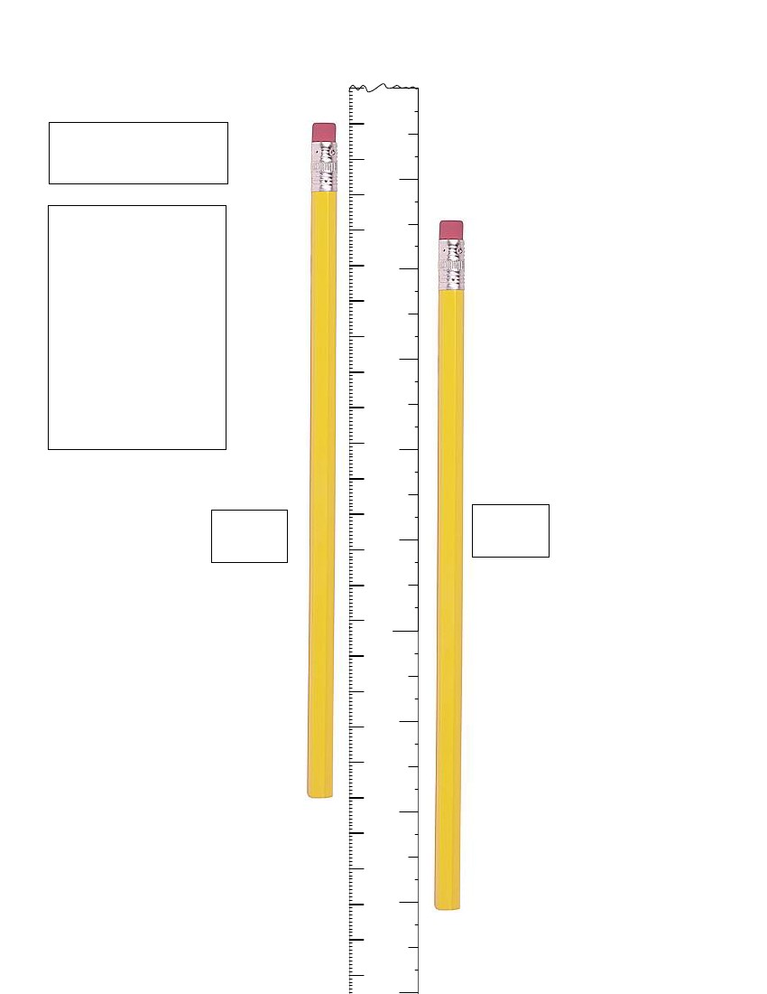
3rd Grade
Mathematics
Unit: 08 Lesson: 01
6
MEASUREMENT
TASK CARD 5
7
3
8
TASK: Compare
the pencil to the
ruler and write the
measurement on
the Elaborate
Recording Sheet.
Measure to the
nearest centimeter
for pencil #1 and
nearest half inch
for pencil #2.
9
10
11
12
13
14
15
16
17
4
5
6
Pencil
#1
Pencil
#2
7
18
19
20
21
22
23
24
25
26
27
28
29
8
9
10
11
©2010, TESCCC
30
12/29/10
page 76 of 89
12

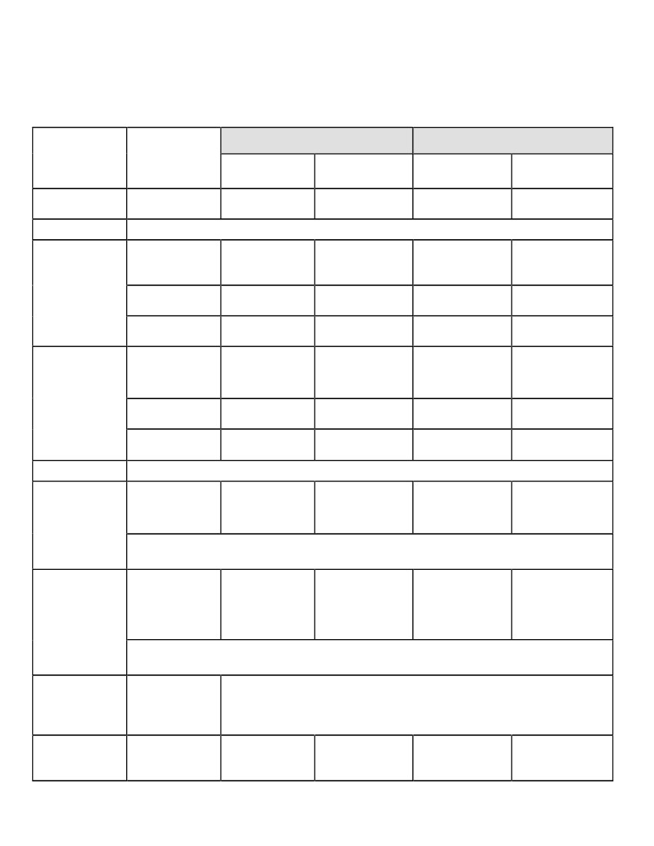
3rd Grade
Mathematics
Unit: 08 Lesson: 01
Measurement Stations Recording Sheet KEY
Metric measurements are to the nearest whole centimeter. Customary measurements are to
the nearest 1/2 inch.
Customary
Item
Station 1
Station 2
Crayons
Height
Box of 16
Box of 24
Box of 48
Estimate
Measurement
Estimate
Metric
Measurement
Marker
Answers
may vary
Answers
may vary
Answers
may vary
Answers
may vary
Answers
may vary
Answers
may vary
Answers
may vary
Answers may
vary
Answers may
vary
Answers may
vary
Answers may
vary
Answers may
vary
Answers may
vary
Answers may
vary
Answers may
vary
Answers may
vary
Crayon box sizes may vary
4 inches
4 inches
1/2 inch
1 inch
1 inch
2 inches
10
centimeters
10
centimeters
13
centimeters
1 centimeter
2 centimeters
6-7
centimeters
Crayons
Box of 16
Box of 24
Width
Station 3
Box of 48
Crayon
Length
Box of 48
If 3 of these boxes were laid end-to-end, what would be the total
length? 39 centimeters
Crayon
Answers
may vary
3 inches
Answers may
vary
Answers
may vary
5 inches
Answers may
vary
13
centimeters
8 centimeters
Width
Box of 48
If 3 of these boxes were laid side-by-side, what would be the total
length? 24 centimeters
Station 4
Station 5
©2010, TESCCC
Area:
Crayon
Box (48)
Pencil
15 square units (or 15 color tiles)
19
centimeters
page 77 of 89
7 1/2 inches
12/29/10

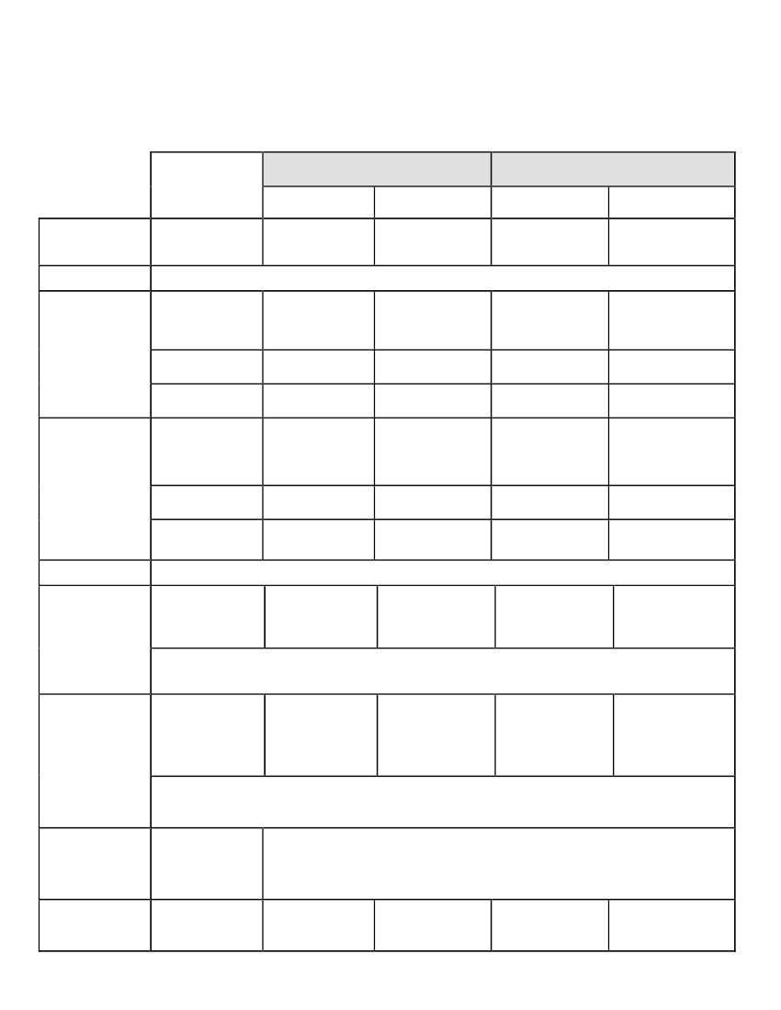
3rd Grade
Mathematics
Unit: 08 Lesson: 01
Measurement Stations Recording Sheet
Metric measurements are to the nearest whole centimeter. Customary measurements are to
the nearest 1/2 inch.
Item
Station 1
Station 2
Crayons
Height
Box of 16
Box of 24
Box of 48
Customary
Estimate
Measurement
Estimate
Metric
Measurement
Marker
Crayons
Box of 16
Box of 24
Width
Station 3
Box of 48
Crayon
Length
Box of 48
If 3 of these boxes were laid end-to-end, what would be the total length?
Crayon
Width
Box of 48
If 3 of these boxes were laid side-by-side, what would be the total
length?
Station 4
Station 5
©2010, TESCCC
Area:
Crayon
Box (48)
Pencil
12/29/10
page 78 of 89

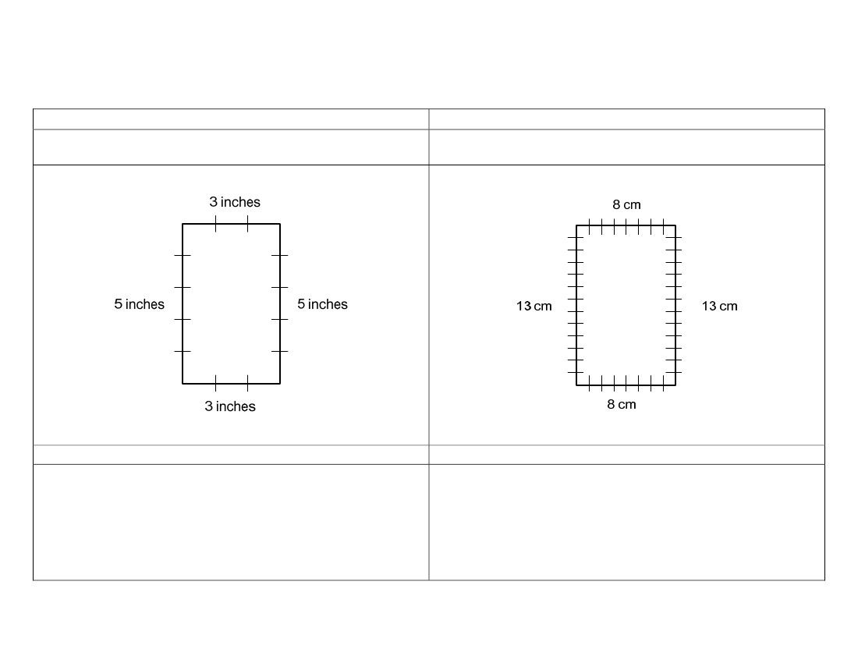
3rd Grade
Mathematics
Unit: 08 Lesson: 01
Crayon Box Perimeter Mat SAMPLE KEY
Customary
Drawing: Draw a picture of your crayon box below
showing the measurements of each side.
Metric
Drawing: Draw a picture of your crayon box below
showing the measurements of each side.
Calculation: Determine the perimeter.
Calculation: Determine the perimeter.
3 + 5 + 3 + 5 = 16 inches
8 + 13 + 8 + 13 = 42 centimeters
©2010, TESCCC
12/29/10
page 79 of 89

3rd Grade
Mathematics
Unit: 08 Lesson: 01
Crayon Box Perimeter Mat
Customary
Drawing: Draw a picture of your crayon box below
showing the measurements of each side.
Metric
Drawing: Draw a picture of your crayon box below
showing the measurements of each side.
Calculation: Determine the perimeter.
Calculation: Determine the perimeter.
©2010, TESCCC
12/29/10
page 80 of 89

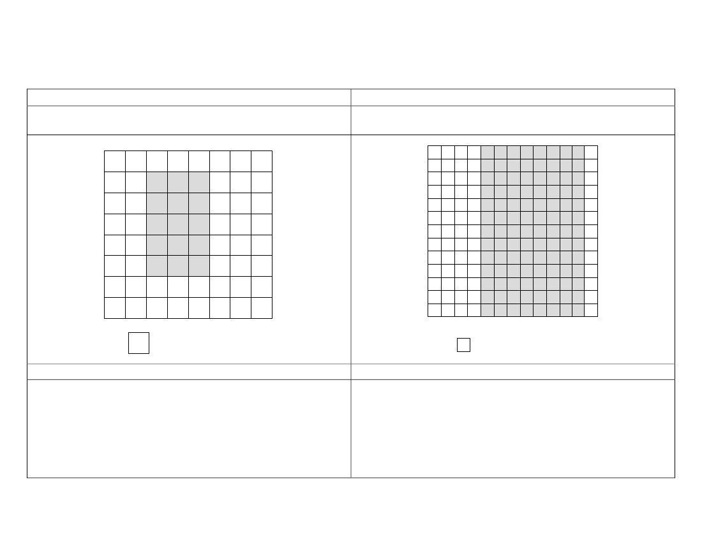
3rd Grade
Mathematics
Unit: 08 Lesson: 01
Crayon Box Area Mat SAMPLE KEY
Customary
Drawing: Use the grid below to sketch the cover of your
box.
Metric
Drawing: Use the grid below to sketch the cover of your
box.
= 1 square inch
= 1 square centimeter
Calculation
Calculation
Calculations may vary.Sample Answers:
5 groups of 3 = 15 or
3 + 3 +3 + 3 + 3 = 15 or
5 x 3 = 15
Calculations may vary. Sample Answers:
13 groups of 8 = 104 or
8+8+8+8+8+8+8+8+8+8+8+8+8=
104 or
13 x 8 = 104
©2010, TESCCC
12/29/10
page 81 of 89

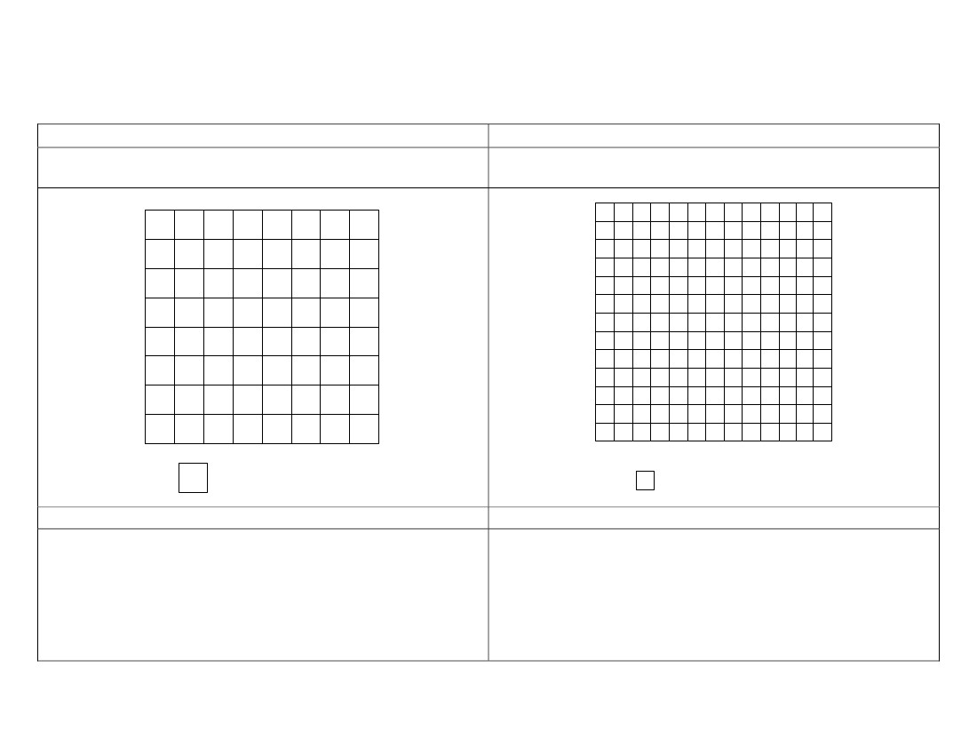
3rd Grade
Mathematics
Unit: 08 Lesson: 01
Crayon Box Area Mat
Customary
Drawing: Use the grid below to sketch the cover of your
box.
Metric
Drawing: Use the grid below to sketch the cover of your
box.
= 1 square inch
= 1 square centimeter
Calculation
Calculation
©2010, TESCCC
12/29/10
page 82 of 89

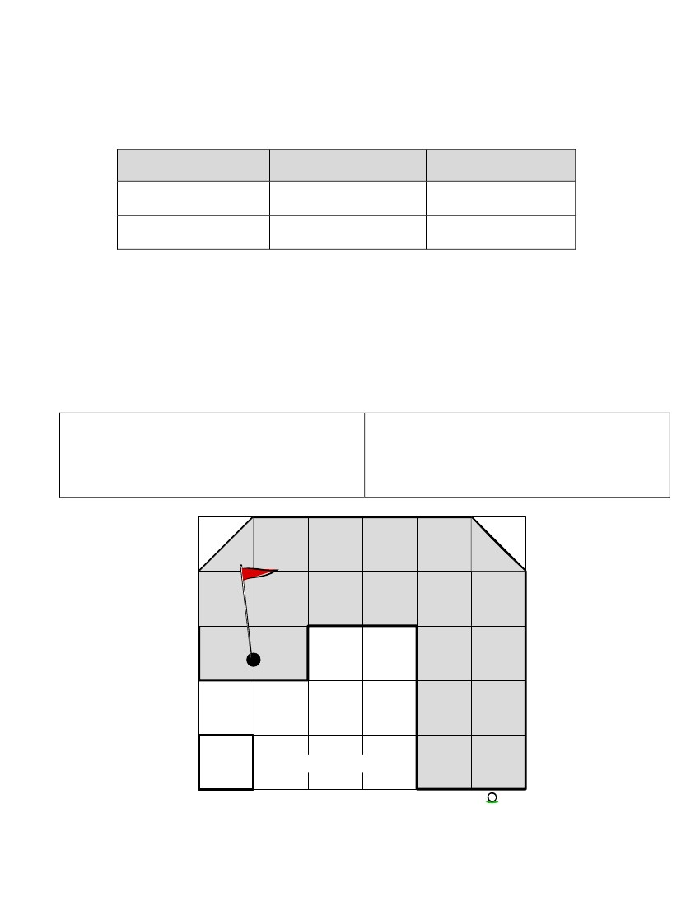
3rd Grade
Mathematics
Unit: 08 Lesson: 01
Measurement Evaluation (pp. 1 of 3) KEY
1. Estimate and measure the length of the top of your desk.
Estimate
Customary Units
Metric Units
Answers may vary
Answers may vary
Measurement
Answers may vary
Answers may vary
2. Estimate and measure the height of your chair using centimeters and label your answer.
Estimate: ______________________ Answers may vary
Actual: ________________________ Answers may vary
Find and record the perimeter and area (in inches) of one hole of a putt-putt golf course shaded
below. Explain how you found each measure.
Perimeter:
22 inches; Answers may vary but should
include counting sides to find the perimeter
Area:
19 square inches; Answers may vary but
should include counting whole units and
half units to find the area
= 1 square inch
Putt-putt
Start
©2010, TESCCC
12/29/10
page 83 of 89

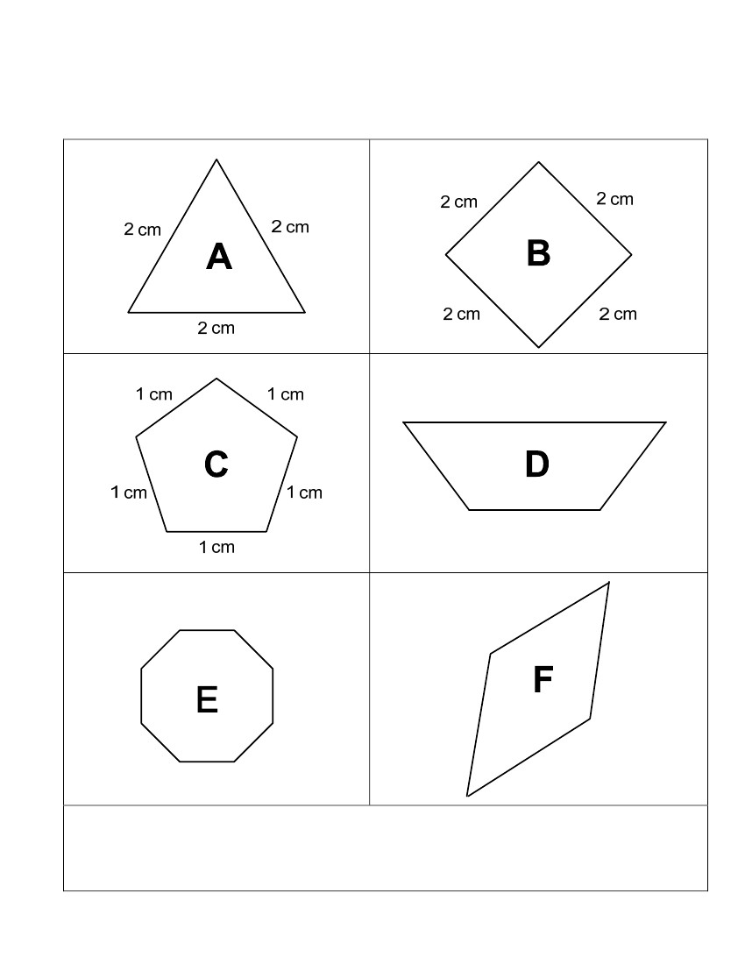
3rd Grade
Mathematics
Unit: 08 Lesson: 01
Measurement Evaluation (pp. 2 of 3) KEY
Look at the figures below. The dimensions are given in centimeters.
4 cm
1 cm
2 cm
1 cm
1 cm
1 cm
1 cm
1 cm
1 cm
Which figures have the same perimeter? How do you know?
3 cm
1 cm
3 cm
1 cm
3 cm
1 cm
3 cm
Figures B, D, and E; Because each perimeter totals 8 centimeters
©2010, TESCCC
12/29/10
page 84 of 89

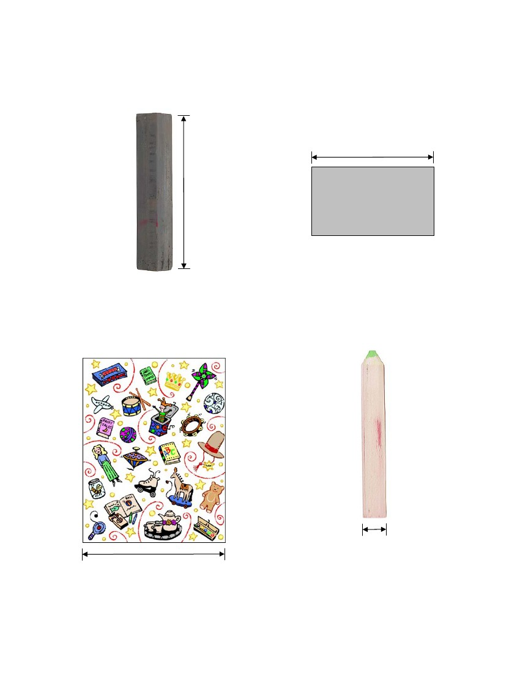
3rd Grade
Mathematics
Unit: 08 Lesson: 01
Measurement Evaluation (pp. 3 of 3) KEY
Use Grade 3 Mathematics Chart to measure the pictures below (along the line segments given)
to the nearest half inch or nearest centimeter.
1. Customary: 2 1/2 inches
2. Metric: 5 centimeters
If 3 of these rectangles were laid
end-to-end, what would be the total
length? 15 centimeters
3. Customary: 2 inches
4. Metric: 1 centimeter
If 7 of these pencils were laid side-
by-side, what would be the total
length? 7 centimeters
08/01/10
page 85 of 89
©2010, TESCCC

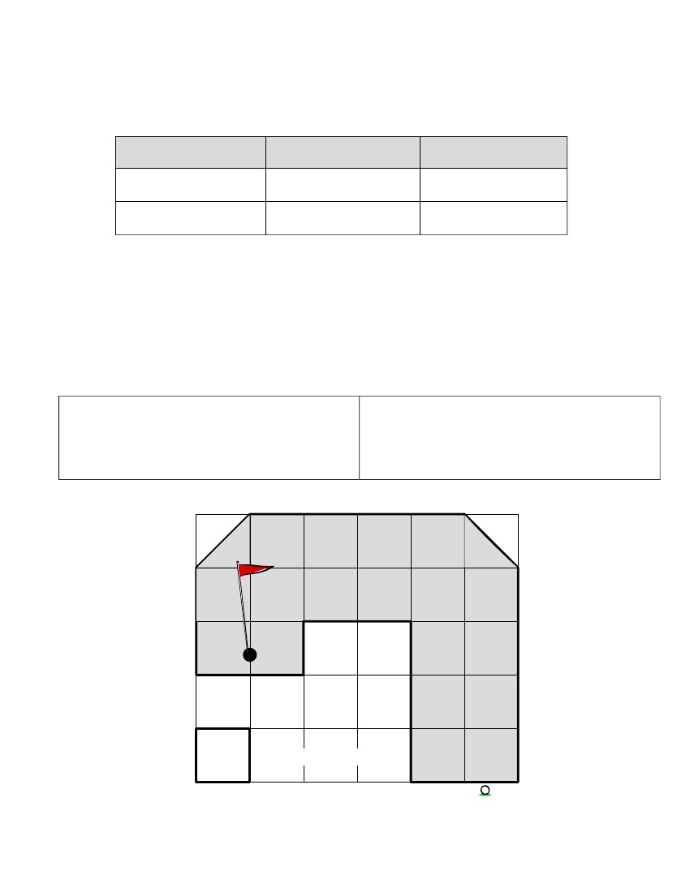
3rd Grade
Mathematics
Unit: 08 Lesson: 01
Measurement Evaluation (pp. 1 of 3)
Include more forms of assessment ( possibly visual or kinesthetic)
1. Estimate and measure the length of the top of your desk.
Estimate
Customary Units
Metric Units
2. Estimate and measure the height of your chair using centimeters and label your answer.
Estimate: ______________________
Actual: ________________________
Find and record the perimeter and area (in inches) of one hole of a putt-putt golf course shaded
below. Explain how you found each measure.
Perimeter:
Area:
Measurement
= 1 square inch
Putt-putt
Start
©2010, TESCCC
08/01/10
page 86 of 89

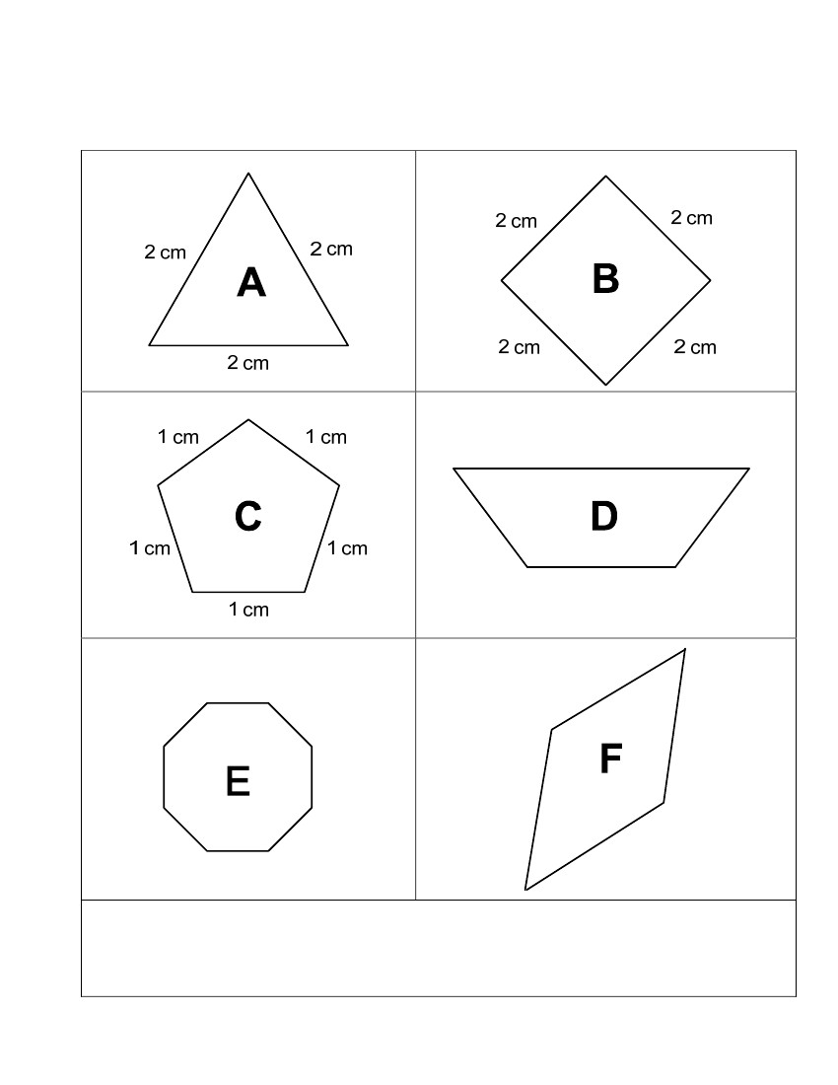
3rd Grade
Mathematics
Unit: 08 Lesson: 01
Measurement Evaluation (pp. 2 of 3)
Look at the figures below. The dimensions are given in centimeters.
4 cm
1 cm
2 cm
1 cm
1 cm
1 cm
1 cm
1 cm
1 cm
Which figures have the same perimeter? How do you know?
3 cm
1 cm
3 cm
1 cm
3 cm
1 cm
3 cm
©2010, TESCCC
08/01/10
page 87 of 89

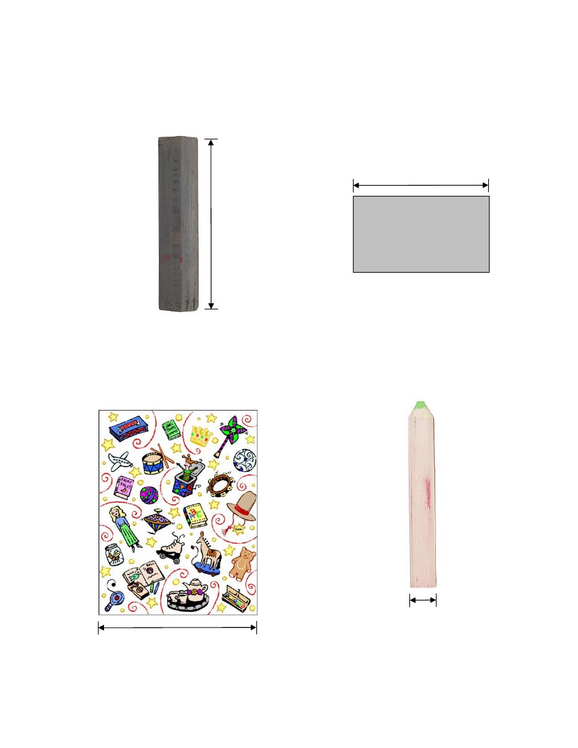
3rd Grade
Mathematics
Unit: 08 Lesson: 01
Measurement Evaluation (pp. 3 of 3)
Use Grade 3 Mathematics Chart to measure the pictures below (along the line segments given)
to the nearest half inch or nearest centimeter.
2. Metric: _____________
1. Customary: _____________
If 3 of these rectangles were laid
end-to-end, what would be the total
length? _____________
3. Customary: _____________
4. Metric: _____________
If 7 of these pencils were laid side-
by-side, what would be the total
length? _____________
08/01/10
page 88 of 89
©2010, TESCCC

3rd Grade
Mathematics
Unit: 08 Lesson: 01
Bibliography
Van de Walle, J. (2006). Teaching student-centered mathematics, Grades 3-5, Boston: Pearson Education, Inc. 258-259.
Publication Manual of the American Psychological Association (5th ed.). (2001). Washington D.C.: American Psychological
Association.
©2010, TESCCC
08/01/10
page 89 of 89

